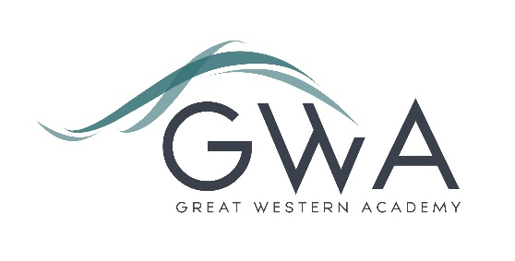

Information for Applicants

Teacher of English
Full-time or Part-time, Main/Upper Pay Scale
Are you looking to join a high-performing and ambitious team of English teachers in a thriving, growing school? We have a tremendous opportunity for you at Great Western Academy and this post would suit a new entrant to the profession or a more experienced practitioner equally well.
Great Western Academy opened in September 2018 and now accommodates over 900 students in years 7 to 11 and the Sixth Form. The results of our first three A-level cohorts in summer 2021, 2022 and 2023 were excellent and enabled 98% university applicants to take up their offers, including three to Oxford and Cambridge; students have also secured prestigious apprenticeships with companies such as Airbus and Rolls Royce. Our first GCSE results in summer 2023 showed that the progress made by the large majority of our first cohort of year 11 students has been excellent, particularly in English and Maths. This includes students of all abilities.
We now have five groups of A-level English. The foundations we have laid in English are excellent; our team of experienced staff ensure students enjoy their learning, and the progress made by our students is excellent both at GCSE and A-level.
This role will provide the successful applicant with the chance to further develop and teach an exciting English curriculum in KS3 and KS4 as well as the option to teach A-level English and Media Studies if desired. You will be part of a dynamic and growing English teaching team and you will therefore have the chance to significantly shape the experiences of our students in the subject as they progress through our growing school. You will also be well supported to enjoy and develop your own practice, whether you are an NQT or more experienced.
There is the potential for this role to develop as the school and Sixth Form grows, with various leadership opportunities becoming available in future years, both subject and whole-school based. Our priority is very much to recruit the best classroom practitioners who can ensure our students arrive at the Academy excited about the day ahead and leave each day talking about the excellent learning they have experienced.
Great Western Academy runs a successful enrichment program for all students from 3.10 to 4.15 on Tuesdays, Wednesdays and Thursdays. The subjects studied are as diverse as Astronomy, Orchestra, Volleyball, Pokemon and Scrabble. Enrichment broadens and deepens a student’s range of experiences at school and gives them the opportunity to learn with other age groups. All teachers will run one enrichment session a week as part of their directed hours. It is an opportunity to engage students’ interest in an area of your own interest.

Great Western Academy aims to radically improve the life chances of every student who attends. Our brand-new building and state-of-the-art facilities help us to achieve this, but it is the fantastic team of staff who turn our vision into reality. If you have the proven ability to inspire students in the classroom and beyond then this provides you with an exciting opportunity to further shape your practice and develop your career.
Additional benefits of working at GWA include:
- Average class sizes of 26 in years 7 to 11
- Flexible working opportunities
- Excellent CPD opportunities
- State of the art facilities
- Leading edge ICT, including a laptop provided for all staff
- Free Health and Wellbeing Support Service
- Cycle to work scheme through Cyclescheme
- Access to EV charging on site. Electric Vehicle Salary Sacrifice scheme
- Easy access to the A419, and free parking

Further details are available on the Academy website www.gwacademy.co.uk and in the information documents attached.
Application process

Please complete the application and equalities forms supplied and enclose a supporting letter, either in the space provided on the application form or as a separate document. The application form should be completed in full in black ink or type. A CV is not required and should not be submitted as part of the application.

Your supporting letter should be no more than 2 sides of A4 (with a font size no smaller than 11) and should enhance your application by providing further information, matched to the person specification, about your suitability for the post. This should include evidence of the impact on student outcomes you have made in your career to date.

Applications should be submitted electronically to recruitment@gwacademy.co.uk by 9am on Thursday 11th July 2024. Interviews will take place as soon as possible after this date. Please note we may interview before the closing date (and close the advert early) depending on the suitability, and number of, applicants.
Great Western Academy is committed to safeguarding and promoting the welfare of children, young people and vulnerable adults and we expect all staff to share this commitment and undergo appropriate checks. All posts within the Trust are therefore subject to an Enhanced DBS and barred list check.

References: References will be taken up prior to interview.

