TEACHER OF ENGLISH

Candidate Pack

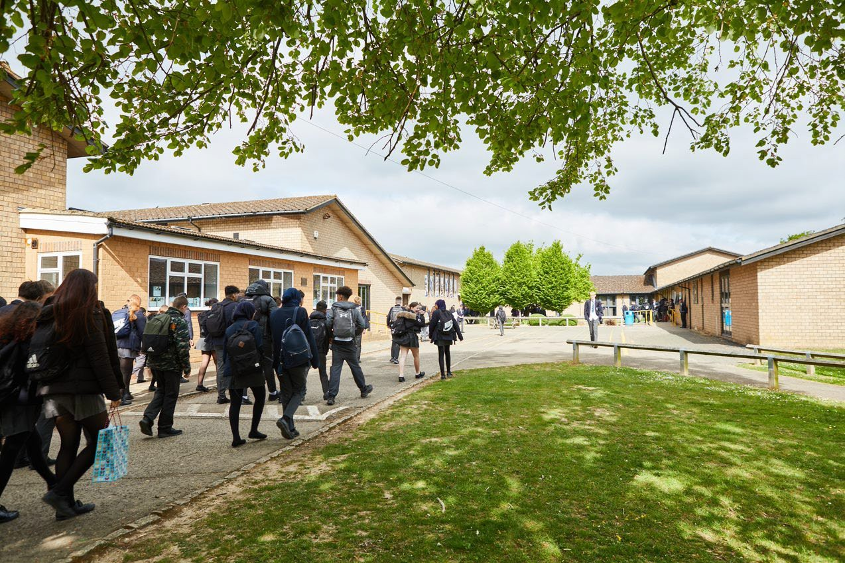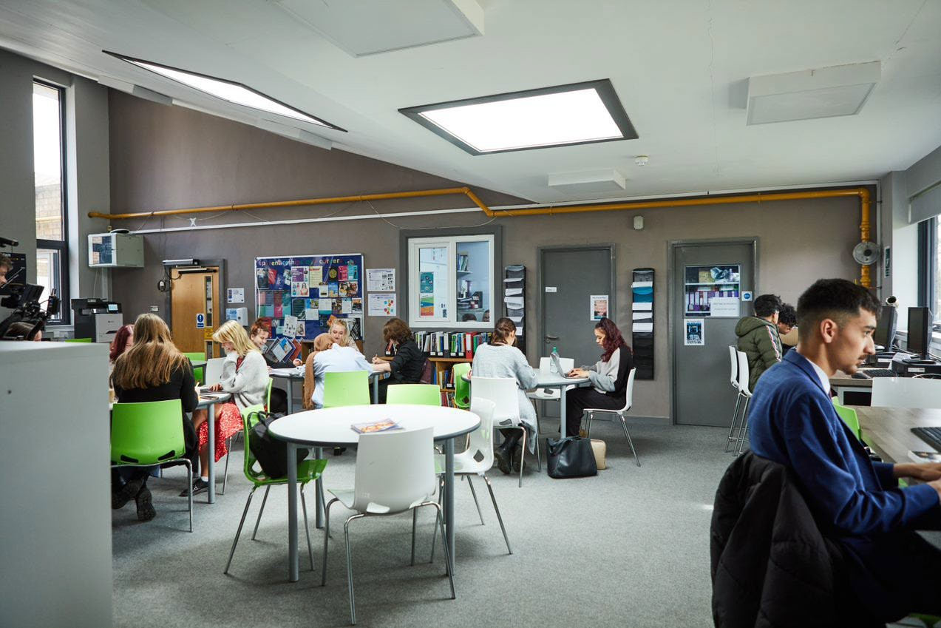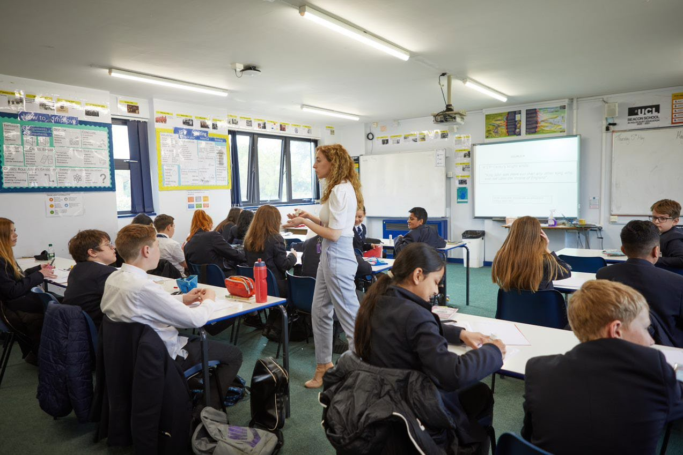
Welcome letter from the Headteacher

Dear Prospective Candidate,

Thank you for your interest in the position of Teacher of English at Sir William Ramsay School.

I joined Sir William Ramsay School as the new Headteacher in May and am committed to getting the school back to ‘Good’ as quickly as possible. Clarity, consistency and rigour are central to our plans to ensure that all students enjoy learning and make good progress. Our plans include significant developments in high quality teaching and learning, the introduction of ambitious targets, a focus on developing excellent teaching, meaningful homework and improvements in behaviour for learning. We are also rolling out a digital learning 'One to One Device' strategy across the school to ensure that students can receive innovative teaching and access state of the art resources at both home and school.

We are looking to appoint a dynamic Teacher of English to contribute to the development of this successful area. The ideal candidate will have a belief in the ability of all students to achieve and a passion for raising student achievement. You will have a desire to strive for continuous school improvement and a commitment to team work as well as a sense of fun.

If you would like to find out more about the role or to arrange a conversation with the Head of Faculty, please contact ETalbot@swr.school

I will hope to meet you in the near future.

Yours faithfully

Paul Ramsey
Headteacher

Vision and Values at Sir William Ramsay School

Empowering Everyone to Achieve

Vision
A community where every voice counts, where talent and creativity are brought to life, where students grow in confidence, build resilience and are prepared for the rest of their lives.

Values
- We are respectful – we always treat people, property and the environment with kindness and consideration
- We are ambitious – we ask for help when we need it and strive to be the best we can be
- We are reliable – we do what is asked of us and deliver on our commitments
- We are resilient – we prepare for the future and adapt and grow from challenges

Mission
We aim to achieve our vision by:
- Raising students above the ordinary by developing and delivering lifelong learning which transforms lives
- Ensuring every person feels valued, safe and happy
- Enabling students to feel proud of themselves, and to take pride in the success of others
- Promoting a culture of mutual respect where everyone is treated as a valued member of the school community
- Encouraging positive communication so that words and actions are thoughtful, supportive and motivational
- Placing parents and carers at the heart of the life of the school
- Having highly dedicated and well-qualified staff who are committed to continuous professional development
- Adopting an ethos of continuous improvement within all aspects of school life

Equality
Sir William Ramsay is an inclusive and diverse community. We work to eliminate all forms of discrimination on the grounds of ethnic origin, religion, sexual orientation, gender, disability or ability. This is achieved via the following principles:
- Ensure that students have the opportunity to reach their potential in all areas of school life
- Ensure that parents and students can make choices free from prejudice and stereotyping
- Oppose any form of racism, sexism, disability discrimination, homophobia or any other form of discrimination
- Value every student’s language and cultural background
Job Description

Job Title: | Teacher of English
Aim and Main Job Purpose: | To teach, enthuse and inspire students about English Language and Literature.

Teaching and Managing Pupil Learning

Teacher of English will:
- Be able to teach effectively across the full range of age and abilities.
- Possess high expectations of students in relation to standards of achievement and behaviour.
- Have an active input in the creation, consistent implementation and improvement of schemes of work which encapsulate key school learning strategies.
- Monitor the progress of students including those requiring additional support and challenge them to ensure students are engaged in their learning and achieve success.

Assessment and Self-Evaluation

Teacher of English will:
- Implement policies and practices for assessing, recording and reporting on student achievement and to assist in setting targets for further improvement.
- In conjunction with the Head of English, use data effectively to identify students who are underachieving and, where necessary, create and implement an effective intervention plan.

Relationships with Parents

Teacher of English will:
- Establish a partnership with parents to involve them in their child’s learning of the subject, as well as providing information about targets and attainment.
- Communicate effectively, both orally and in writing, with parents.

Managing Own Performance

Teacher of English will:
- Prioritise and manage their own time effectively.
- Take responsibility for their own professional development.
- Share good practice resulting in a tangible impact on student learning.
- Form constructive relationships with staff including team working and mutual support.
- Actively implement the key aspects of the school’s behaviour management policies.
- Be a form tutor.

- Make a contribution to the wider school life including specialist English enrichment activities.
- Contribute to faculty planning and developments.

Strategic Leadership

Teacher of English will:
- Contribute fully to the Faculty Development Plan which contributes positively to the achievements of the School Development Plan.

Other Responsibilities
- To promote the School’s vision, values and aims.
- To be aware of and comply with the codes of conduct, regulations, policies, procedures.
- To work as part of a team.
- To be generally responsible for safeguarding and promoting the welfare of students.
- To be responsible for own and team health and safety including well-being.
- To actively participate in the School’s appraisal system.
- To do Continued Professional Learning as agreed with the Line Manager.

This job description is current at the date indicated below but, in consultation with the postholder, it may be changed by the Headteacher to reflect or anticipate changes in the post commensurate with the grade or job title.
The English Department

The Department
As a department we are committed to high standards of creativity and integrity. We seek to develop these characteristics through dealing with students, colleagues and leaders with trust, openness and honesty. These, we believe, are values which enable learning for all. We care about our students and about the integrity of the work that we set for them. We seek positive and supportive relations with all staff in Sir William Ramsay and we seek development as teachers through our own learning, research and relationships and skills. Operating as a team, we share good practice and ideas, meet regularly, and continually standardise assessment work across the key stages.

We are actively committed to the equality of all students in our care regardless of race, religion, sex or sexual orientation. As such, we explore a wide range of literature from all corners of the world in order to broaden the minds and increase understanding of the world we live in.

A love of reading is something we strive for across the school and the English department are committed to ensuring students have a diverse plethora of literature and non-fiction texts to continue their love of reading from earlier key stages.

The Curriculum

With the demands of 9-1, we ensure that all the skills required are addressed and built upon during KS3. Developing pupils’ communication skills, the essential reading, writing, speaking and listening, we encourage their creativity and exploration of the subject. All students are given the best opportunities to reach their potential. Students follow the reading programme Accelerated Reader during their library lessons as well as group reading session to develop discussion and oracy.

Students in KS4 complete a comprehensive study of skills and literature to prepare them for life long learning and complete examinations of English Language and English Literature GCSE with AQA. This exam board requires students to sit four GCSE papers, two language and two literature, and also complete a Speaking and Listening Endorsement.

All Key Stage 4 students study the following literature texts; Macbeth by William Shakespeare, An Inspector Calls by J.B Priestley and A Christmas Carol by Charles Dickens.

We have a thriving English Literature A Level course taken with AQA, which covers a wide range of poetry, prose and Shakespeare in the ‘Aspects of Tragedy’ element and contemporary
literature in ‘Social and Political protest’ studies. Students are encouraged to discuss and debate perspectives in their lively A Level classes. Our Sixth Form offers and individualised approach to students, meaning in English students have the benefit of smaller class sizes, two dedicated members of staff and regular opportunities for personalised feedback and support.

Our Facilities and Extra-Curricular Opportunities
Each of our full-time members of the department have their own rooms fully equipped with whiteboards. We have a team room for meetings and storage for our extensive resources. All students in KS3 have regular lessons in our well stocked library. We are keen to take students on visits to the cinema and theatre when appropriate: we also invite theatre and performance groups to school, as well as having a visiting author at least once a year. Students in Key Stage 3 are encouraged to take part in our highly popular creative writing workshops which run twice a week.

Literacy
We run a variety of schemes to promote and improve literacy across the school organised by a Literacy Coordinator.

How to Apply

If you wish to discover more about this exciting opportunity, need any further information or you wish to have an informal discussion, please contact Liz Talbot ETalbot@SWR.School or 01494 815211.

Please email your completed application form to: jointheteam@swr.school

Closing Date: Noon, Wednesday 15th March 2023
Interviews: week commencing Monday 20th March 2023

Sir William Ramsay School is committed to safeguarding and promoting the welfare of children and young people and expects all staff and volunteers to share this commitment. We will ensure that all our recruitment and selection practices reflect this commitment.

All successful candidates will be subject to DBS checks along with other relevant pre-employment checks.

