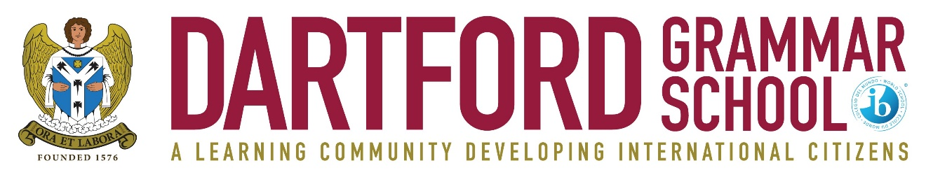

FULL TIME TEACHER OF ENGLISH
Required for January 2023
(MPS/UPS + LFA)

An enthusiastic and committed teacher to teach English in a high performing IB World School offering excellence within the state sector.

The post would be equally suitable for an exceptional new entrant to the profession or a more experienced teacher looking to return to the profession and who is looking for significant amounts of Sixth Form teaching in one of the largest sixth forms in the country. A TLR would be available for an experienced candidate.

Dartford Grammar School is one of the highest performing schools nationally at Key Stage 4 and Key Stage 5, with excellent facilities, designated as ’outstandingly successful’ in successive national and international inspections. The ability to teach a second subject would be welcome and a willingness to be an active participant in the extra-curricular life of the school are important.

We are keen to hear from you if you are:
• an excellent classroom practitioner
• committed to raising achievement and transforming learning
• well-organised, proactive and able to work effectively as part of a team
- excited at the prospect of teaching bright, hard-working students

We can offer you:
• the opportunity to inspire highly able and well-motivated students to fulfil and exceed their potential
• a dynamic and supportive working environment
• a well-established Induction Programme
• opportunities for professional development

Please use the contact details below if you would like the opportunity to tour the school or to meet the Head of Department before making an application.

For further details and an application pack please contact the school - telephone: 01322 223039; fax: 01322 291426; e-mail: mbexley@dartfordgrammarschool.org.uk

Please return a completed application form, to the Head, Mr Julian Metcalf, Dartford Grammar School, West Hill, Dartford, Kent DA1 2HW.
Closing date: 30 September 2022
Interview date to be confirmed
(The school may interview early in the case of an exceptional candidate)

Dartford Grammar School is a selective secondary academy for boys, which admits girls to its sixth form. There are six forms of entry to Year 7, and all of the students joining the school are from the top 25% of the ability range. The current roll is 1,515, including 597 in the sixth form.

The school is committed to safeguarding and promoting the welfare of children and young people and expects all staff to share this commitment. An enhanced DBS check is required for all successful applicants.

