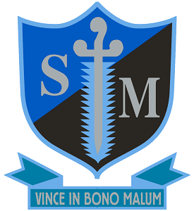

St Michael’s Catholic College
Llewellyn Street, Bermondsey, London SE16 4UN
11–18 Academy in the St Benedict Catholic Academy Trust
Required for September 2024
Roll: 952
Teacher of English
Salary MPS/UPS

St Michael’s Catholic College is an outstanding school which offers exceptional opportunities for a talented, and enthusiastic teacher of English to join a committed and enthusiastic English department. As a core subject English is high profile at the College and as a result we have very high levels of engagement across all key stages, including a very good uptake at A’ Level.

St Michael’s Catholic College has been judged outstanding by Ofsted on two consecutive occasions and also in the most recent Diocesan Inspection in March 2023. Outcomes continue to be above all local and national performance measures and St Michael’s is the only school in England to receive three SSAT awards for exceptional outcomes in 2023, winning for attainment, progress and closing the gap.

The person appointed would be joining a very strong English Department regularly achieving well above national average results at both GCSE and A’ Level. The successful candidate will be a motivated individual with a keen interest in encouraging and inspiring students and who can enable them to flourish. The person appointed will have the opportunity to teach across the age and ability range and this position would suit either an experienced teacher or an exceptional ECT.

St Michael’s is an outward looking school with an excellent reputation in the local area. As well as being a strategic partner in the Catholic Schools’ Partnership and Southwark Schools Learning Partnership, St Michael’s is a founding school in the St Benedict Catholic Academy Trust which opened on 1st April 2024. Founding school Headteachers and Governors have worked with Trustees and the Diocese to establish a Trust with a vision and mission to be a beacon of Catholic education, where schools retain their unique identity whilst also being part of a wider community and support network.

Alongside these opportunities to work with professionals from a range of other establishments, the college was awarded transforming status by SSAT reflecting the outstanding professional development and wellbeing support we offer to staff. The college’s excellent location by Tower Bridge facilitates a large number of business partnerships and enrichment opportunities.

St Michael’s College is committed to safeguarding and promoting the welfare of children and young people and expects all staff to share this commitment. This post is subject to a Disclosure and Barring Service (DBS) check.

For an application form and information pack please contact Mrs Valerie Ferguson, email: v.ferguson@stmichaelscollege.org.uk

Early applications are advised as the College reserves the right to appoint at any stage during the application process. Closing date: 9am Friday 14th June

