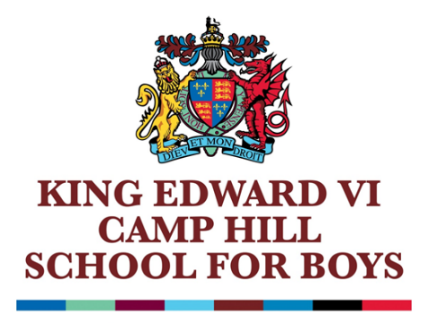

Teacher of English
Information for Applicants

March 2025

GENERAL INFORMATION ABOUT THE SCHOOL

King Edward VI Camp Hill School for Boys is a selective state school; it is a member of the King Edward VI Academy Trust Birmingham, which is a group of twelve schools, six of which academically select their pupils. These schools, together with two independent schools, form the King Edward’s Foundation. The school moved from the inner city to its present location on the former Cartland Estate in 1956. Kings Heath is a pleasant suburb in South Birmingham with easy access to the M42, M40, M5 and M6 motorways, to Stratford and to the Warwickshire/Worcestershire countryside. In recent years, we have benefited from a new Sports Hall, Library, laboratories, classrooms and Sixth Form Common Room.

There are 1054 students on roll, of whom 336 are in the Sixth Form. The school admits 120 students (150 in the current Year 7,8, 9 & 11; 150 in next year’s Year 7) a year at the age of 11. Nearly all of the students stay on at the school to the age of 18 and proceed into Higher Education. Academic standards are very high – in 2024 the percentage of GCSEs passed at grades 8 and 9 was 74%. At A Level the percentage of exams passed at A*-B was 83%. 20 (9 Cantab, 11 Oxon) Oxbridge hopefuls achieved their places.

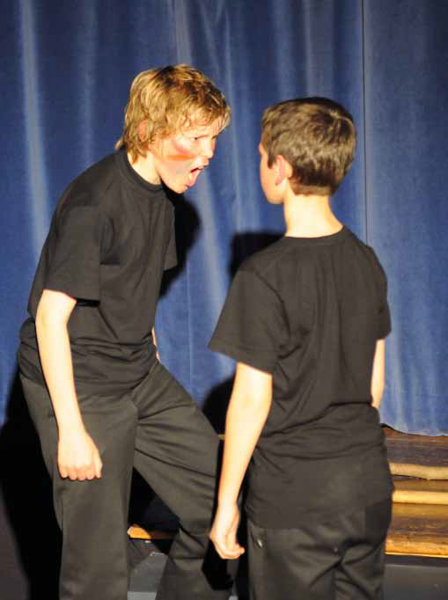

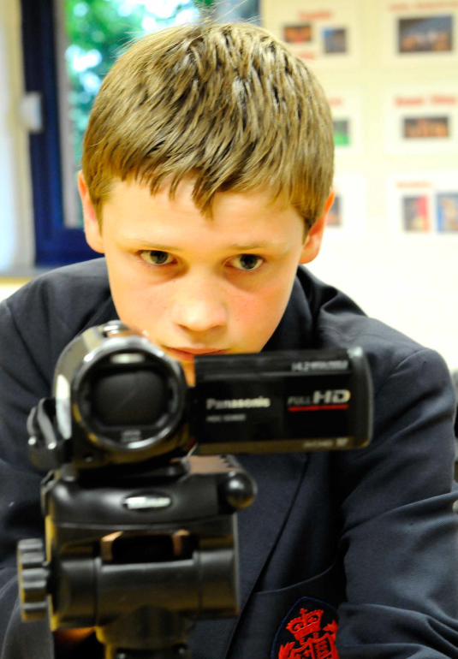
THE ENGLISH DEPARTMENT
Staffing:

Mr N Hill (Head of Department)
Mrs J Parmar (Second in Department)
Mrs H Robertson (part-time)
Mrs C Bicknell (part-time)
Mrs C Dawson (part-time)

Accommodation:

There are five well equipped classrooms used for English teaching, as well as access to a separate Drama Studio, which is shared with the Girls’ School. Each classroom is equipped with an LCD projector, SMART interactive whiteboard, and DVD player. In addition to this, the department has six laptops for general ICT work, to complement our six HD camcorders; this equipment is used extensively in our curricular and extra-curricular Media and Drama work. Each member of staff is also provided with their own laptop. We are fortunate to benefit from a large, well-stocked library, as well as having extensive stocks of books across all three Key Stages within the department.

Curriculum:

The English Department is an enthusiastic and progressive department striving to stimulate and challenge well-motivated students.

At KS3, English is taught for six periods a fortnight. The scheme of work is broken down into thematic units, usually lasting half a term, which offers some scope for individual text selection by each teacher. Medium term plans outline the main focal points of a unit and the tasks that need to be carried out, but there is enough flexibility for teachers to develop their own individual teaching approaches.

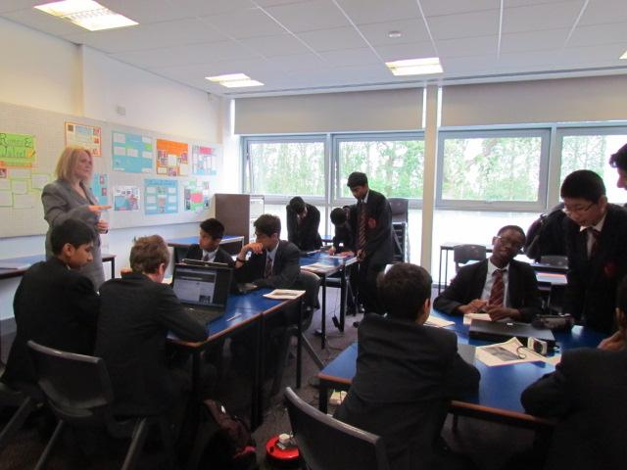
At KS4, students follow AQA English Language and Literature GCSEs. Both Year 10 and 11 have six periods a fortnight, with all students doing both subjects as an integrated two year course.

At A-level, students follow AQA English Literature Specification A. Currently there are two sets (one in Y12 and one in Y13), totaling 23 students overall. Each group is taught by two teachers, sharing 9 lessons a fortnight.

There is no discrete Drama Department at Camp Hill Boys, but through the curricular and extra-curricular work of the department across all three Key Stages, there are plenty of opportunities for Drama work to take place. We are now also providing Y7 students with one Drama lesson a fortnight, introducing them to a variety of core skills.

The ethos within the department is a belief that teaching should be as engaging and active as possible. We aim to enthuse students by building a thorough grounding in the core principles of English, both in terms of Language and Literature skills, whilst also providing opportunity for ‘stretch band challenge’. A range of enrichment activities are organised, which include theatre visits, author visits, GCSE and A level study days, Junior Drama Productions, Junior Poetry and Music Concerts, Poetry Competitions, Public Speaking Competitions, Debating Competitions and a Year 8 Media Day. We also run a variety of clubs, including Junior, Intermediate and Senior Debating societies, Drama Club and Scrabble Club.

Results in public examinations have been very pleasing and the statistics for 2024 are reproduced below:
 | 9 | 8 | 7 | 6 | 5 | 4 | 9/8/7 | 9-5
GCSE Eng Lang | 32 | 43 | 19 | 20 | 3 | 1 | 79.66% | 99%
GCSE Eng Lit | 43 | 29 | 28 | 11 | 7 | 1 | 84.7% | 99%
 | A* | A | B | C | D | E | A*/A | A*-B
A Level | 1 | 5 | 2 | 1 | 0 | 0 | 66.7% | 88.9 %

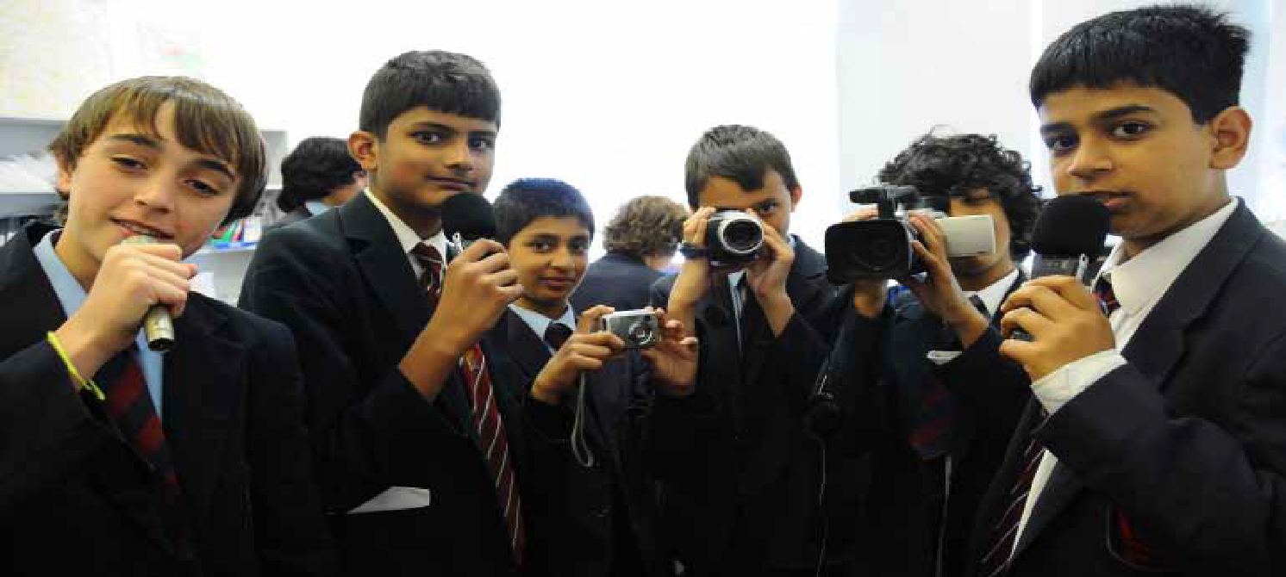

THE POST

The post has become vacant due to a member of the team going on maternity leave until the 31st August 2026. We are seeking a suitably qualified and talented classroom practitioner, who is able and willing to contribute to this highly successful department.

FURTHER INFORMATION

Candidates are asked to complete the application form which is available from the school and on the school website. This document should be sent to the Head’s PA as soon as possible, but by no later than 9:00am on Monday 31st March 2025. Interviews are scheduled to take place shortly after.

Please do not hesitate to email or telephone if you require any further information. Camp Hill Boys is a happy, flourishing and friendly community as well as an outstandingly successful grammar school. I look forward to receiving your application.

R Bowen
Headmaster

