***Teacher of English & Drama***

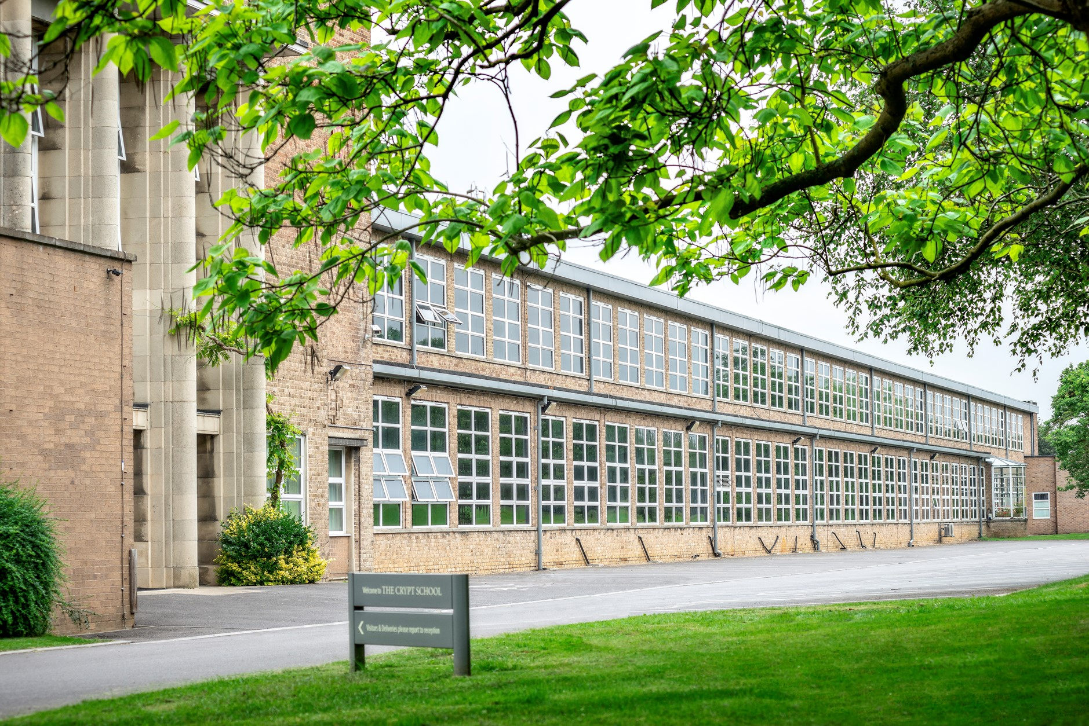

If you would like any further information on the role, please contact Sharon Bailey, HR Administration on [sbailey@crypt.gloucs.sch.uk](mailto:sbailey@crypt.gloucs.sch.uk) or T: 01452 530291.

**The closing date for applications: Noon, Tuesday 2nd March 2021**

**Interview date: Term 4, exact date to be confirmed**

Due to the current global situation interviews may take place remotely, if necessary; however, that remote interview will try to replicate as far as possible what would have occurred if candidates had been in school.

If you are invited into school, we have covid-19 procedures in place, temperature checks, hand sanitiser, one way system, social distancing and wearing of a face mask in all communal areas.

***The Crypt School is committed to safeguarding and promoting the welfare of children and young people in its recruitment and selection of job applicants and expects all staff to share this commitment.***

***The successful candidate will be required to undergo an enhanced DBS check.***

***Message from the Headmaster – Mr. Nicholas Dyer***



I am delighted that you are considering a role here at The Crypt School. I hope that you find this information helpful and we look forward to receiving your application.

The School is located just outside of the City of Gloucester in the West of England. Gloucester is known for its 11th century Cathedral and close; for Blackfriars, which is a stunning example of a 13th century medieval priory site; the British Waterways Museum, which celebrates the city’s industrial past, and now the vibrant Gloucester Quays, which has a selection of shops and restaurants. Gloucester is a vibrant and growing city, and the School is conveniently located close to the City, and close to good road and rail links to Cheltenham and the surrounding region, including Bristol for example.

Founded in 1539, The Crypt School’s vision is derived from its Latin motto “Floreat Schola Cryptiensis”: floreat means “to flourish” and at The Crypt we wish all our pupils and our young adults in the sixth form, as well as our staff, to flourish in all that they do both in school and in their later adult lives.

We are a vibrant co-educational selective school, a place where learning is valued for its own sake within an environment of strong pastoral care. At the centre of our school life, is a powerful sense of community, where pupils are supported and encouraged to learn and engage with each other. Confident, friendly and respectful, the high quality of our pupils’ personal development is remarkable and is one of the greatest strengths of the School.

We recognise the time and thought that goes into an application and we will certainly give yours our serious consideration.

If you have any further questions or wish to visit the School prior to sending in an application, please contact Sharon Bailey via [sbailey@crypt.gloucs.sch.uk](mailto:sbailey@crypt.gloucs.sch.uk) who will be able to assist you.

With best wishes

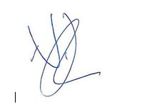  
  
Nicholas Dyer

**The Appointment**

A well-qualified teacher of English & Drama is required with the ability and enthusiasm to teach across the age range. This post is suitable for NQTs, or equally those colleagues with more experience seeking a new challenge.

In September 2018, the School became fully co-educational in its intake and most of its year groups are now co-educational; however, we must continue to work hard to ensure we meet the academic, pastoral, and wider needs of all the young people within school.

**Drama Department**

The Drama Department is a highly successful and creative hub for staff and students. Academic results are very strong at both GCSE and A Level and all pupils make fantastic progress in their learning.

The department currently comprises of one two full time members of staff, one of which is split between the Drama and English departments, this is the role you are applying for. We have a large Drama Studio with a black sprung floor and we use the sports pavilion and the hall to teach some lessons. There is a wonderful departmental office and may textbooks and resources at the teacher’s disposal. The KS3 curriculum is completely paperless and all trackers and assessments are done on the iPads.

Every year we produced a full school production. Last year we did Grease the musical. This is something that many of our pupils enjoy getting involved in. Many members of staff also get stuck in during show week – it is a real team effort!

**Key Stage 3**

Pupils receive 1 hour every week of Drama on their timetables. The KS3 curriculum is very diverse and completely practical. Please find our full program of study on the website. We are making some changes to the curriculum this year and have made room for new exciting SOW and are including BLM topics and a historical focus to broaden the learning of our pupils. As well as lesson time, we take pride in running a drama club for each KS3 year group which run at lunch times.

**Key Stage 4**

At GCSE, we study the Eduqas specification which offers a range of practical, technical and performing elements. Our uptake at GCSE level varies each year, but classes are usually from 10-20 students. Students studying Drama and GCSE have 5 lessons per fortnight on their timetables. We do encourage lunch time or after school rehearsals when practical exams are near.

**A Level**

We continue with the Eduqas specification at A Level which forms a nice transition from GCSE to A Level. Class sizes vary each year but normally range from 4-10 students. We like to encourage Y12 and Y13 to perform and feedback to each other regularly.

**Personnel**

The department is very successful, and the Head of Department has been at the school for 5 years. It is crucial that the candidate is good at communicating and is open to new courses and professional development. The appointee will work closely with the head of department to teach the Drama curriculum and fulfil wider responsibilities in the school. The Drama department is where our pupils thrive and express themselves, our students enjoy the relaxed atmosphere and critical approach to learning about theatre and acting.

**English Department**

The Crypt School English Department is an academically exciting place to work, offering A-levels in English Language and English Literature. We have a shared vision of both inspiring and enabling our students to become outstanding communicators in all respects.

Our GCSE classes are streamlined sets from a five-form intake which has an average class size of 28 students.  All students take both AQA GCSE English Literature and English Language. The Key Stage 3 classes follow a well-planned and resourced curriculum that introduces GCSE and A level skills from the outset of Y7 and progressively revisits them.  KS3 and 4 is supported by one-to-one intervention and support sessions. All departmental resources and assessments have been adapted to align with the newly reformed KS3, 4 and 5 specifications.

Creativity and risk taking are encouraged and we like to show students that we can do as well as teach, to provide models for a critically and creatively engaged life beyond school.  As a team, we enjoy robust discussion about our teaching strategies, as well as about texts and interpretations.  We are a very ‘forward-looking’ team who realise the need to reflect, while also keeping a clear vision in mind for what we want our students to achieve. A future member of our team is someone who thrives on real teaching and who has a good sense of humor.

Job Description

Teacher of English and Drama

|  |  |
| --- | --- |
| Name |  |
| Post | Teacher of English & Drama |
| Scale | MPS |
| Relationships | The postholder is responsible to the Heads of English & Drama |
| Purpose | The role of the subject teacher is to provide learning opportunities to which all students can respond with enthusiasm and commitment, and demonstrate real progress sin their learning |
| Duties and responsibilities | Your duties and responsibilities are contained in the ‘School Teachers Pay and Conditions Document’ and in The Crypt School contract |

Guidelines for the post of Subject Teacher

The subject teacher:

* under the guidance of the Head of Department, the subject teacher ensures curriculum coverage, continuity and progression in the subject for all students;
* plans lessons with clear objectives for learning outcomes, understands the sequence of teaching and learning in the subject, and effectively communicates such information to students;
* uses appropriate teaching and learning methods to meet the needs of the subject and of different students;
* ensures that there are opportunities for effective development of students’ literacy, numeracy and information communication technology skills through the subject;
* uses the school and departmental policies and practices for assessing, recording and reporting on students’ achievement, and uses this information to recognise achievement and to assist students in setting targets for further development;
* ensures that information about students’ achievement in previous classes and schools is used effectively to secure good progress in the subject;
* sets expectations and establishes clear targets for students’ achievement, and evaluates progress and achievement in the subject by all students;
* ensures that there are opportunities for the effective development of students’ individual and collaborative study skills necessary for them to become increasingly independent in their work and to complete tasks independently when out of school;
* is aware of the subject’s contribution to students’ understanding of the duties, opportunities, responsibilities and rights of citizens;
* establishes a partnership with parents to involve them in their child’s learning of the subject, as well as providing information about curriculum, attainment, progress and targets;
* ensures that there is a safe working and learning environment in which risks are properly assessed;
* responsible for the safeguarding and promoting the welfare of students;
* contributes to the extracurricular activities and support sessions that the department offers

**As a form tutor, the subject teacher:**

* plays a key role in supporting, guiding and motivating students;
* monitors academic progress and attendance;
* monitors students’ planners;
* liaises with the Head of Year
* embodies the vision for the school

We are committed to safeguarding and promoting the welfare of children and young people and expect all staff and volunteers to share this commitment. This post will be subject to an enhanced DBS disclosure. The Crypt School values the diversity of our workforce and welcomes applications from all sectors of the community.

Please read our **Safeguarding Policy** and **Recruitment, Selection and Disclosure Policy and Procedure** which can be found on our school website by clicking on the link below.

<https://www.cryptschool.org/parents/parents-hub/policies-forms>

**The Crypt School**

February 2021