**DRAMA DEPARTMENT**

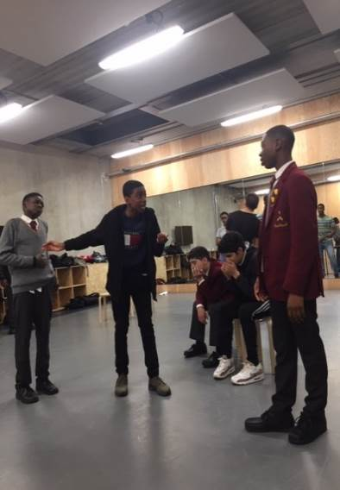We offer a wide range of extracurricular activities in drama, which enable students to develop skills in the areas of performing, devising and technical theatre. There are projects for all Key Stages as well as whole school.

Key Stage Three Drama club is open to all students in Years 7, 8 and 9 where students are able to develop playmaking and characterisation skills through improvisation games and tasks. This culminates in an outdoor Shakespeare performance at school in the summer term. Key Stage Four and Sixth Form students have opportunities to work with professional organisations and theatre companies throughout the year.   Mountview Academy of Theatre Arts, one of the UK’s leading Drama schools, work with a selected group of GCSE Drama students in the autumn term. The project culminates in a showcase of their work at Mountview in front of an audience of friends, family and industry professionals. Audible run workshops on audio drama at their studios which culminates in a recording of a play. Students can participle in two projects from The National Theatre. New Views is a playwriting competition for young people and Connections festival gives young performers an opportunity to perform in a new piece of writing at a local theatre.

Our annual musical theatre production is open to the whole school. Past productions include: We Will Rock You (2019), Bugsy Malone (2020) and Little Shop of Horrors (2022)

The school has close links with the Young Vic Theatre, Old Vic Theatre, National Theatre, Southwark Playhouse, Shakespeare’s Globe and Theatre Peckham resulting in free ticket offers for our students as well as workshop and exciting placement opportunities.