
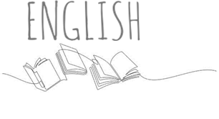

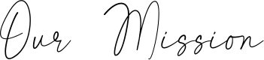
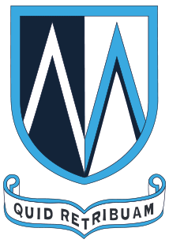


The English department at Mount St Mary’s is passionate about developing empowered, empathetic and aspirational students who see that there are no limits to what they can achieve in English. Our aim is that all students have equal access to an ambitious and rich English curriculum which enables them to develop extensive literary knowledge and become inquisitive, critical and appreciative readers, deep thinkers and confident writers and speakers.


The English department at Mount St Mary’s is part of a Language Faculty together with the Languages department who are united by a love of language and a shared belief in the power of language, literacy and literature. The English department has seven classrooms which are located in a unique and historic part of the school building with beautiful period features. The department currently consists of a Faculty Director, two Joint Curriculum Leaders and six English teachers.

We are a committed, unified and aspirational team working towards a common goal of achieving excellence for our students. We pride ourselves on having the highest expectations of ourselves and students whilst providing a supportive and caring learning environment which inspires our students to be resilient and reflective learners who take pride in their work and in their achievements. Our high aspirations and dedication to our students is evident in the exceptional outcomes students achieve year on year. Students at Mount St Mary’s achieve a full grade higher on average in English than similar students nationally with the percentage of students achieving a strong pass in English significantly above both city and national averages (grades 9-5: 21.5% above national). In 2025, 70% of students with English as an additional language achieved a strong pass in English and the department has consistently achieved one of the top progress 8 scores in the city since 2022, with disadvantaged students at Mount St Mary’s achieving the top progress 8 score in the city in 2024.

Our ambitious, carefully sequenced English curriculum ensures students develop an understanding of time, place and identity and are immersed in the worlds of writers and characters, past and present, from diverse cultures and classes, so that they have the historical, cultural and literary knowledge they need to be successful beyond Mount St Mary’s. Students are exposed to a wide range of culturally rich fiction and non-fiction texts which span the most important and influential eras and writers in literary history, from the very beginnings of story-telling and the oral tradition, to Shakespeare, Victorian fiction and contemporary poetry, prose and drama. Alongside a relentless focus on technical accuracy and the explicit teaching of increasingly complex sentence structures and punctuation as students move through each year, students are given frequent opportunities to develop and practise their writing skills in a wide range of engaging and creative contexts. The curriculum is also underpinned by an explicit focus on ensuring students build an extensive vocabulary over time and students are provided with frequent opportunities to learn and use high frequency tier two vocabulary, ambitious vocabulary and tier three subject terminology. Our KS4 curriculum has been sequenced with knowledge and skills needed for success in English Language interwoven with the teaching of the Literature texts. All students study the AQA GCSE English Language and English Literature courses with the content and skill of English Language interleaved with the teaching of our chosen Literature texts which include ‘An Inspector Calls’, ‘A Christmas Carol’, ‘Power and Conflict’ poetry and Shakespeare’s ‘Macbeth’.

