



Teacher of English
Information for Candidates


Welcome to Woldgate

Woldgate is a school with a distinct vision for education. Our view of an outstanding school is based on shared values, where every child is known and cared for as an individual. To cultivate this, we build a supportive and caring community, where a child’s talents can grow through academic study and the opportunity to participate in the many activities, productions and visits that make Woldgate School unique. We are a school with a positive, welcoming, warm atmosphere, in which pupils take pride in their achievements and where each individual pupil achieves academically through consistently good teaching, in an environment that seeks to nurture their love of learning and challenges them to excel.

Founded in 1958, Woldgate’s original school motto celebrated the distinct education the school sought to bring. This motto is, for me, an integral part of our school life; it defines who we are as a community.
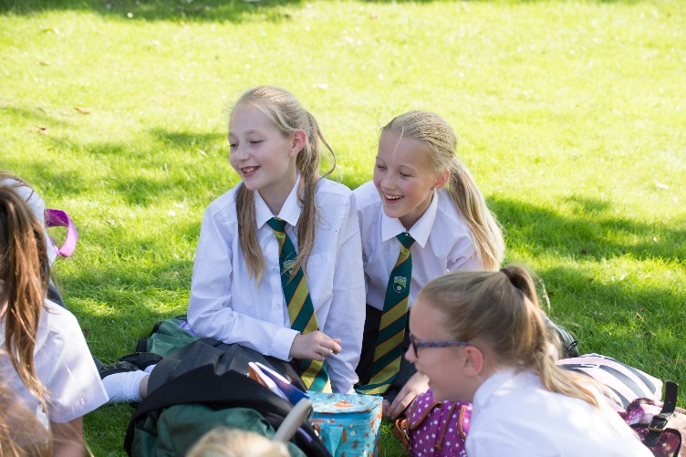
"Everything you do should be worthy, of great merit, character and value."
Of great merit:
The quality of being particularly good or worthy, especially deserving of praise or reward.
Of great character:
The moral qualities that define an individual.
Of great value:
The principles or standards of conduct we work to; our judgment of what is important in life.
We truly believe that part of what makes this community so special is the holistic education we provide for our pupils. Our Performing Arts status, extra-curricular clubs, sporting activities and House competitions, combined with our wonderful visits programme, provide pupils and students with a unique opportunity to appreciate the world around them. We have long believed that the creative arts provide an exceptional platform upon which pupils and students can develop new skills, grow in confidence and, as people, develop qualities, in an environment where their talents are nurtured and then celebrated. The arts offer us something special, whether it be learning an instrument, acting in a play, dancing, singing or just being involved in a production as part of a company. This holistic approach to school life is integral to a good education and wonderful preparation for future life.

As we look to the future, we are committed to ensuring Woldgate School continues to develop with a clear, confident and strong identity based on shared values and with every pupil and student known and cared for as an individual. Our culture of collaboration and success will be matched by our determination to do the very best, both pastorally and academically, for the children in our care.

- A School where each child is known and cared for as an individual.
- An environment in which our pupils feel valued, safe and enjoy school.
- A School where every child is challenged and supported to succeed academically.

Woldgate Sixth Form College also provides exciting opportunities for both pupils and students to continue their educational journey, to build upon their GCSE results and progress onto qualifications that provide academic rigour and challenge. There is also a wide variety of enrichment opportunities, with students participating in the wonderful range of expeditions, visits, internships and leadership programmes.

Lauren Adams
Headteacher

Job Information
JOB DESCRIPTION

Post Title: | Teacher of English
Base: | Woldgate School and Sixth Form College
Salary: | Main Scale M1-6
Line Management: | Director of Studies for English
Contract: | Full Time – 1 year Fixed Term – Required for September 2026

Core Purpose:
To plan and deliver challenging and well organised lessons, and sequences of lessons, in a safe and stimulating learning environment, across the age and ability range. To assess and report on learners’ progress.

Duties & Responsibilities:
Principal Accountabilities:
- To plan, teach and evaluate the effectiveness of lessons, and sequences of lessons, which show good knowledge and understanding of a range of up-to-date teaching, learning and behaviour management strategies, and which are in line with Departmental SOWs.

- To communicate effectively with colleagues, parents and students regarding student learning and other matters within ECM responsibilities.

- To know the assessment requirements and arrangements for their pupils and use data with a range of approaches to assessment, to inform teaching and learning.

- To maintain up-to-date knowledge of their subject area and of the Professional Standards and duties of teachers.

- To work as part of Learning Teams, both Departmental and Year Group-based, to enhance curriculum provision, support the aims and ethos of the College as an inclusive learning community and understand how wellbeing impacts on learning.

- To retain up-to-date knowledge and understanding of Safeguarding procedures and practices and to know and understand the roles of other colleagues in these.

Other duties and responsibilities
- Any other duties commensurate with the general level of responsibility of the post that the Headteacher may from time to time ask the post-holder to perform.
General Information:
- The above principal accountabilities are not exhaustive and may vary without changing the character of the job or level of responsibility.
- The Health and Safety at Work etc. Act, 1974 and other associated legislation places responsibilities for Health and Safety on all employees. Therefore, it is the post holder’s responsibility to take reasonable care for Health and Safety of him/herself and other employees in accordance with legislation.

PERSON SPECIFICATION

Criteria | Essential | Desirable | Evidence
Qualifications and Experience
Relevant qualification: degree and postgraduate programme | X |  | A/C
Recent experience of English teaching | X |  | A/I
Experience of A Level Teaching |  | X | A/I
Professional knowledge and understanding, skills and attributes
English curriculum and strategies, assessment, use of data to inform practice, Safeguarding Procedures | X |  | A/I
Classroom management skills | X |  | A/I
Ability to communicate at all levels | X |  | A/I
Attention to detail | X |  | A/I
Self-Evaluation and Reflection | X |  | A/I
Ability to negotiate | X |  | A/I
Personal skills/attributes
Suitable to work with children | X |  | A/I/R
Knows professional boundaries, establishes professional relationships with children | X |  | A/I/R
Self-motivated but able to work in a team | X |  | A/I/R
Able to act on advice | X |  | A/I
Resilient and able to work under pressure | X |  | A/I/R
Enthusiastic about teaching and subject | X |  | A/I/R
Adopts a positive approach to change | X |  | A/I/R
Seeks solutions and thinks creatively | X |  | A/I/R
Able to contribute positively to the school, its aims and ethos | X |  | A/I/R

A= Application; C = Certificate; R = Reference; I = Interview

As this is a new role it will be regularly reviewed and amended as required, in consultation with the postholder.

Note - This person specification is not necessarily a comprehensive definition of the post. It will be reviewed and may be subject to modification and amendment after consultation with the post-holder.

The Wonder Learning Partnership operates a safe recruitment process and appointment to the post will be subject to suitable references and an enhanced Disbarring and Barring Service check. The school is committed to safeguarding and promoting the welfare of children and expects all staff and volunteers to share this commitment.

How to apply
If you would like to apply for this vacancy, please download a Teaching staff application form from the school website.
Applications should be returned to Ceri King (People & Culture Lead) via cking@woldgate.net

CLOSING DATE: 8th July 2026 (9am)
INTERVIEWS: 14th July 2026

Child Protection Policy
Woldgate School fully recognises its responsibilities for child protection. Our policy applies to all staff, governors and volunteers working in the school. There are five main elements to our policy:

- Ensuring we practice safe recruitment in checking the suitability of staff and volunteers to work with children.
- Raising awareness of child protection issues and equipping children with the skills needed to keep them safe.
- Developing and then implementing procedures for identifying and reporting cases, or suspected cases, of abuse.
- Supporting pupils who have been abused in accordance with his/her agreed child protection plan.
- Establishing a safe environment in which children can learn and develop.

We recognise that because of the day-to-day contact with children, school staff are well placed to observe the outward signs of abuse. The school will therefore:

- Establish and maintain an environment where children feel secure, are encouraged to talk and are listened to.
- Ensure children know that there are adults in the school whom they can approach if they are worried.
- Include opportunities in the PSHE curriculum for children to develop the skills they need to recognise and stay safe from abuse.

We will follow the procedures set out by the Area Child Protection Committee and take account of guidance issued by the Department for Education and Skills to:

- Ensure we have a designated senior person for child protection who has received appropriate training and support for this role.
- Ensure we have a nominated governor responsible for child protection.
- Ensure every member of staff (including temporary and supply staff and volunteers) and governing body knows the name of the designated senior person responsible for child protection and their role.
- Ensure all staff and volunteers understand their responsibilities in being alert to the signs of abuse and responsibility for referring any concerns to the designated senior person responsible for child protection.
- Ensure that parents have an understanding of the responsibility placed on the school and staff for child protection by setting out its obligations in the school prospectus.
- Notify social services if there is an unexplained absence of more than two days of a pupil who is on the child protection register.
- Develop effective links with relevant agencies and co-operate as required with their enquiries regarding child protection matters including attendance at case conferences.
- Keep written records of concerns about children, even where there is no need to refer the matter immediately.
- Ensure all records are kept securely, separate from the main pupil file, and in locked locations.
- Develop and then follow procedures where an allegation is made against a member of staff or volunteer.
- Ensure safe recruitment practices are always followed.

We recognise that children who are abused or witness violence may find it difficult to develop a sense of self-worth. They may feel helplessness, humiliation and some sense of blame. The school may be the only stable, secure and predictable element in the lives of children at risk. When at school their behaviour may be challenging and defiant or they may be withdrawn. We will endeavour to support the pupil through:

- The content of the curriculum.
- The school ethos, which promotes a positive, supportive and secure environment and gives pupils a sense of being valued.
- The school behaviour policy, which is aimed at supporting vulnerable pupils in the school. The school will ensure that the pupil knows that some behaviour is unacceptable, but they are valued and not to be blamed for any abuse which has occurred.
- Liaison with other agencies that support the pupil such as Social Services, Child and Adult Mental Health Service, Education Welfare Service and Educational Psychology Service.
- Ensuring that, when a pupil on the child protection register leaves, their information is transferred to the new school immediately and that the child’s social worker is informed.

How to Find Us
Woldgate School and Sixth Form College, 92 Kilnwick Road, Pocklington, York. YO42 2LZ Tel: 01759 302395

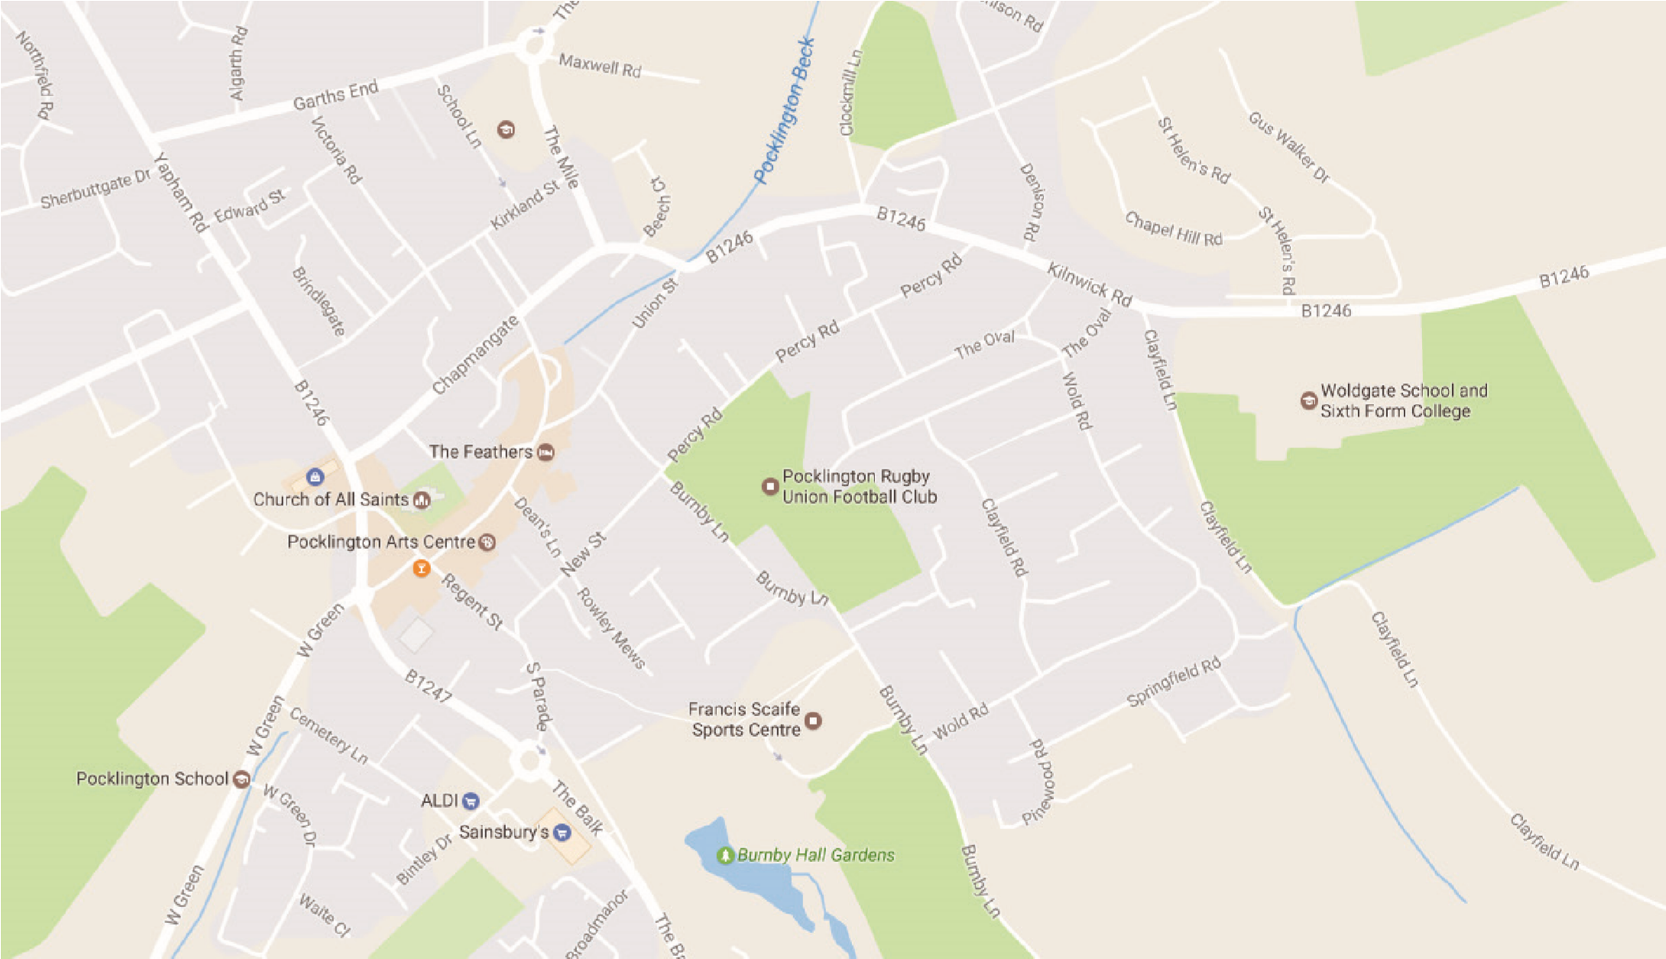

A. From Hull - Take the A1079 including the by-passes of Beverley and Market Weighton
- Take the right-hand fork from Pocklington at the Yorkway Hotel
- Take the 3rd exit from the roundabout; past the Rugby field on your right
- Turn right at the B1246 signposted Warter, Driffield, Bridlington
- Woldgate School is the last building on the right as you leave the town.

B. From Humber Bridge - Take the Westward route towards Leeds along the A63
- Leave the A63 at the slip road and bridge over signposted for Market Weighton, Bridlington
- Pass through villages of South Cave and Sancton
- Turn west at Market Weighton bypass, A1079 towards York
- Follow instructions A3, A4, A5

C. From Leeds - Take A64, York by-pass towards Scarborough
- Leave A64 at Grimston Bar roundabout signposted York, Bridlington, Hull
- Exit from roundabout onto A1079 towards Hull
- Twelve miles approximately along A1079 after Pocklington Industrial Estate, turn left for Pocklington, just after Bonds International.
- Pass Pocklington School on left, at roundabout take 3rd exit past bus station, fire station
- Take the first exit from the roundabout
- Follow instructions A4, A5

D. From North-East England - Take A19 southwards until Northern by-pass of York
- Follow signs for Hull, Bridlington
- At A64 turn West for Leeds
- Follow instructions C2, C3, C4, C5, C6

E. From Scarborough, Bridlington - Follow sign from Driffield
- Bypass Driffield along North and West side
- Leave bypass where signposted for M62, Market Weighton
- At Bainton roundabout take second exit along B1246 towards North Dalton, Warter, Pocklington.
- Woldgate is the first building on the left as you reach Pocklington.

