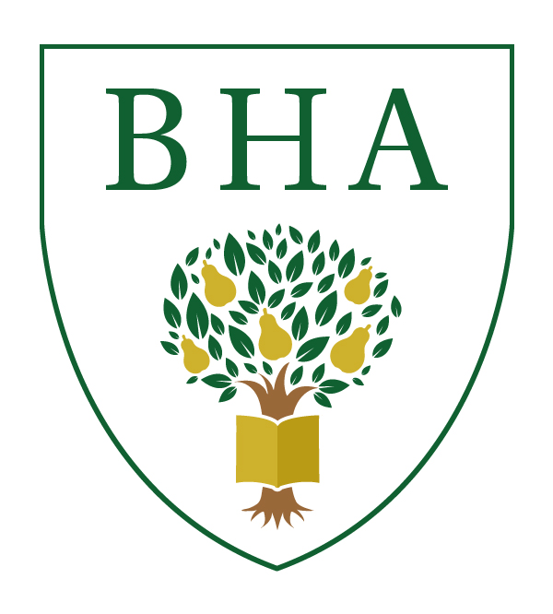

BREDON HILL ACADEMY
Learning Together for Success

Person Specification - English

Criteria | Essential | Desirable
- Qualifications
- Qualified Teacher Status | 
- Relevant degree in subject. | 
- Experience
- Teaching English across the ability and age range (KS2 and KS3). | 
- Teaching a second subject. |  | 
- Knowledge
- Have strong subject knowledge. | 
- Keep knowledge and skills up-to-date. | 
- Teaching and Learning
- An understanding of what makes good teaching and learning for all students. | 
- Apply a range of teaching and learning strategies effectively. | 
- Communication
- Ability to work well with all stakeholders. | 
- Ability to lead and manage a team. |  | 
- Personal Attibutes
- Positive approach to promote learning and excellent behaviour. | 
- Effective organisational skills. | 
- Act with honesty and integrity. | 
- General
- Make a positive contribution to the wider life and ethos of the school. | 
- Commitment to running extra-curricular activities. | 
- Professional Conduct
- Personal and professional conduct as outlined in DfE Teachers’ Standards. | 

Bredon Hill Academy is committed to safeguarding and promoting the welfare of young people and requires all staff and volunteers to share this commitment.

