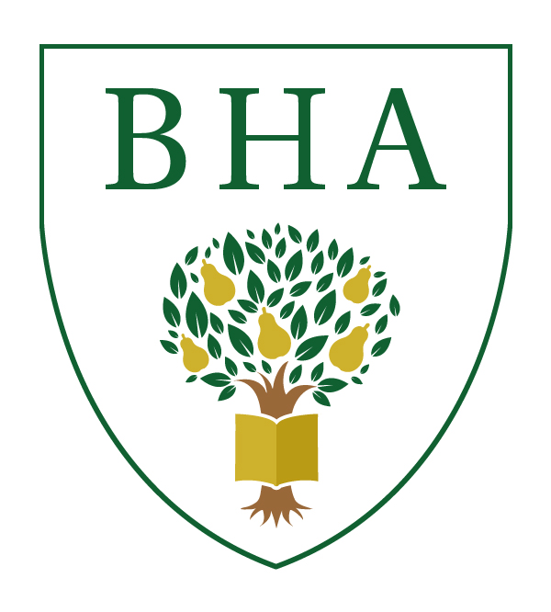

BREDON HILL ACADEMY
Learning together for success

PERSON SPECIFICATION

Post Title: Main Scale Teacher/TLR Post Holders
Pay Scale: MPS → UPR

Criteria | Essential | Desirable
- General
- Qualified Teacher Status | 
- Relevant degree in subject. | 
- Proven record of consistently effective teaching at Ofsted level ‘good’ or above. | 
- Set high expectations which inspire, motivate and challenge students
- Be able to establish a safe and stimulating environment for students, rooted in mutual respect. | 
- Be able to give appropriate challenge in their learning to students of all backgrounds, abilities and dispositions. | 
- Be able to demonstrate consistently the positive attitudes, values and behaviour which are expected of students. | 
- Promote good progress and outcomes by students
- Be aware of students’ capabilities and their prior knowledge, and plan teaching to build on these. | 
- Be able to guide students to reflect on the progress they have made and their emerging needs. | 
- Demonstrate knowledge and understanding of how students learn and how this impacts on teaching. | 
- Demonstrate good subject and curriculum knowledge
- Have a secure knowledge of the relevant subject(s) and curriculum areas, foster and maintain students’ interest in the subject and address misunderstandings. | 
- Demonstrate an understanding of, and take responsibility for promoting, high standards of literacy, articulacy and the correct use of standard English, whatever the teacher’s specialist subject. | 
- Plan and teach well-structured lessons
- Know when and how to differentiate appropriately, using approaches which enable students to be taught effectively. | 
- Have a secure understanding of how a range of factors can inhibit students’ ability to learn, and how best to overcome these. | 
- Make accurate and productive use of assessment
- Know and understand how to assess the relevant subject and curriculum areas, including statutory assessment requirements. | 
- Make use of formative and summative assessment to secure students’ progress. | 
- Use relevant data to monitor progress, set targets and plan subsequent lessons. | 
- Give students regular feedback, both orally and through accurate marking, and encourage students to respond to the feedback. | 

- Manage behavior effectively to ensure a good and safe learning environment
- Have high expectations of behaviour, and establish a framework for discipline with a range of strategies, using praise, sanctions and rewards consistently and fairly. | 
- Manage classes effectively, using approaches which are appropriate to students’ needs in order to involve and motivate them. | 
- Fulfil wider professional responsibilities
- Make a positive contribution to the wider life and ethos of the school | 
- Develop effective professional relationships with colleagues, knowing how and when to draw on advice and specialist support. | 
- Deploy support staff effectively. | 
- Take responsibility for improving teaching through appropriate professional development, responding to advice and feedback from colleagues. | 
- Communicate effectively with parents with regard to students’ achievements and well-being. | 
- Personal and professional conduct
- Maintain high standards of ethics and behaviour, within and outside school | 
- Maintain high standards in their own attendance and punctuality. | 
- Leadership roles (TLR posts only)
- To be a confident leader of others, able and willing to hold team members to account for their responsibilities. | 
- To be able to create, maintain and develop a positive team culture. | 
- To be able to use data and other sources of information to monitor and evaluate team and individual performance. | 
- To have a proven record of CPD to prepare for, or maintain, leadership responsibilities. |  | 

Bredon Hill Academy is committed to safeguarding and promoting the welfare of young people and requires all staff and volunteers to share this commitment.

