English Department Information

Department Results
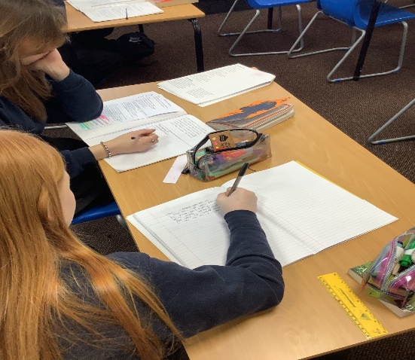
The English Department at Carnforth High School performs consistently well with a history of good results. The department have made recent changes to improve GCSE grades at 5+ and ensure the best possible outcomes for all students.

Current Curriculum
The English curriculum follows a 5-year plan. Students study a range of fiction and non-fiction texts and explore ways to develop writing in a wide range of formats. The units build on prior learning and have been designed to continuously improve knowledge and skills, challenging learners at all levels.
Students currently sit the Eduqas GCSE qualifications in Language and Literature at the end of year 11. A range of interventions take place to ensure that students are fully prepared for their exams. By ensuring that students are successful in English, we give them a wide range of skills that they can use in the future as well as providing them with greater life chances.

Resources

The English Department has 6 classrooms all situated in one area of the school. All rooms are fitted with a dual screen computer, projector, speakers and interactive whiteboard as well as one or two ordinary whiteboards.
We try to ensure that each teacher has their own classroom for their lessons and that they are able to individualise their classroom space to suit their own teaching styles. In addition, class sets of iPads can be booked to use in lessons when needed.
There is also an office with 2 computers for members of the English Department to use, as well as a storeroom with various resources for the teaching of English.

Department Development
Over the last few years, the department has worked collaboratively to update the curriculum to ensure that there are opportunities to engage in a huge variety of topics, from studying the literary cannon to using linguistic theory to create children’s books. Staff are encouraged and supported to develop their own teaching and learning through research and partnerships with external institutions. We are all passionate teachers and lifelong learners, keen to continue to develop and evolve to ensure the best outcomes for the students we teach.

