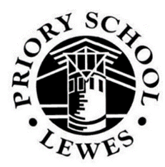
Knowing ∙ Belonging ∙ Becoming

LEWES

Lewes is a small county town of architectural, cultural and historical interest; it is set in an exceptional environment surrounded by downland and farmland and is only a short journey from Brighton and the coast, as well as just over an hour by train from London. Consequently, many people find it attractive to live in the school's catchment area and house prices are high compared to other parts of the country; however, in areas away from Lewes / Brighton they can be lower.

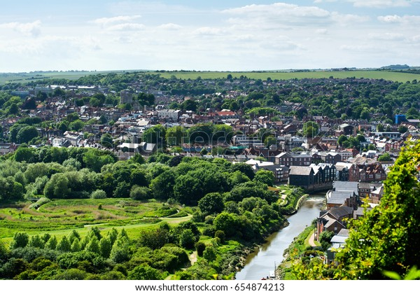

The town is the administrative centre for the county with County Hall for East Sussex, and the County Police Headquarters for the whole of Sussex. Within a few miles there are the campuses of Sussex and Brighton Universities. These all provide opportunities of various kinds as far as pupils and staff in the school are concerned, and many people working for these organisations live in the school's catchment area.

SCHOOL VISION

Priory School, Lewes is an 11-16 mixed comprehensive school. We are proud of the highly successful rounded education we provide. At Priory, we have a long-standing history of academic excellence within a culture of strong pastoral care.

Priory is a school where students are expected to work hard and as a result make excellent progress. We believe in balancing the pursuit of academic excellence with the wellbeing of our community. Our broad and balanced curriculum reflects the community we serve. Priory School is well regarded and is consistently oversubscribed.

Our aim is for Priory to be the leading inclusive and creative state secondary school in the region, a school in which all students acquire powerful knowledge, feel a strong sense of social connection and belonging, and become ethically-aware citizens who are ready to confidently take their place in the world. Our school also aims to reflect the uniqueness of Lewes, historically and socially.

Based on the principles of educational philosopher Professor Gert Biesta, education at Priory School is centred around three domains: ‘knowing, ‘belonging and ‘becoming.’ Biesta (2009) writes about the purposes of education being:
- Qualification (Knowing) – preparing students for the future, whether that be work, citizenship or further study.
- Socialisation (Belonging) – through education, students become part of society or culture by learning knowledge, values and norms that make up that society.
- Subjectification (Becoming) – students develop their sense of individuality through learning knowledge, so that they can make sense of themselves, others, and their place in the world.

THE SCHOOL

Priory is a larger than average mixed community comprehensive school serving the county town of Lewes but also drawing from surrounding villages and towns, as well as the eastern fringe of Brighton and Hove. The school's academic record over many years has gained it a high reputation, so that many parents from outside the catchment area are encouraged to ask for entry for their children. Priory is the only state secondary school in the town and is thus fully comprehensive for this area. Many disadvantaged families also send children to the school from within and outside the catchment area. Although Lewes is a largely affluent area, relative deprivation is increasing with around a fifth of the school now designated Pupil Premium. The range of concern and educational expertise which needs to be exercised by the staff is as wide as in any school, but the overall ability profile on entry is above average: the majority of our students come to us with average prior attainment (c.50%), with a larger proportion of students with high (c.30%) than low (c.20%) prior attainment. We have slightly more boys (54%) and fewer girls (46%) than average, although this is not unusual for a school of this type.

Priory was first designated a Performing Arts Specialist School in 2002 and this status was re-assessed and renewed. In 2006 the award of Language Specialist School and subsequently Specialist School Status in Science and Mathematics in 2007 increased the specialist focus. Funding and recognition of specialisms was ceased in 2011 but the specialisms still influence the school ethos.

In 2017 the school was designated as a Teaching School, and although this designation no longer applies, we have a number of staff who have been designated as Specialist Leaders of Education (SLE), and we continue to provide a clear development programme for our ECTs and trainee teachers which supports the development of their knowledge and skills, provides high quality mentoring and ensures access to high quality training under the ECF, through Ambition Institute.

Priory School provides a renaissance style of education in which arts and sciences go hand in hand, and creativity, performing and public speaking flourish. Our broad and balanced curriculum is powerful because it embraces the distinctive value of individual subject disciplines, enrichment and enhancement which challenges students beyond their previous experiences, and deep and rich knowledge, which empowers all students as future citizens.

‘Priory School continues to be a good school’

Ofsted last inspected Priory School on 7 and 8 November 2023. Following the inspection, the inspection team concluded that the school continues to be a good school.

Extracts from the inspection report:

- Pupils enjoy a broad, interesting, and engaging curriculum, which is demonstrative of the school’s aim to be ‘inclusive and creative’. The school is ambitious, and staff strive to deliver high quality education for all. Most pupils achieve well, and the majority go on to successful further education, employment or training. Pupils in the specially resourced provisions for those with complex special educational needs and/or disabilities (SEND) receive excellent support from well-trained staff.
- Pupils feel safe. They are confident they can share concerns with an adult, and about how any worries are dealt with by staff. They understand and respect each other’s differences and are accepting of different beliefs. Most pupils behave well and follow clear school rules. Learning is rarely disrupted.
- Pupils have many opportunities to develop their talents and interests. They take part in a wide range of extra-curricular clubs. Many pupils also take part in the Duke of Edinburgh’s Award scheme. Pupils can contribute to the life of the school by taking on responsibilities like being anti-bullying ambassadors or sitting on the student council.

The inspection report also recognises the school’s ‘insightful’ leadership, the strategic work of the governing board and the support for the school from parents, who ‘commend the approachable, knowledgeable and encouraging staff, and appreciate the many opportunities that their children receive.’

ACCOMMODATION

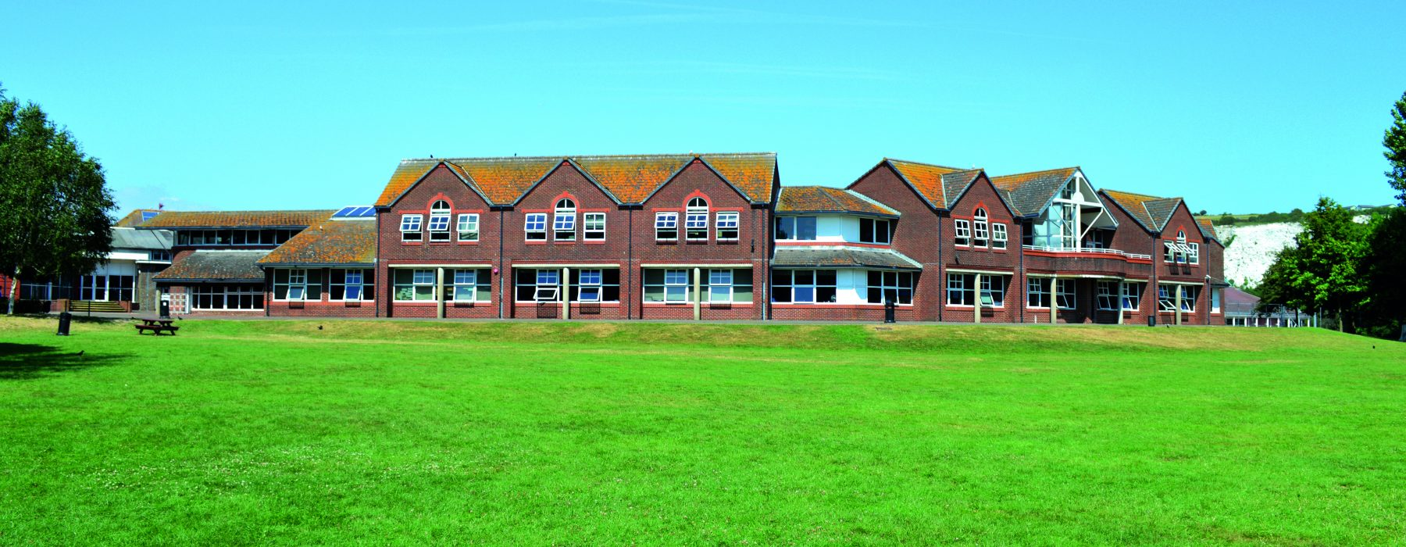

Although parts of the school building date back to the 1930s, the accommodation also consists of new and refurbished buildings as a result of remodelling the school in 1993, and various additions to the site since. All subjects have their own suite of teaching rooms that surround subject resource rooms. The buildings have been specifically built to accommodate students with physical handicaps. The school retains its own free-standing purpose-built chapel that is used for assemblies and the many musical presentations of which the school is rightly proud. Arts College Status delivered a Performing Arts Centre which opened in 2006 and a new purpose-built music block which was opened in January 2008. The school has two specialist resourced provisions for pupils with education, health and care plans. The Oak Centre, which supports pupils with a primary diagnosis of autism, was purpose built in 2020. The Deaf Support Facility is a centrally funded provision, managed by the Sensory Needs Service for East Sussex County Council.

The school is adjacent to the Lewes Leisure Centre which is used by the school on a joint use basis. Extensive sports fields and an all-weather athletics track surround it, which provides adequately for our needs.

SCHOOL ORGANISATION

Students are placed in mixed prior attainment tutor groups of their own age group with a form tutor who has the key role in providing guidance, care and ensuring their welfare whilst at school.

The school is organised around a year group pastoral structure, with a teaching Head of Year and non-teaching Assistant Head of Year responsible for the academic oversight, pastoral care and personal
development and welfare of each cohort of students.

The school has 8 Curriculum Areas which are led by a Curriculum Leader (CL). In larger subjects (English, Maths and Science) there is a CL plus a Deputy CL and an Assistant CL. Where a Curriculum Area comprises distinct subjects (e.g. Humanities) there is a Subject Leader in addition to the CL.

The Curriculum

“The curriculum is well planned. Subject leaders have chosen content carefully to match the aims of the national curriculum and have sequenced it logically. This ensures that pupils gain important knowledge and build this over time.” Ofsted, 2023

Our curriculum is ambitious and designed to give students the powerful knowledge they need to succeed in life. Subject teams have worked together to identify the essential disciplinary and substantive knowledge that our students should know. Curricula are sequenced to build on prior learning and curriculum development maps set out each cohort’s learning journey in each subject. Programmes of study, lessons and homework tasks are carefully planned to ensure that students are inspired and motivated to become inquisitive, disciplined and persistent learners. There are also lots of planned opportunities for students to extend learning beyond the classroom via homework, trips and competitions.

All students enjoy a curriculum that is broad and balanced. In KS3, students follow 16 subjects for three years which, in addition to the core subjects of English, maths and science, includes four arts subjects (art, dance, drama and music), four languages in Year 7 (French, German, Latin and Spanish) before specialising in Years 8 and 9, three humanities subjects (history, geography and religious studies) as well as three subject disciplines within technology (computing, design and food technology), PE and PSHE.

At KS4, in addition to the core subject most (c.75%) students, including those who are disadvantaged or those with SEND, study the EBacc combination of subjects, taking a language (inc. Latin), history or geography and two further options. We encourage as many of our young people as possible to study an arts subject at KS4.
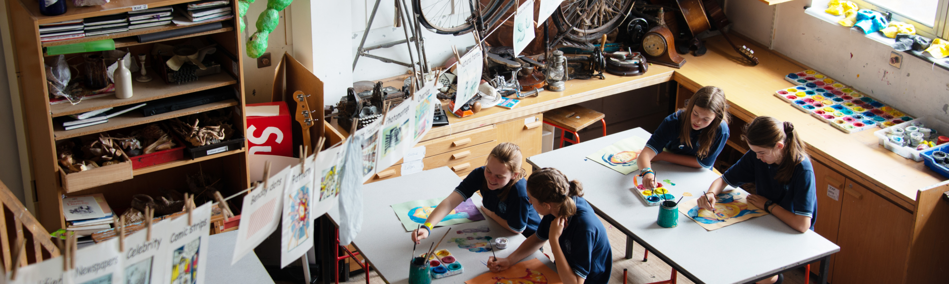

Students have the opportunity to follow an academic or more vocational route at KS4: we work in partnership with our partners such as Plumpton College to offer vocational qualifications.

Priory has developed an adaptive curriculum that enables students who might experience barriers to accessing a mainstream curriculum to participate in courses that are designed to support a deeper, immersive leaning experience. The Forest School (yr8) and Media School (yr9) programmes provide a practical experience, led by specialists, in which some of our more vulnerable students (for example, students requiring support with social engagement including some of our SEND and PP students and students who have been persistently or severely absent) integrate literacy, numeracy, PHSE and a range of mainstream subjects with learning experiences that happen both within and outside of the classroom.

In order to meet our ambition of delivering a curriculum for the head, heart and hands, this year sees the introduction of outside learning experiences to all students in year 7, through which students will experience two days of Forest School during the school year with our two forest school leaders and their form tutors in order to strengthen a sense of belonging with their form group and to provide a learning experience that develops skills including problem solving and team building.

Pastoral care

“The school prioritises pastoral care and support for pupils.” Ofsted 2023

Priory is a happy, safe, calm and orderly school, with students demonstrating positive behaviour and attitudes for learning in lessons and across the school. Our students have a positive and respectful attitude towards school, cooperating well with each other in a community where everyone is included, and our aim is to ensure that all students feel a strong sense of social connection and belonging to a school community that is kind, respectful and honest. Relationships between staff and students are warm and empathetic, and the school provides a safe and welcoming environment for all children, where mutual respect and dignity are deep-rooted.

The school has a Year Group pastoral structure, in which a Head of Year is supported by a non-teaching Assistant Head of Year to meet the pastoral needs of students. The organisation of the school day offers students time with their form tutor twice each day, for pastoral support as well as to engage in an organised programme of activities designed to encourage students’ personal development. Students also read regularly with their form tutor and engage in meta-cognitive ‘study capture’ to consolidate their learning.

A House system also exists at Priory to further a sense of social connection. Each House is made up from students from every year group in the school, providing competition, events and activities which help build a happy community by giving students of different ages the opportunity to work closely together and engage in friendly competition.

Extra-Curricular Activities

“Pupils have many opportunities to develop their talents and interests. They take part in a wide range of extra-curricular clubs. Many pupils also take part in the Duke of Edinburgh’s Award scheme. Pupils can contribute to the life of the school by taking on responsibilities like being anti-bullying ambassadors or sitting on the student council.” Ofsted 2023

The aim of the Priory School curriculum is to form and transform individuals who are aspirational, imaginative and optimistic, so that they can confidently take their place in the world. We do this by enhancing student personal development including enrichment which challenges students beyond their previous experiences.

An extensive enrichment programme gives students the chance to build upon what they have learned in class, and to further develop skills such as teamwork and leadership that prove invaluable both at school and later in life. Students are provided with opportunities to use and develop a range of social skills via the broad curriculum, extracurricular, alternative provision, and enrichment activities such as trips. In addition to trips and activities throughout the school year, our annual Activities Week offers students a diverse range of opportunities to help them discover and forge their own personal identities. The Duke of Edinburgh Bronze Award is offered to students in Year 9. The monitoring and tracking of the students involved in these activities is now robust and allows for careful identification of the uptake of these enriching activities by students, especially our most vulnerable.

Achievement and Standards

“Teachers deliver the curriculum effectively, using their strong subject knowledge…Most pupils achieve well across the broad curriculum, with many learning the full English Baccalaureate suite of subjects.” Ofsted 2023

In national tests, Priory students consistently achieve outcomes in excess of both local authority and national averages. Student motivation and attitudes to learning are strong and outcomes demonstrate that from their respective starting points, most students make good progress and achieve well. Overall attainment is well above local and national averages, with attainment in English, Humanities and Languages particularly strong. Outcomes are also strong in the EBacc subject areas, and attainment in the EBacc is well above national and local averages. English is another strength, with attainment and progress significantly above average.

In 2023,

- GCSE English Language, Science: Double Award, Art & Design, Photography, Drama, Media Studies and Food Technology were all in the top 20% for average point score
- For P8, English and EBacc are both significantly above national, with English in the 81st percentile and EBacc in the 71st percentile
- For Value Added (VA), Science, Languages and Humanities are all significantly above national, in the 74th, 69th and 89th percentiles respectively
- For A8, English, Mathematics, EBacc, Open and Overall are all significantly above national, with English in the 82nd percentile, Maths in the 70th, EBacc in the 78th, Open in the 68th and Overall in the 76th percentile.

Governance

Priory is a Foundation School, and a member of The Lewes Co-operative Learning Partnership, established in 2014 as a charitable trust with a founding intention to improve the learning outcomes for all Lewes pupils, enhance the effectiveness of all our teaching professionals and deliver a broader range of opportunities for parents and other stakeholders to contribute to the success of our local education services. Our governing body is experienced and stable, with wide expertise, including educational experience; those responsible for governance understand their role and carry this out effectively. Priory School governors ensure that the school has a clear vision and strategy, that resources are managed well and that leaders are held to account for the quality of education. The Framework for Ethical Leadership in Education is used to support and guide ethical governance, decision-making and behaviour.

Equality information and objectives

Schools and colleges serve children and young people and help them grow into fulfilled and valued citizens. As role models for the young, how we behave as leaders is as important as what we do. Priory School is guided by the Framework for Ethical Leadership in Education, and expects all leaders, including both those who are paid to lead the school and those who volunteer to govern it, to behave with:
- Selflessness
- Integrity
- Objectivity
- Accountability
- Openness
- Honesty
- Leadership

Leaders should also show leadership through the following personal characteristics or virtues:
- Trust
- Wisdom
- Kindness
- Justice
- Service
- Courage
- Optimism

As part of this broader vision, Priory School is committed to a proactive approach to equality, diversity, and inclusion, developing an accessible, anti-racist, gender-equal, LGBTQ+ inclusive community.

Priory School is made up of a broad range of individuals and groups with a wide variety of backgrounds, experiences, lifestyles, languages, and cultures. We are proud of this diversity which enriches all the lives of those in the school and informs our inclusive approach: we promote the benefits of such pluralism and challenge any and all prejudicial and discriminatory practices.

It is the duty of all members of the school community to uphold this policy and see that it is put into practice. Our school aims to meet its obligations under the Public Sector Equality Duty (PSED) by having due regard to the need to:

- Eliminate discrimination and other conduct that is prohibited by the Equality Act 2010
- Advance equality of opportunity between people who share a protected characteristic and people who do not share it
- Foster good relations across all characteristics – between people who share a protected characteristic and people who do not share it

Closing Date for All Posts

Will be included in the advertisement.

The school is committed to safeguarding and promoting the welfare of young people and expects all staff and volunteers to share this commitment.

