

**Teacher of English**

**0.8 FTE**

**Fixed term for 1 year in the first instance.**

**Candidate Information**

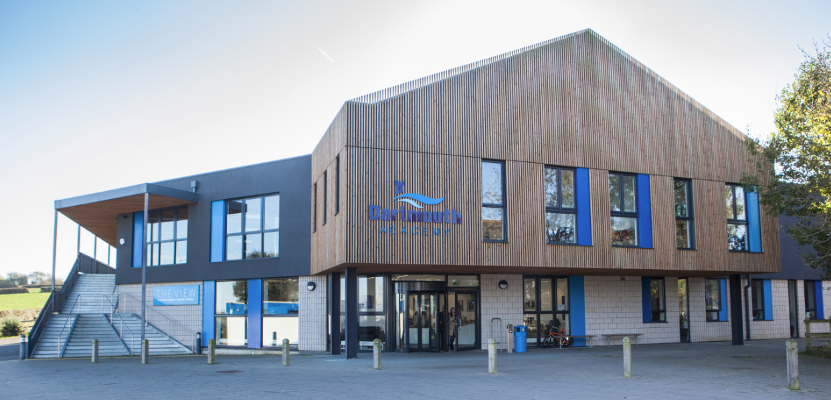







**Letter from the Principal**

**Teacher of English – MPS**

**0.8FTE. 1-year fixed term in the first instance, immediate start or January 2024, dependent upon candidate availability.**

Thank you for your interest in Dartmouth Academy and the position that we have available. I am delighted that you are considering joining our school: our aim is to seek the very best practitioners in the profession to join our team and I hope to read your application soon. The information within this pack is designed to provide you with all of the information which, alongside our website, will give you the information you need to apply for the post.

We have a post available for a teacher of English within our thriving English department. This is an excellent opportunity for an enthusiastic and capable individual who wants to work with a team of people who are passionate about their subject and share a commitment to ensuring pupils have the best experience possible in the study of English. This is a role suitable for a newly qualified or more experienced teacher and scope to develop leadership if this is a path you are interested in.

*Pupils feel happy at Dartmouth Academy. They embrace the school’s mantra to ‘be your best self’. As a small, all-through school, pupils and staff value the strong relationships they have. Pupils join the school at different stages. Leaders support pupils at those different transition points. Pupils say they feel welcomed at the school.*

*Ofsted, April 2023*

Woven throughout both our aspirational curriculum and ethos of empathy and understanding is the drive for every child to be a **scholar** in their learning. Staff create and teach academically-rich schema whilst understanding, and planning to overcome, the barriers a child may face. The concept of **scholarship** drives the role which staff play in being instrumental to every child’s development, not simply in their academic achievements but also as a person. From the moment pupils arrive into our Early Years Foundation Stage, we share with them the school mantra that fosters academic success as not a measure of ability but an indication of how hard pupils work: **Be Your Best Self**.

This is also an opportunity to join the school at an exciting point in our journey. In January 2017, we merged our Multi Academy Trust to form Education South West, with 10 schools spanning primary, all-through and secondary: nearly 5,000 students and 600 staff in total.  The aim of the Trust is simple: **to work together so that children can lead great lives.**

If you have a genuine desire to do the best for young people, then we would welcome your application. The school is committed to safeguarding pupils and personnel, and will conduct checks based on the information in your application. If you are selected for interview, safeguarding will feature in the interview programme.

If you wish to visit the school or have any questions about this role, please feel free to contact the school and my PA, Vicki Hart, on [**admin@dartmouthacademy.org.uk**](mailto:admin@dartmouthacademy.org.uk). Applications must be made by completion of an application form, and candidates invited to interview must supply a signed copy of their application form before their interview takes place. We would also request that interviewees bring to the interview original copies of relevant exam certificates, and where available original copies of their DfE registration and DBS disclosure.

The closing date for applications is **9.00am on Thursday 28th September** with interviews likely to take place **week commencing 2nd October**.

**Paul Girardot  
Principal**

**ENGLISH**



This is an exciting time to be joining the Academy. The collaborative relationship for subjects, including English, with colleagues across the Trust provides opportunity for professional development and engagement in subject pedagogy which current staff identify as a huge strength.

English is a particular strength of the Academy and of the Trust. The English department is a thriving faculty which teaches an ambitious, rich and inspiring curriculum. This is supported by a collaborative, aligned curriculum shared by the Trust leading to excellence for all children and significant professional development opportunities for staff.

Building upon the curriculum taught at Primary, children join secondary from Year 7 and follow a five-year curriculum which is carefully and thoughtfully sequenced to ensure progression towards GCSEs and beyond. Aspirations are high for all pupils, and teachers at Dartmouth are enthusiastic and passionate about their subjects.

The pupils’ journey through the English curriculum is enriched by an emphasis on writing confidently, reading fluently and speaking powerfully.

Literacy is a shared responsibility for staff in all subject areas and consistencies in CPD in whole-class reading, phonics and vocabulary acquisition support children’s progress across the curriculum.

**THE POST AND APPLICATION**

  
We have a post available from September 2023 (or January 2024, dependent upon candidate availability) to teach Secondary English as part of this department. We are always looking to support aspirational leaders and would welcome applications from candidates who are interested in leadership.

Whether you are relatively new in the profession or have more experience, we don’t mind – what we are looking for is someone who is enthusiastic and passionate about their subject area and have the drive and desire for pupils to have an excellent experience of English.

During our Ofsted inspection in April 2023 we were designated to be a ‘Good’ school and the Academy has a superb platform to move from now, with our value added and Progress 8 data rising. If you are the kind of person who wholeheartedly believes in offering the very best for children in their school life, who wants opportunities to develop your own practice and who strives for excellence, then this is the place for you.

We would encourage interested candidates to get in touch to

discuss further.

Please specify, in your application, your availability and any

Further interests you may have.

**THE ACADEMY**

Dartmouth Academy is an all-through school and a member of Education South West which comprises 5 secondary schools and 7 primary schools within Devon. The schools with the ESW family share a common desire to give our children the education, opportunities and confidence that will enable them to lead great lives.

The Academy is in the beautiful town of Dartmouth which is situated on the mouth of the River Dart within the South Hams. It is a wonderful area to live and work. Open since September 2010, with modern, purpose-built facilities since 2014, we are one of a small but growing number of schools nationally which offer education for children from ages 3-16.

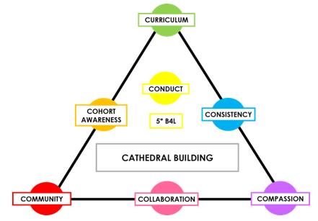

As a staff body, we enact our values through the metaphor of a ‘**Cathedral Building’ approach**, believing that, at each stage in a child’s journey from EYFS to Year 11, we are laying strong foundations for their future. We may not see the immediate impact but every action we take contributes to shape who they will be in the future.

As a community of individuals we have a **shared vision** for creating the current and future happiness and success of every child who attends Dartmouth Academy. Regardless of our role within the school, or the point in their school career when we are working with them, our involvement will shape aspects of their **future selves**. We may not see the immediate impact of the vision we have for them but we each play a vital part in its creation.

We also pride ourselves on being an outward-facing school, seeking partnerships and networks with other like-minded schools in order to support all children, regardless of their school, to have the best possible school experience. It means that you have strong opportunity to work with colleagues in other schools, lead professional development programmes and develop the skills and profile you need for your next promotion.

**THE ACADEMY’S FACILITIES**

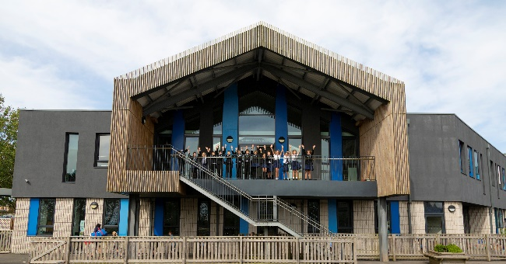

Visitors often comment on the excellent building which the school is housed in, the facilities it has and the unrivalled view of the River Dart. The Academy’s building facilitates a seamless transition for children at each crucial stage in their school journey, ensuring they feel part of the whole community.

Subjects benefit from access to great facilities to enable the curriculum, whether that is the Science labs, the Food Technology suite, the Product Design & Engineering room, the Art rooms and Sculpture Studio, the Fitness Suite, the Forest School Area or the Dart Centre, home to Music lessons.

We would recommend a visit to the Academy so that you can see the wonderful environment which you could be teaching in.

**STAFF AND PUPILS OF THE ACADEMY**

As a smaller school, and especially as an all-through school, relationships between staff and pupils are excellent. New members of the team are quickly able to build strong relationships with all pupils at the Academy, whether they teach them or are simply greeting them in the corridor. This is an important part of the overall sense of community and also supports pupils’ focus and positive attitude in the classroom. Staff commitment is high and positive relationships are evidenced through the time which staff devote to helping pupils continue to develop out of classes.

We value the voice of every colleague and give staff the opportunity to participate in decision-making process through regular whole school, pastoral and developmental meetings, as well as whole school events.

**CONTINUING PROFESSIONAL DEVELOPMENT**

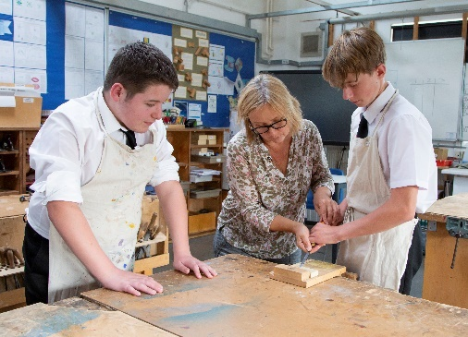Staff are the most valuable resource in a school and we are committed to ensuring that all colleagues have access to ongoing professional development that is supportive of each person’s needs and aspirations. All teaching staff engage in a programme of Incremental Coaching with fortnightly drop-ins from their coach and subsequent developmental discussions.

Staff Voice is clear that this is a highly appreciated part of the CPD programme and all new members of staff will also be expected to embrace this opportunity to continue developing their practice. Our policy is to train our own staff who can then lead others. All staff also have access to a range of professional development opportunities led by the Trust, as well as through the engagement with the Research School and qualifications such as NPQs.

We also have a strong open-door policy throughout the school and colleagues will welcome you into their classroom at any time.

For trainee teachers and NQTs, we have a strong programme of support. All of our ECTs have mentoring support, as well as from a member of the Senior Leadership Team, and we offer a bespoke programme adaptive to the needs of the individual when this arises. We have been an early adopter of the ECF, compulsory from September 2021, and are confident in this support.

**THE CURRICULUM**

In Secondary, we have a two-form entry with up to 60 pupils in each year group. These are taught in mixed ability groups at Key Stage Three, except in Maths and English.

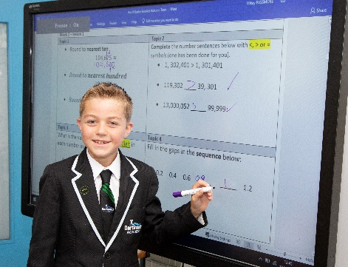All staff are committed to providing a quality-first, academic curriculum which enables all learners to achieve their potential. The curriculum is carefully planned and sequenced to build upon the learning from the Primary school and is designed so that any pupil with a desire to study the subject further, beyond school, has the foundations by which to do so.

The Graduated Response is a vital tool for enacting the curriculum for all learners which staff use consistently in their planning.

We have three core principles for our curriculum:

* High level of academic rigour, including transformational   
  knowledge and skills, and cultural capital, to take pupils beyond   
  their known experience, scaffolded for all learners to be successful
* Planning which is informed by cognitive science, teaching  
   in a coherent and carefully considered sequence to   
  build on the incremental development of knowledge within each subject and help pupils form durable long-term memories
* Rigorous, clear use of assessment, both formative and summative, which follows a Three Cycle model and where the outcomes of assessment informs planning

New colleagues will benefit from shared expertise within the Academy and across the Trust.

**EXTRA CURRICULAR**

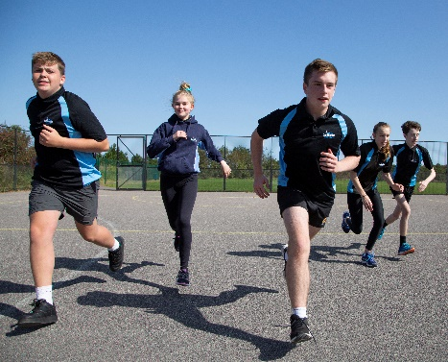We have a thriving extra-curricular programme which is always changing and always developing. As a small school, we adapt this based on the interests of our current cohort. We look forward to hearing from you, at interview, about your interests and intended contributions to this.

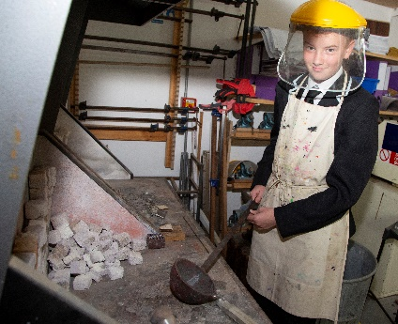We run many sports activities which are participated in enthusiastically by pupils. Other clubs and activities range from Dance Club to Photography Club to Chess Club to Art Club. We also hold a Challenge Week at the end of the Summer Term where all pupils select from a range of either residential-based activities or a daily programme, with options ranging in recent years from a trip to Paris and London through to learning how to sail.

Running alongside the regular programme are always extracurricular opportunities which individual staff members have chosen to run, such as an expedition to Borneo. Staff would not give up this time if they did not enjoy working at Dartmouth alongside our pupils and we are enormously appreciative of their time and goodwill.



**DARTMOUTH ACADEMY**

**Job Description**

Post Title: **Teacher of English; 0.8FTE. September 2023 or January 2024 start, dependent upon candidate availability. 1 year temp in the first instance.**

Scale: **MPS**

This job description is not a comprehensive definition of the post. Discussions will take place on a regular basis to clarify individual responsibilities within the general framework and character of the post as identified below. The conditions of employment of teachers in the School Teachers’ Pay and Conditions of Service Document apply to this post, whose holder is expected to carry out the professional duties of a teacher as circumstances may require, under the reasonable direction of the Headteacher. Appropriate level of performance is defined in the Framework of Performance Standards for Teachers in England.

## Job Purpose

To support the development of English and Literacy effectively, ensuring all children benefit from an excellent curriculum.

To be an effective teacher and tutor who supports and challenges all pupils to achieve their full potential.

**Accountabilities:**

1. To contribute to the design and implementation of the English curriculum, working closely with the department head and Trust’s English CDL.
2. To use and manage data in English effectively to monitor pupils’ progress within the subject.
3. To support the implementation of literacy intervention programmes, monitoring engagement and effectiveness.
4. To support the design and implementation of the reading programme.
5. To maintain a thorough and up-to-date knowledge of the teaching of your subject(s) and take account of wider curriculum and pastoral developments which are relevant to your work.
6. To plan tutorials, activities, lessons and sequences of lessons to meet pupils’ individual learning needs.
7. To use a range of appropriate strategies and follow Academy policies for tutoring, teaching, behaviour management and classroom management
8. To do all you can, involving parents and other agencies, to ensure that as a result of your tutoring and teaching you promote the health, safety, economic wellbeing and achievement of your students.
9. To assess, monitor and record the progress of pupils in your teaching and tutorial groups and give them clear and constructive feedback.
10. To set well-grounded expectations for pupils in your teaching and tutorial groups using information about prior knowledge and previous attainment, making progress as good or better than similar pupils nationally.
11. To take responsibility for your own professional development and use the outcomes to improve your tutoring and teaching and your pupils’ learning.
12. To make an active contribution to the policies, aspirations and plans of your year group, of your curriculum team and of the Academy.



**DARTMOUTH ACADEMY**

**Person Specification**

The successful candidate will meet the following person specification. Please note that the listed criteria will form the basis of the selection process.

|  |  |  |
| --- | --- | --- |
| **Essential** | **Desirable** | **Evidence Base** |
| **Qualifications** | | |
| Degree and Qualified Teacher Status | Essential | Application Form / Certificates |
| Successful experience of teaching subject in placement or a previous school | Essential | Application Form / Certificates |
| **Professional Experience and Knowledge** | | |
| Leadership aspiration | Desirable | Application Form |
| Successful teaching and curriculum experience | Essential | Application Form |
| Ability to teach subject to GCSE | Essential | Application Form |
| Ability to communicate effectively with pupils, parents and colleagues | Essential | Application Form / Interview |
| Ability to use assessment for learning and data to improve student performance | Essential | Application Form / Interview |
| High level ICT skills | Essential | Application Form / Interview |
| Inspirational practitioner with a passion to enthuse and engage students so they achieve their full potential | Essential | Application Form / Interview |
| Excellent understanding of the curriculum and current developments in teaching and learning | Essential | Application Form / Interview |
| Positive attitude towards your own and others’ professional development | Essential | Application Form |
| Able and willing to make a full contribution to the life of the department and the wider school community | Essential | Application Form |
| Other relevant qualifications within the field | Desirable | Application Form / Interview |
| **Personal Qualities** | | |
| Adaptable, flexible. | Essential | Application Form / Interview |
| Able to take responsibility and show initiative. | Essential | Application Form / Interview |
| Enthusiastic and inspiring. | Essential | Application Form / Interview |
| Able to command respect. | Essential | Application Form / Interview |
| Excellent team member, able to work both independently and cooperatively with others. | Essential | Application Form / Interview |



**How to apply**

**Application deadline**

Completed applications must be received by **9.00am,** **Monday 25th September**

Please submit your application to Vicki Hart via [**admin@dartmouthacademy.org.uk**](mailto:admin@dartmouthacademy.org.uk)

**Completing your application**

Candidates are asked to complete all the standard information required on the application form, and to submit a supporting statement outlining your suitability for the role.

The Governors are committed to safeguarding and promoting the welfare of children and applicants must be willing to undergo child protection screening appropriate to the post, including checks with past employers and an enhanced disclosure via the Disclosure and Barring Service.

It is the Governors’ Policy to ask to see original certificates for all qualifications of A Level or equivalent, and above, at interview.

**Discussion and visits**

Informal discussions with a member of the team are welcomed, as well as visits to the Academy. Please arrange a suitable time with Vicki Hart via [**admin@dartmouthacademy.org.uk**](mailto:vicki.hart@dartmouthacademy.org.uk).

**References**

Candidates are advised that references will be taken up immediately after shortlisting. Candidates are asked to ensure that their referees are informed of the need to respond within the timescale set. In all cases, at least one professional reference is required.

The post will be offered subject to satisfactory completion of pre-employment checks.

