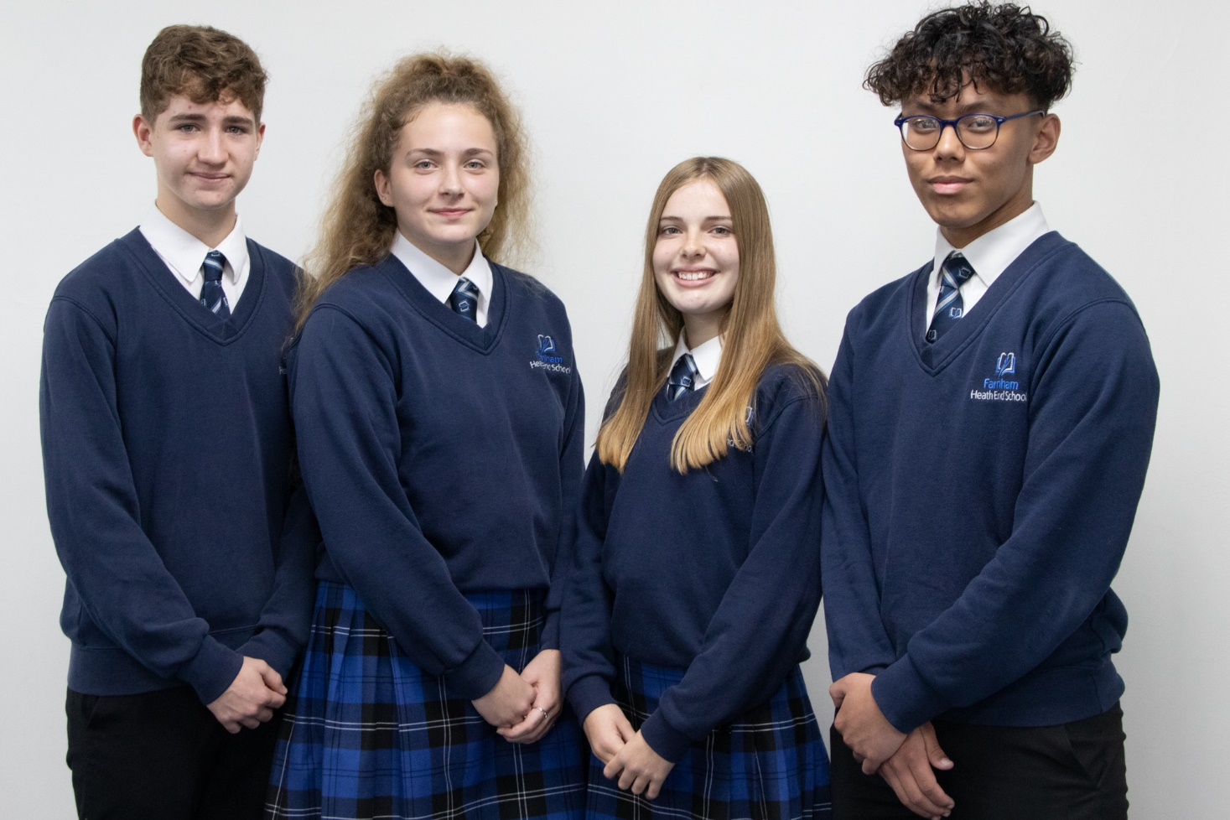



**Staff Prospectus**

# Letter from the Principal

Dear applicant

Welcome to Farnham Heath End School. I know how important choosing the right school for the next stage in your career is and I hope that this booklet will provide an interesting and helpful insight and help you with your decision making. I am looking for enthusiastic professional colleagues to join me in developing the school into an Outstanding educational establishment.

As a school working as part of the Weydon Multi Academy Trust, we have exciting plans to make this an exciting, purposeful and forward thinking educational establishment. I can assure you that you will be given the support required to assist you in becoming an outstanding classroom practitioner and also the coaching to prepare you for future leadership opportunities.

Staff wellbeing and reducing workload is at the forefront of our vision for great teamwork, and we have created the FHES 50 initiatives and strategies to reduce workload and improve staff wellbeing, including ‘no meeting’ weeks at the end of each half term, and a feedback guidance policy, which states that written comments on student work aren’t required.

## About the school

Students come to us from 4 main partner schools, with whom we work closely to ensure a smooth transition. Currently, at 16, students move to Farnham College, Alton, Farnborough or Guildford Colleges.

## An outstanding community

I believe that every child has talents and, as parents and teachers, we need to identify, nurture and develop these so that every individual succeeds. Our core values of trust, respect, aspiration and high moral standards underpin our ethos of encouragement and achievement. We expect that all members of our school community will show the respect to others that they would like shown to them. We encourage students to become involved in our school community as much as possible through contributions to house competitions, community activities and participating in a wide range of student leadership opportunities.

## Delivering Excellent Learning and Teaching

Teaching and learning is at the very centre of everything we do at Farnham Heath End School. Our vision is to ensure that we are evidence-formed in all that we do in the classroom, and our research-informed ‘FLOW’ teaching and learning policy supports this. Last year we were asked to host ‘research ED Surrey’ which was highly successful and we will be hosting this event again in October 2020 which further highlights our commitment to professional growth of staff.

We ensure that all teachers receive regular instructional coaching and bespoke CPD opportunities through their curriculum are and through a pedagogical approach to ensure that they remain at the top of their profession and are striving to be more and more effective in all that they do. We strongly believe that there is no substitute for well qualif9ied and committed staff. Every member of staff also benefits through wider WMAT programmes, one of which sees departments meet across the WMAT, once a half-term. This level of collaboration and sharing of expertise and best practice is part of our CPD programme. We meet across the trust once a term and also enjoy a WMAT Conference each year.

We believe in teaching to the top and scaffolding upwards to equally support and challenge all students ensuring that thinking and participation ratio are high for all students, every lesson. We have a condensed Key Stage 3 for Years 7 and 8. At Key Stage 4 students have the opportunity to take between 9-11 subjects to GCSE level.

## Extra-Curricular Activities

We enhance the curriculum with a wide ranging extra-curricular programme. This includes a range of clubs and trips. We encourage all students to take part in clubs. We also run the Duke of Edinburgh Award. I would encourage staff to want to run extra-curricular activities for the benefit of both students and staff.

## At Key Stage 3

At Farnham Heath End School we believe in a traditional academic curriculum. Our curriculum is designed to *reflect the national curriculum and* to ensure that all students have access to challenging content which prepares for the world beyond Farnham Heath End: at Key Stage 3 we endeavour to show students the breadth across and within subjects. Underpinning our curriculum are the values of friendship, courage, resilience and high moral standards.

## At Key Stage 4

Our students follow have the opportunity to choose from a stimulating and extensive range of academic and vocational pathways. A three year programme at Key Stage 4 allows students to follow extra academic subjects as part of an enriched curriculum.



**Delivering excellent behaviour**

We are committed to the belief that a great education takes place in a secure and disciplined environment where students are healthy and safe. Learning is most effective when students enjoy what they do and feel valued. As a small school we are able to build positive relationships with our students and this is at the core of the outstanding behaviour seen at Farnham Heath End.

Ofsted had the following to say about behaviour in the school: *“Students are proud of their school and are keen to talk about what makes it different to other schools locally. Behaviour is good. There are few incidents of disruption of poor behaviour. Leaders have established good systems to ensure a calm and orderly environment.”* Senior leaders are on duty every period of every day to support staff and to regular monitor the quality of classroom practice.

We became an academy in April 2013 and joined the Weydon Multi Academy Trust (WMAT) in April 2017. Being part of the WMAT allows our staff and students to collaborate with staff in other schools as well as being part of a teaching school alliance. In March 2019, we held the first WMAT ‘Stronger Together’ conference that brought all WMAT colleagues together for a day of training and professional growth around our collective vision.

This is only a small soundbite into school life at Farnham Heath End School. This is a really exciting transition in the history of the school and future plans for its expansion, both in building work and student numbers, are exciting for its progression. The first part of the expansion has been the building of the Betjeman building including 7 state of the art classrooms and a Sports Hall. Refurbishment of the main campus is taking place and we are looking forward to further exciting improvements over the coming years.

This is truly an exciting time to join this forward thinking and research driven school where our numbers have had a 30% increase over the last two years. If you would like any further information about the roles advertised please do not hesitate to contact me.

**Stuart Maginnis**

**Principal**



# The Post

The successful applicant’s primary role will be to deliver effective sequences of learning to students in Key Stage 3 and 4.

We are seeking to appoint a teacher who has a great depth of knowledge and passion for their subject. The ability to enthuse students through depth of content, rather than purely for engagement, and the desire to be a proactive leader of within the department is a must.

All departments are well resourced with all rooms equipped with projectors and many with interactive facilities. Wi-Fi is available throughout the school. Visualisers are in the majority of classrooms.

The department will share the responsibility for improving and developing the curriculum for the subject.

We expect a lot from our students and we also expect a lot from our staff. However, staff feel supported and want to provide the highest possible quality of education for the students in our care. This is a good school in which to develop your career as your professional development is vitally important to us; many of our middle leaders have been promoted internally or have been promoted to leadership positions in other schools.

We actively promote staff well being and have recently reviewed staff workload; creating FHES 50 which demonstrates positive efforts made to support staff.

If you are prepared to work hard, teach effective sequences of learning, to go the extra mile for our students and are committed to your own professional development then this is the school for you.

Applications should be via the school application form and a letter of application which should be no more than 2 sides of A4 paper outlining:

* your educational experience
* your educational beliefs
* why you are the candidate that we are looking for.

Appointment to this post is subject to medical clearance, an enhanced DBS check as well as references which will normally be sought prior to interview.

Application forms and supporting letters should be returned to Mrs Linda Mitchell, PA to the Principal, [lmitchell@fhes.org.uk](mailto:lmitchell@fhes.org.uk) as soon as possible.

It is not possible to acknowledge all applications.



# Arriving as an NQT

You will be employed and trained through your first 2 years. We have developed an excellent support programme which includes:

* NQT Teaching and Learning coach (separate to NQT mentor)
* Weekly NQT meetings with a focus on teaching and learning.
* Weekly research-informed Teaching and Learning forum.
* A preparation day which will prepare you for all you need to know on your first day.
* A programme of effective teacher observations
* A professional mentor and NQT mentor.
* Developmental observations and classroom support.
* Bespoke CPD across the year for subject knowledge and pedagogy.

# For Experienced Teachers

To be an outstanding teacher we believe you must be an enthusiastic learner with access to high quality development opportunities.

If you have been teaching for some years you can expect:

* To be able to apply for Specialist Leader of Education status as part of our teaching school.
* To be part of a positive success orientated culture.
* Examination Board training.
* Weekly research-informed Teaching and Learning forum
* Bespoke CPD across the year for subject knowledge and pedagogy
* Potential to be part of the Teaching and Learning team.
* NPQML
* SSAT Lead Practitioners

# For Middle and Senior Leaders

If you join us as a Leader you will benefit from bespoke development including:

* Middle Leadership Training as part of our accredited programme through teaching schools. This includes areas such as managing and leading people, how to develop Teaching and Learning and data analysis are covered.
* Assigned a leadership coach.
* Assigned a log-in for ‘Leadership Matters’.
* Weekly Middle Leader meetings to share effective practice and inform school leadership
* Leadership Team member will provide you with one-to-one support and guidance on areas such as managing a budget and holding staff accountable for performance.
* Access to i2i Partnership, our Teaching School, curriculum groups to share good practice with other schools.
* Opportunity to access NPQML and NPQSL.

# Staff Benefits

* Farnham Heath End School performance bonus scheme and pay scales.
* FHES 50 to reduce staff workload and improve well-being (see end of document)
* The staff social area, staff workrooms.
* Whole staff social events.
* Free tea and coffee at break time served in the staff room.
* Assisted car maintenance agreement with local garage.
* Pension scheme.
* Opportunities to visit other countries such as Iceland, Borneo, Germany, France and USA as part of school visits.

# Working in Farnham

Farnham is a bustling lively town of over 38,000 people at the western end of Surrey, bordering on Hampshire. An old Georgian market town, with many historical features, including its own 12th Century Castle, it is within easy travelling distance of London, Basingstoke, Alton, Guildford and the South coast.

There are many small businesses in the area, but people also commute to work in the city and towns in the surrounding area.



Farnham Heath End School is a thriving and successful oversubscribed mixed comprehensive school at the north east end of Farnham which is held in high esteem by the local community. We are a popular school with approximately 950 students on our current roll, taking between 30-35% of students from across the border in Hampshire.

# Accommodation

Built in the 1960s Farnham Heath End School comprises mainly of a 4 storey tower block with two single storey wings. As well as playgrounds and fields, we have a 14 acre sports field and a flood-lit All Weather Pitch for school and community use. The pitch is managed by the school and enjoys extensive community use. The Betjeman building opened in September 2019 with 8 state of the art classrooms, a new library and sports hall. There is still renovation of existing classrooms taking place.

We believe strongly that environment influences the work of both staff and students and so over the past few years we have invested in the quality of our accommodation. All departments are located in specialist areas and we have carried out extensive refurbishment, although more still remains to be done.

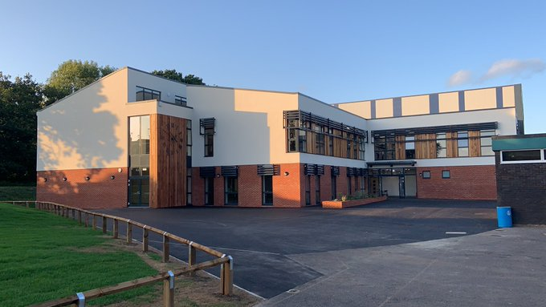

# Staff and Governors

Farnham Heath End School has been fortunate to remain fully staffed with specialists despite the difficulties in recruitment. Whilst there are probably many reasons for this, as key factor is that staff enjoy working at Farnham Heath End School and like its welcoming and warm atmosphere.

We are fortunate in having excellent quality teachers and non-teaching staff and the focus of all staff at the school is enabling great learning to take place. Children only have one chance at education and therefore we only recruit and retain the highest quality staff at Farnham Heath End School, we won’t keep poor staff.

The Governors of the school, chaired by Mr Rob Williams are our very supportive critical friends. A reflection of this is that they have moved from separate staffing and curriculum committees to form a single committee which focuses on the School Development Plan.

One of the Governors’ priorities over the past few years has been to reduce the administrative burden on teachers so that they can focus their energies on teaching and learning. The school is therefore well staffed by support, administrative and technical staff.



# Curriculum and Pastoral

One of our most important aims is to ensure that Farnham Heath End School is a pleasant place for students to learn and for staff to work. Staff joining or visiting the school frequently comment on how friendly, helpful and positive our students are.

We have a very effective system of student support and guidance based on a year system and tutor groups. All staff are attached to a House and many staff are personal tutors to a group of students.

