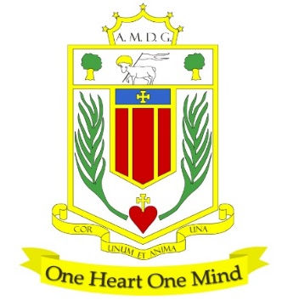
BROUGHTON HALL CATHOLIC HIGH SCHOOL
Yew Tree Lane

Liverpool, L12 9HJ

Telephone 0151 541 9440 / Fax 0151 259 8448
E.mail: smithg@broughtonhall.com
Head Teacher: Mr G Preston B.A. (Hons), NPQH, PGCE
Number on Roll 1211 including 182 in Sixth Form

TEACHER OF ENGLISH MPS/UPS

MATERNITY COVER/FIXED TERM CONTRACT: Until 31st December 2022
HOURS: Full Time
CLOSING DATE FOR APPLICATIONS: 4th July 2022 at 10.00 am
REQUIRED TO START: 1st September 2022

The Governors wish to appoint a first rate, enthusiastic English Teacher. English is a popular subject at GCSE and at A Level, with English being one of the top performing subject areas. The department have eleven English specialists (and one Drama specialist) and is an integrated team who work together to implement a curriculum which prepares students for the wider world and developing the student as a whole.

The successful candidate will be:
- An outstanding classroom practitioner with a dedication and desire for teaching and learning
- Someone who is passionate about the subject and has the ability to inspire and foster a love of learning
- Committed to the school’s vision and demonstrating compassion through the mission statement
- Dedicated in ensuring students achieve the best outcomes

Applications from newly qualified teachers or more experienced colleagues most welcome. The ability to offer KS3 History would be welcome.

About Broughton Hall Catholic High School
Broughton Hall is a Catholic High School, proud of its strong Catholic ethos and values. The school has an excellent reputation and promotes an inclusive education which develops creativity, confidence and independence. The school is committed to the continuous professional development of all staff including our Aspiring Leaders, NPQML and NPQSL programmes.

The Trustees are the Sisters of Mercy

Application is by way of the school’s Application Form which is available from the school’s website together with the Job Description and Person Specification. Please email your application to smithg@broughtonhall.com

Applications from newly qualified teachers most welcome.

Closing Date: 4th July 2022 at 12.00 noon
Interviews: To take place as soon as possible after the closing date.

Broughton Hall Catholic High School is committed to safeguarding and promoting the welfare of children and we expect all staff and volunteers to share this commitment to keeping children safe. Any offer of employment will be subject to statutory pre-employment checks including satisfactory references and Enhanced DBS and Barred List checks. This post is exempt from the provisions of the Rehabilitation of Offenders Act 1974 (as amended in 2013 & 2020) and shortlisted candidates will be required to disclose any relevant criminal history prior to interview.

