
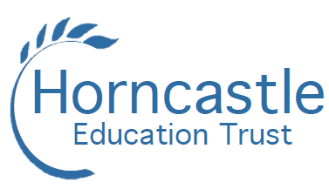
BANOVALLUM SCHOOL

TEACHER OF ENGLISH
Full Time, Maternity Cover: June – December 2021
MPS/UPS

We believe that every student whatever their background has the right to flourish, to achieve and to succeed and everything undertaken by Horncastle Education Trust should have this ambition at its heart.

Horncastle Education Trust comprises four local schools: Banovallum School, Frithville Primary School, New York Primary School and Queen Elizabeth's Grammar School. The Trust was formed from a genuine desire to work more closely together following the success of existing partnership work between the schools. Having both secondary and primary schools that are geographically close is something we take a pride in as a Trust.

We wish to appoint an ambitious, well qualified and dynamic teacher of English to join this leading department. The successful candidate will have a commitment to inspiring excellent outcomes, quality learning and a love of the written word. We require candidates to have a record of effective teaching of Key Stage 3 and Key Stage 4 English as well as experience of tutoring.

Banovallum is a mixed 11-16 secondary school at the heart of the local community in Horncastle. “Pupils behave well in lessons. They listen attentively to their teachers and to each other. They support and encourage their classmates. Pupils know the high standards of behaviour expected of them and as a result, low-level disruption in lessons is rare and more serious disruption is very rare. ……The school is calm and orderly throughout the school day.” (Ofsted 2017)

An information and application pack is available from the school and can be downloaded from www.horncastleeducationtrust.org. Further information about the school can be found on www.banovallumschool.co.uk. Please send your completed form along with a covering letter telling us about your experience and the skills you could bring to our Trust. Applications can be made in writing or by email to admin@banovallumschool.co.uk.

The closing date is Thursday 22 April, with interviews taking place during week commencing Monday 26 April.

The Trust is committed to safeguarding and promoting the welfare of children and young people and expects all staff and volunteers to share this commitment. The post is subject to enhanced DBS disclosure.
The Banovallum School
Boston Road, Horncastle, Lincolnshire LN9 6DA
Tel: 01507 522232 www.banovallumschool.co.uk

