

Teacher of English
Application Pack
1







Contents
Welcome
01
Page 3
Vision & Values
02
Page 4
03
School Information
Page 5
04
Job Description
Page 6
-
10
05
Person Specification
Page 11
06
How to Apply
Page 12

Welcome 
Dear prospective candidate,
Thank you for considering an application to join the team at Holly Lodge.
At Holly Lodge, we believe that all students are entitled to an ambitious and diverse education, regardless of their background or starting point. We believe that it is our job to teach all of our students the best of what has been thought, said and created, through a powerful knowledge curriculum. In addition, we believe in the explicit teaching, practice and development of kindness, community and the soft skills which will stand our students in good stead for happy, successful and positive lives.
Our vision doesn’t end with what we want for our students. We also believe that schools should be rewarding, inspiring places for staff to work, and that it is our responsibility to keep workload down and to intentionally build a positive and supportive culture. We do want our staff to work hard but we want them to have plenty of time and energy for the other things in life. We believe that supportive relationships between colleagues are fundamental to successful organisations.
Colleagues joining our team can expect the following:
- Comprehensive induction, a senior staff link and a buddy
- High expectations for student behaviour
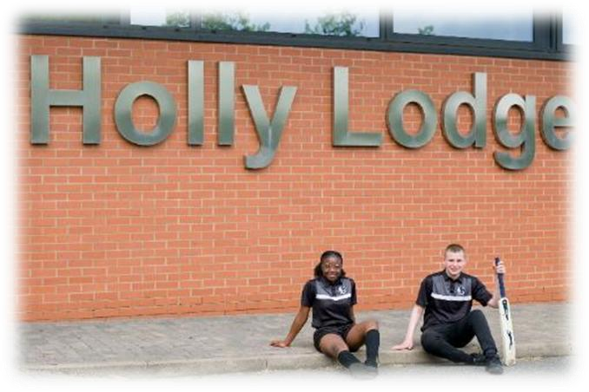

- A senior team who believe their job is to create the conditions where teachers can teach and students can learn

- A focus on feedback and not marking
- No performative documents or requirements to “evidence” your work
- No graded lesson observations
- Research informed and subject-specific CPD
- Multiple career progression pathways
- An open-door and pro-active feedback policy – questions and suggestions are welcome all day, everyday
We are unashamedly ambitious in our aspirations, and our team of staff is key to our success. If you share our vision for the entitlement of all young people to an ambitious and diverse education, if you want to work in a school that focuses on what works and on genuine staff wellbeing, if you are prepared to work hard on the things that make a difference, and play your part in a strong, open and supportive culture, then please apply today. I strongly encourage you to contact the school and look forward to either arranging a telephone call, virtual or meeting in person through a visit to the school.
I look forward to meeting you.

Imran Iqbal
Headteacher

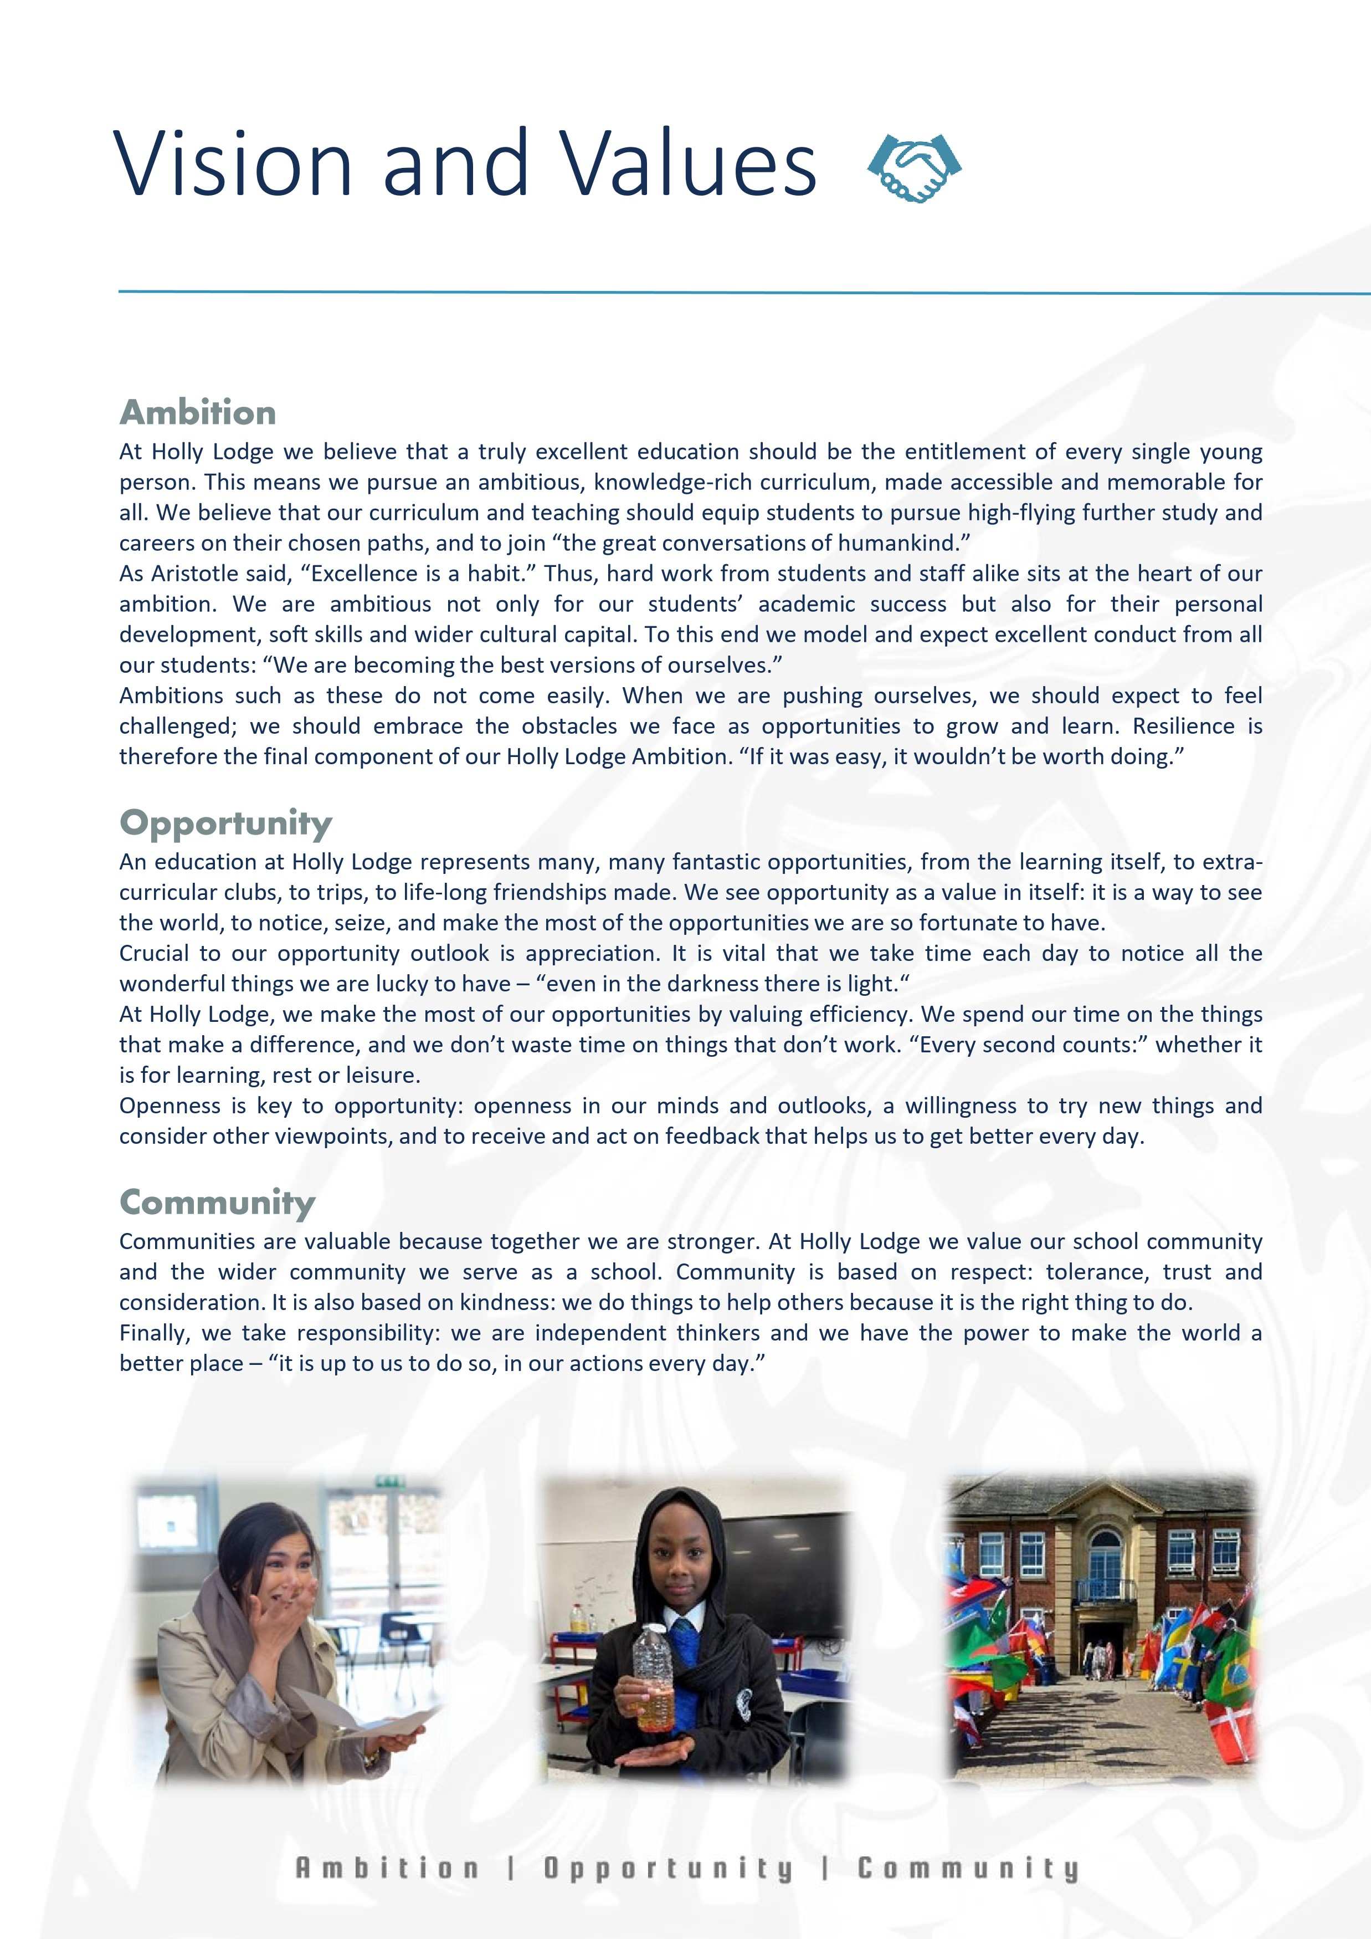
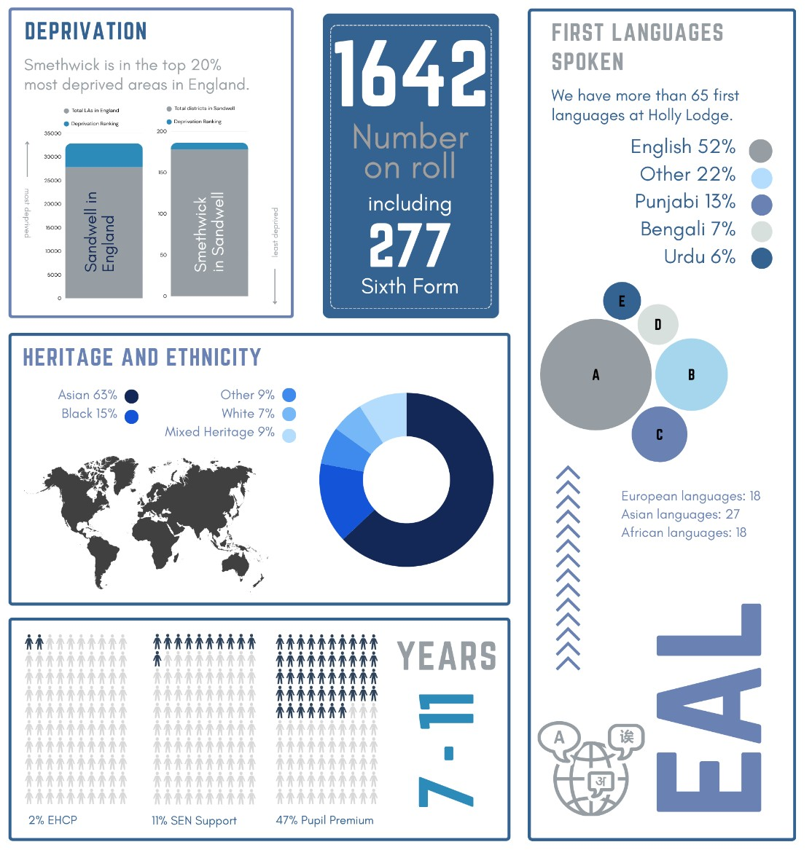
School Information
Job Description
Position
Teacher of English
Scale
TMS/UPS
Start Date
J
anuary
2027

Responsible to
H
eadteacher
and Governors
The
core
purposes
of
the
role
:
•
Teaching and contributing to curriculum development
•
Pastoral care and supporting students in their personal development
•
Contributing to the staff professional culture of the school
Key
Duties
&
Responsibilities
Plan and teach highly effective, motivating, ambitious and supportive lessons
Support students to develop excellent habits of learning through modelling, monitoring and discussion
Read around your subject and the education literature in order to continuously develop your teaching and
curriculum thinking
Attend whole
-
school, department and pastoral CPD and apply what you learn to your practice
Visit colleagues’ lessons and welcome visitors into your own lesson as part of our commitment to continuous
improvement
Contribute to department discussion and development of curriculum materials
Use information from lessons, looking at student classwork and assessments to inform future planning and
teaching
Apply the school systems to ensure excellent behaviour from all students
Support students through your role as form tutor
Actively participate in duties, engaging students in conversation and helping to ensure an excellent climate for
break and lunch
Contribute to the staff culture through professionalism, discussion, openness and warmth.
This appointment is subject to the current conditions of employment contained in the School Teachers’ Pay and
Conditions Document, the required Teacher Standards, other current educational legislation and the school’s
articles of governance.
This job description may be amended at any time following discussion between the Headteacher and member
of staff, and will be reviewed annually.
The
school
will
endeavour
to
make
any
necessary
reasonable
adjustments
to
the
job
and
the
working
environment
to
enable
access
to
employment
opportunities
for
job
applicants
with
disabilities
or
specific
requirements
or
continued
employment
for
any
employee
who
develops
a
disabling
condition
or
specific
requirement
.
