English Department

The heart of Chesterton Community Sports College can be found within the confines of the English department. It is one of the largest departments in the school, with seven full time English specialists, furthered with the addition of a full-time librarian and English Learning Support Assistant. Oversubscription to the school is a delightful consequence of the school’s success, and with this comes the need for a new member to join our passionate, personable and proficient department on a maternity cover contract.
Our ethos is driven by humility: we work collaboratively and cohesively in order to provide the best outcomes for our children. Teaching standards are high within the department, and we relentlessly scrutinise and evaluate how we can develop our progress to sustain levels of excellence. This is achieved through the sharing of good practice and utilising one another’s skill sets to engender a holistic approach to teaching. A key aspect of the aforementioned qualities relate to the cornerstone of our practice: hard work.
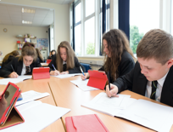
The school is fully equipped with the latest Apple technology: each English classroom benefits from wireless Apple TV access which connects to a personal MacBook, alongside a personal iPad. In addition to this, pupils in KS4 enjoy the use of their own iPad, which acts as an invaluable resource to our already, bountiful teacher-toolkit.
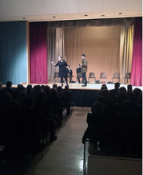
The GCSE English results have been excellent for many years: the progress measures have been outstanding. We have always produced excellent results either in-line with or above national average, and this has continued despite the changes to the specification and grading system. This is testament to the strength and depth of the department, underpinned by its ability to adapt to change. The English department contributed greatly to the school’s overall success with regards to results and specifically the Progress 8 measure.

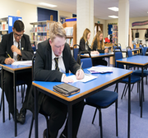
In light of such adverse changes, the English curriculum has been overhauled to ensure that students are fully equipped to handle the demanding GCSE course content in KS4. Invaluable core skills are embedded into learning from Year 7, thus allowing students to progressively acquire knowledge, whilst giving them the scope to explore their potential within the subject. This enables students to build confidence in an inherent way, which in turn inspires innovation and individuality.

It goes without saying that the jewel of the English department is found in our well-resourced library. The room is spacious and fully equipped with books for all ages and abilities. The library has access to its own set of iPads in order to supplement the wealth of provisions already accessible in the library. Some students utilise this space for many extra-curricular activities, whereas others enjoy it to foster their love for books. It is in this noteworthy space, that the passion for reading and writing, through the vehicle of English teaching, can truly be seen.

