February 2026

Dear Applicant

Thank you for your interest in the teacher of English (maternity cover) from March 2026 – March 2027.

This is an excellent opportunity for an enthusiastic and creative teacher, who has a passion for their subject and a commitment to high quality teaching, which plays a significant part in the curriculum to ensure the highest expectations for each child in every lesson.

Archbishop Tenison’s is a friendly, aspirational and high achieving school, where pupils and students take their studies seriously. As a Church of England school, we are keen for staff to help us develop our Christian ethos and educational vision.

We look forward to receiving your application and to meeting with you to talk about the opportunities here. In your supporting statement please include the following:

- why you would like to take up this post at this time;
- which experience and qualities make you particularly suitable for the post;
- examples of what you would contribute to the department and school, if appointed.

Please see our website for further details.

Yours sincerely

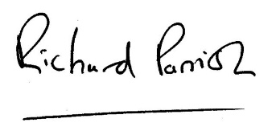

Richard Parrish

Headteacher

