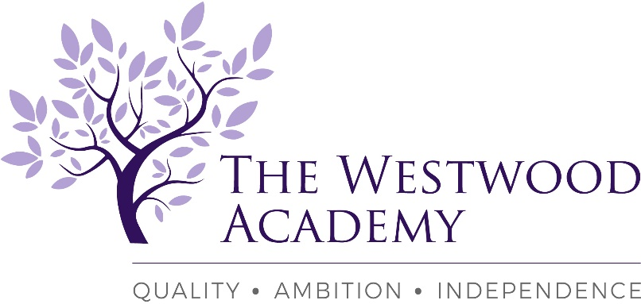

The Westwood Academy – Part of the Kenilworth Multi Academy Trust family of schools
Mitchell Avenue,
Coventry, CV4 8DY

Teacher of English (maternity cover in the first instance)
TMS/UPS currently £25,714 - £41.604
Full Time
Required November 2021

We are looking to appoint, an enthusiastic, creative and passionate teacher of English into a thriving, highly successful and ambitious department. This is initially a maternity cover post (November 2021 – July 2022), however as a rapidly growing and popular school this is an excellent opportunity to gain a full-time permanent post for the academic year 2022/2023 onwards. This is an exceptional opportunity for an experienced Teacher or enthusiastic ECT looking to build a career. We are looking for teachers with a love of their subject, ambition and the ability to engage young people in learning. We provide a unique environment in which both teachers and pupils thrive.

The Westwood Academy is part of the Kenilworth Multi-Academy Trust a forward thinking and ambitious trust. We offer a motivating learning environment with an excellent shared CPD programme. We are proud of our academic record and of our pastoral care, which maintains a feeling of community in a small, but growing school.
The school works tirelessly to ensure that every pupil’s potential is successfully achieved, through excellent teaching, the establishment of positive learning relationships, effective assessment and constructive feedback.

We encourage all potential candidates to come and visit the school and meet the staff and pupils to fully appreciate our wonderful community.

Role Requirements:
- Qualified Teacher Status or ECT with recent UK classroom experience essential gained in a training environment
- Up to date knowledge of your specialist area for years Year’s 7 – 11. Post 16 experience would be beneficial.
- Dedicated, creative and hardworking individual
- A real willingness to learn new skills
- Employees benefit from an extensive and bespoke CPD programme.

You are most welcome to visit the school to meet our staff and pupils. If you would like to discuss this opportunity further, please contact the Head of School.

Further details and application forms are available via the school website at:
https://www.thewestwoodacademy.co.uk/760/recruitment
Please send completed application forms to admin@thewestwoodacademy.co.uk

If you require any further information please contact
Mrs J Westwell: PA to Head of School
Telephone number: 024 7642 6901
E-mail: admin@thewestwoodacademy.co.uk
Closing date: Wednesday 29th September: 10:00am
This school is committed to safeguarding and promoting the welfare of children and young people and expects our staff and volunteers to share this commitment. This post is subject to two satisfactory references and an Enhanced Disclosure and Barring Service check.

