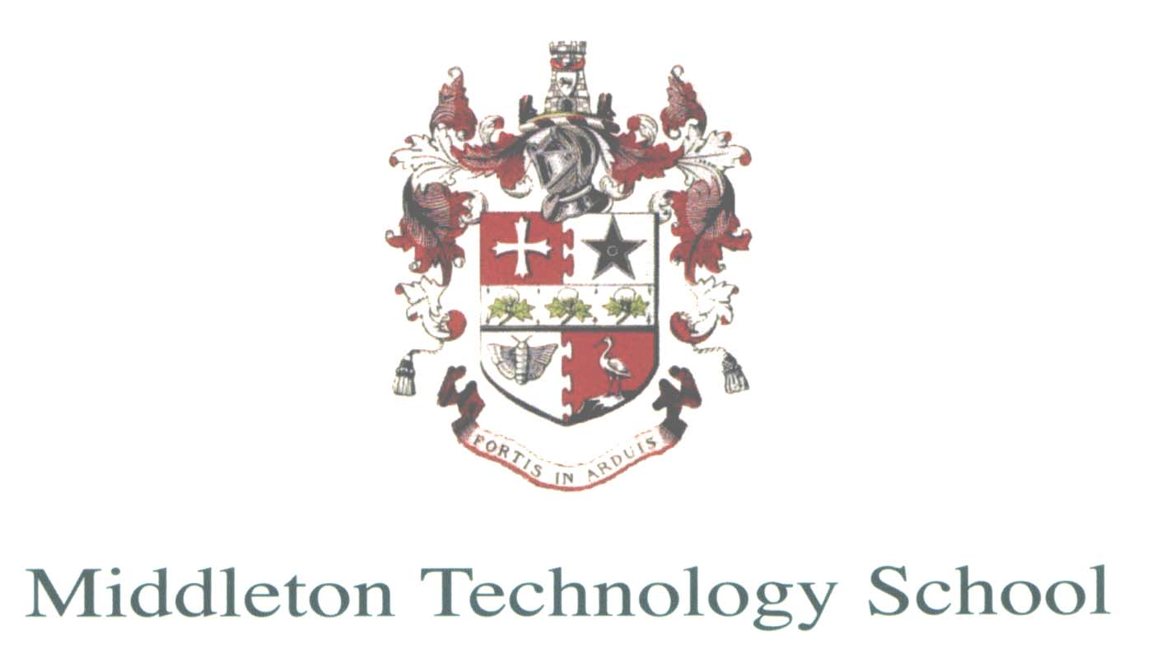

Information about the English Department
Are you someone who:
- Is passionate about all things English?
- Is dedicated to the improvement of students’ reading and writing skills through a diverse curriculum?
- Is able to motivate and inspire students to achieve their absolute best regardless of their ability?
- Has excellent subject knowledge and believes that personal development is continuous?
The English department at Middleton Technology School has a determined and dedicated spirit, resulting in a successful and passionate team of staff who are committed to the young people of our school.
Our curriculum has a clear focus on developing key English skills through reading. Thereby fostering a love of reading as well as building the key skills of our curriculum. Our students are taught in ability groups and our curriculum is carefully sequenced to ensure they progress successfully, enjoying and being challenged by its diverse content.
We also are privileged to offer a bespoke library based curriculum that all of our KS3 students enjoy. Library sessions focus on not only developing students’ resilience but also their love of reading.
At Key Stage 4 all students follow the AQA course in English Language and the OCR course in English Literature. Expectations of every student, regardless of ability, are high and we are passionate about ensuring that we make our curriculum accessible to all.
As a teaching school we offer excellent opportunities for professional development, ensuring our CPD is a curriculum in itself. We invest in our staff, their development and wellbeing, as we truly believe they are the most important resource that we have.
Finally, you would be joining a dynamic, sociable and passionate department that enjoy our job and the students that we teach. We are excited at the prospect of a new member of our team that we can both learn from and help to develop. So, if you are resilient, hardworking and passionate about all things English, we look forward to hearing from you.

