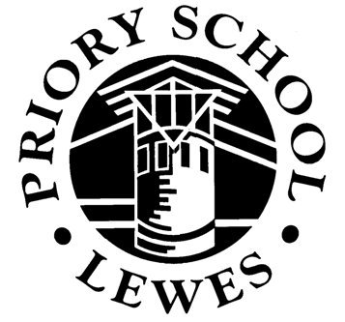

PRIORY SCHOOL, LEWES

LEWES

Lewes is a small county town of architectural, cultural and historical interest; it is set in an exceptional environment surrounded by downland and farmland and is only a short journey from Brighton and the coast, as well as just over an hour by train from London. Consequently, many people find it attractive to live in the school's catchment area and house prices are high compared to other parts of the country; however, in areas away from Lewes / Brighton they can be lower.



The town is the administrative centre for the county with County Hall for East Sussex, and the County Police Headquarters for the whole of Sussex. Within a few miles there are the campuses of Sussex and Brighton Universities. These all provide opportunities of various kinds as far as pupils and staff in the school are concerned, and many people working for these organisations live in the school's catchment area.

SCHOOL VISION

Priory School is an 11-16 mixed comprehensive school situated in the County Town of Lewes. Our vision is for all of our community to share high aspirations, to aim high and achieve our very best. We want our learners to:

- Have a love for learning
- Understand the strength of community taking collective responsibility for ourselves and others
- Be adaptable and creative and to strive for a sustainable future
- Be prepared for challenge but also for change; to value questions as much as answers
- Be critical in their thinking, informed in their choices and confident in their ability to succeed in the modern world

THE SCHOOL

Priory is the only state secondary school in the town and is thus fully comprehensive for this area. The school's academic record over many years has gained it a high reputation, so that many parents from outside the catchment area are encouraged to ask for entry for their children. Many disadvantaged families also send children to the school from within and outside the catchment area. The range of concern and educational expertise which needs to be exercised by the staff is as wide as in any school, but the overall ability profile on entry is above average.

Extract from an email from parent (2021)
“I am writing to thank you for all you and your staff have done for (my son) over the past five years. Please pass on thanks to all staff for their dedication and commitment, for the hundreds of hours of unseen preparation and for their patience…

Priory was first designated a Performing Arts Specialist School in 2002 and this status was re-assessed and renewed. In 2006 the award of Language Specialist School and subsequently Specialist School Status in Science and Mathematics in 2007 increased the specialist focus. Funding and recognition of specialisms was ceased in 2011 but the specialisms still influence the school ethos.

In 2017 the school was designated as a Teaching School and we have a number of staff who have been designated as Specialist Leaders of Education (SLE). The school is a lead provider of NPQs and other recognised training courses.

Priory School provides a renaissance style of education in which arts and sciences go hand in hand, and creativity, performing and public speaking flourish. This approach has contributed to further external accreditation for its high standards. The school holds Committed to Carers, Healthy Schools awards and the Cooperative Identity Mark.

OFSTED reports that Priory School is ‘a Good School’

OFSTED inspected Priory School on 9 May 2018. After a rigorous inspection, the team of OFSTED inspectors concluded that the school remains a good school.

Extracts from the OFSTED Letter:

“There is a stimulating and challenging ethos in the school which enables pupils to make strong progress and achieve well”
“…leadership embeds a culture of strong pastoral care and high academic standards.”
“…leaders know the many strengths of the school, including the strong progress made by all pupils, including disadvantaged pupils, in English, mathematics and science.”
“In lessons, we saw pupils working hard and making confident articulate contributions to discussions.”

The OFSTED letter also recognises the significant contribution of the governors of Priory School. The governors voluntarily and generously give their time and energy to the school and we greatly appreciated their support.

ACCOMMODATION

The school has excellent accommodation consisting of new and refurbished buildings as a result of remodelling the school in 1993. Together these provide very imaginative accommodation for the school. All subjects have their own suite of teaching rooms that surround subject resource rooms. The buildings have been specifically built to accommodate students with physical handicaps. The school retains its own free-standing purpose-built chapel that is used for assemblies and the many musical presentations of which the school is rightly proud. Arts College Status delivered a Performing Arts Centre which opened in 2006 and a new purpose-built music block which was opened in January 2008.

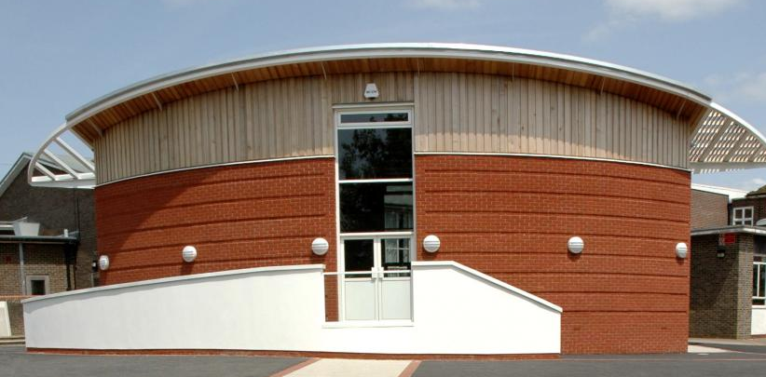

The school has 4 ICT suites and an extensive Library equipped with PC’s.

The school is opposite the East Sussex College Group (Lewes Campus) and adjacent to the Lewes Leisure Centre which is used by the school on a joint use basis. Extensive sports fields and an all-weather athletics track surround it, which provides adequately for our needs.

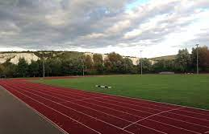

SCHOOL ORGANISATION

Students are placed in mixed prior attainment tutor groups of their own age group with a tutor who has the key role in providing guidance, care and ensuring their welfare whilst at school.

The school is divided into four Houses comprising two tutor groups from each of years 7 to 11. The school has an eight-form entry therefore each House has ten tutors and the system is led by a non-teaching House Head who is closely involved in the academic progress, pastoral welfare and the behaviour of students.

There are eight Curriculum Leaders responsible for the Curriculum Areas, each Curriculum Area additionally has Deputy Curriculum Leader/Head of Subject with direct subject responsibilities in that area. In addition, the core subjects of English, Maths and Science have an Assistant Curriculum Leader.

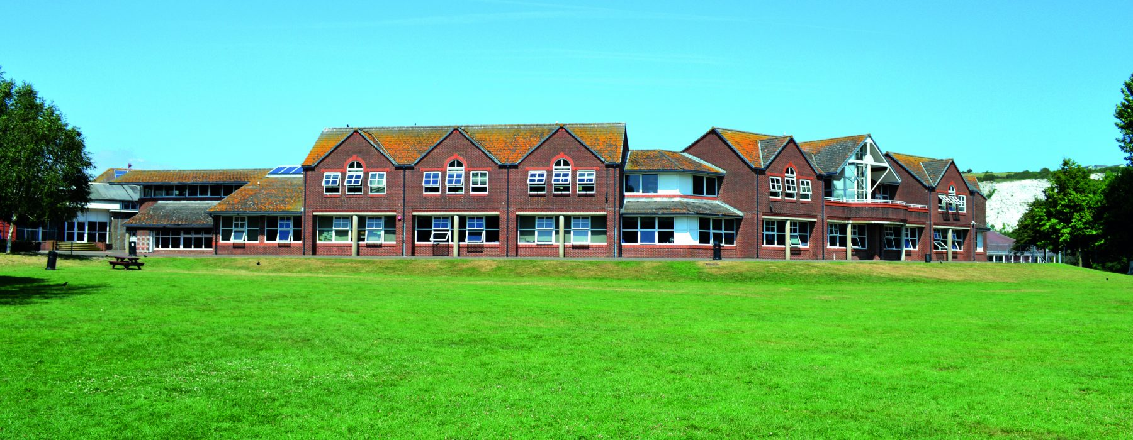

The Curriculum

“Leaders and governors are committed to providing an innovative curriculum supported by an extensive enrichment programme” OFSTED 2018

The curriculum of the school fulfils all National Curriculum requirements. In addition, though, we offer a wide range of subjects providing students with a breadth of study unmatched by most secondary schools.

In Key Stage 3 students have the opportunity to study Classics, within Creative Arts Music, Dance and Drama are taught as separate subjects and within MFL French, German and Spanish are offered as the main languages.

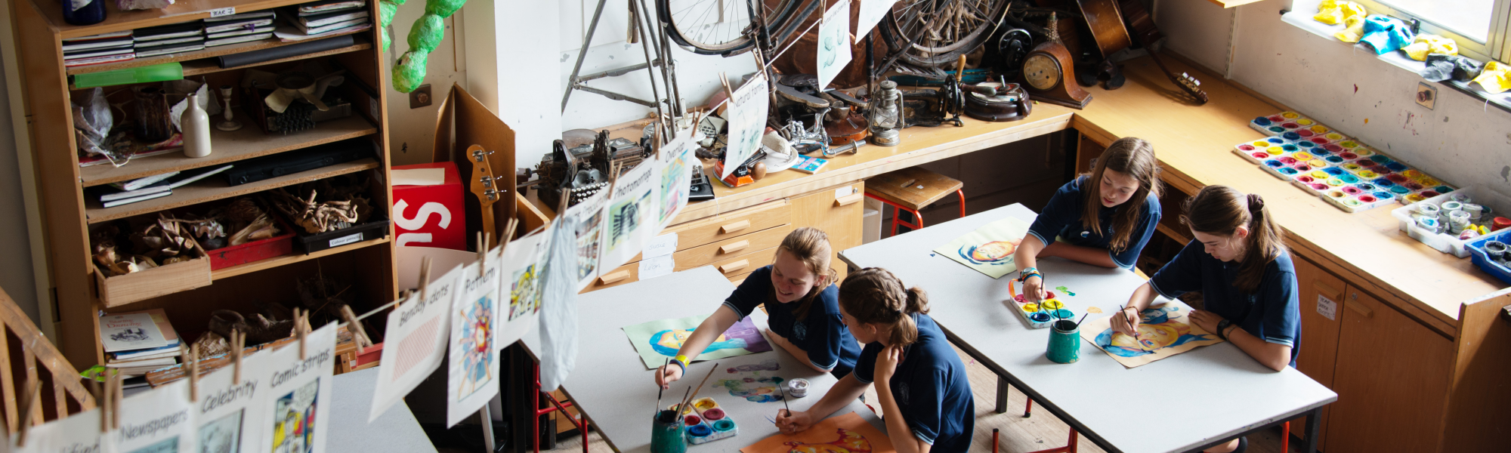

At Key Stage 4 students have a very wide choice of subjects including, for example, separate sciences, photography, media studies, three different languages and Sports Leadership

Students have the opportunity to follow an academic or more vocational route at KS4: we work in partnership with our partners such as Plumpton College to offer vocational qualifications.

Accreditation is through a mixture of GCSE, BTEC and VCERT. Extensive provision is made for the Gifted and Talented students.

For those with learning difficulties, there is a system of withdrawal from, or support in, lessons for individuals or small groups. As part of Inclusion policy there are Learning Support and Behaviour Support units. There are a significant number of support colleagues working in these areas.
There is also a special unit for hearing impaired students who are generally integrated into the mainstream of the school.

Extra-Curricular Activities

“Pupils are proud of their school. They told inspectors that they enjoy school and appreciate the wide range of well-attended clubs and activities on offer” OFSTED 2018

The school has always provided a wide range of extra-curricular activities – music productions, choirs, bands and orchestras, sport teams and clubs, trampoline club, drama clubs and productions, public speaking and much else. Trips and visits and too numerous to list here.

All staff are encouraged to take part and it is hoped that newly appointed staff will be no less enthusiastic in providing similar opportunities for students.

Achievement and Standards

“…pupils make strong progress in a wide range of subjects.” OFSTED 2018

Priory School regularly performs towards the top of the East Sussex league tables.

In 2019 over 80 % of Year 11 GCSE students obtained Grade 4 or higher grades (English and Maths), progress in English was 0.38 and 0.01 in mathematics. Science performed in the top 5% across the country

Progress in many other subjects is significantly above national averages.

The Governors

We value our partnership with the Governors who are always active in the interests of the school. They have been influential in the provision of the new buildings and are supportive in all areas of school life.

Equal Opportunities

The school is committed to Equal Opportunities.
.

Closing Date for All Posts

Will be included in the advertisement.

The school is committed to safeguarding and promoting the welfare of young people and expects all staff and volunteers to share this commitment.

