Teacher of English
Permanent Contract – Main Pay Scale – Full Time

Recruitment Pack

From the CEO and Executive Principal
On behalf of the Trustees and Local Governing Body Members I would like to thank you for your interest in the post of Teacher of English here at Rayner Stephens High School.

Due to the increase of student numbers and growth of the school, Stamford Park Trust is looking to appoint a committed and inspirational teacher with the proven qualities to drive improvement and change the life chances of those students who attend Rayner Stephens High School.

Rayner Stephens High School was established in 2017. The school joined Stamford Park Trust, a Multi-Academy Trust established by Ashton Sixth Form College, in January 2021 at the same time as Longdendale High School. The school is located in Dukinfield and serves the local community. It is situated 8 miles to the east of the city of Manchester and within easy commute from most of the North-West region. The last Ofsted inspection in February 2020, prior to joining Stamford Park Trust, rated the school as inadequate overall. The school has been on a journey of improvement both in the quality of provision and in the development of facilities with £1 million building project starting this year.

Rayner Stephens High School is at the beginning of an exciting improvement journey. Stamford Park Trust is committed to creating an outstanding quality of education and a culture of ambition and learning at Rayner Stephens High School through collaboration and innovation. The appointed individual would be supported by the Head of School, Mr Martin Davies, the Executive Principal (Secondary), Miss Melanie Wicks and the wider Senior Team and will become an important member of the Trust. The Trust is committed to the development of all members of staff through tailored CPD and support.

Rayner Stephens is a highly inclusive school and holds the Inclusion Quality Mark ‘Centre of Excellence’ for the level of provision provided. Currently, the school has around 600 students on roll which provides the opportunity to create a strong community where all of our students are known as individuals.

If you have a commitment to excellence, aspiration and a strong focus on improvement, we would like to hear from you. Applications will be assessed against the requirements set out in the job description and person specification. We will also expect to see evidence of a good fit with the culture and ethos of the Trust as outlined in our strategic plan.

Stamford Park Trust offers a number of benefits for employees including free gym membership, free parking, well-being activities, access to an Employee Access Programme and strong investment in personal and professional development through an extensive CPD Programme.

Once again, thank you for your interest in this position. We look forward to receiving your application. Yours sincerely

Anton McGrath
CEO Stamford Park Trust

Melanie Wicks
Executive Principal

From the Head of School
I am extremely proud to be able to offer a warm welcome and to thank you for your interest in the position of Teacher of English here at Rayner Stephens High School.

We are a school at the heart of our community, with our school name honouring one of Dukinfield’s heroes. Our school is a warm and caring community for all learners. We celebrate all of our learners’ achievements and believe strongly in providing an environment where all young people are able to thrive.

I have served here as Head of School since September 2021 and have been massively impressed with the ambition and support from Stamford Park Trust and the staff within the school. Every day, I find work at Rayner Stephens exciting, challenging and hugely rewarding. I am delighted that every member of staff here is committed to providing the best opportunities and experiences to enable all students to flourish, achieve their full academic potential and develop as confident individuals.

We are an inclusive 11-16 school, part of the family of schools that make up the Stamford Park Trust. Our core purpose is to support learners of all abilities and backgrounds to develop high aspirations, believe in themselves and achieve their full potential. We expect all students to work hard and aim high in order for them to succeed academically and personally. Our whole school community has much to be proud of. We value our students as our greatest asset and encourage student leadership and student voice so they can be fully engaged in all aspects of the school.

For the successful candidate, our school will offer a fantastic chance to work with a collaborative and passionate staffing body and dedicated and extremely talented senior leadership team, who wholeheartedly understand school improvement and focus on the things that matter.

The best way to get a real flavour of our school is to visit us. Senior Leaders, including myself as the Head of School, are in and amongst the school all day supporting students and staff. I am able to facilitate visits in the school day. If you wish, for a tour with myself, then please contact my PA, Mrs Thirza Partovnia who will help you arrange this on 0161 338 2374 or by emailing t.partovnia@rshs.spt.ac.uk.

Candidates selected for interview will receive further information about the process to help them prepare for the interview. I would also strongly encourage you to visit our website at www.raynerstephens.org.uk.

After reading the supporting job description and information pack, I hope you will pursue an application for this wonderful and rewarding role. In the meantime, I very much look forward to hearing from you. I do understand the amount of time that goes into preparing an application, so thank you in advance for thinking about joining our team.

Please send your completed application to recruitment@spt.ac.uk

Yours sincerely

Martin Davies
Head of School

Stamford Park Trust
Stamford Park Trust was established as a Multi-Academy Trust in February 2019. The Trust initially comprised of one educational institution, Ashton Sixth Form College, which converted from a designated Sixth Form College to a 16-19 Academy on the same date.

The College was joined by two 11-16 High Schools in January 2021 with Longdendale and Rayner Stephens High Schools transferring into the Trust.

The Trust’s Vision and Mission The vision for Stamford Park Trust is Excellence and ambition for all. In meeting our vision to provide excellence and ambition for all, we will:

Our Values
- Establish a dynamic Trust capable of building on its success, extending its influence and making a significant contribution within Greater Manchester
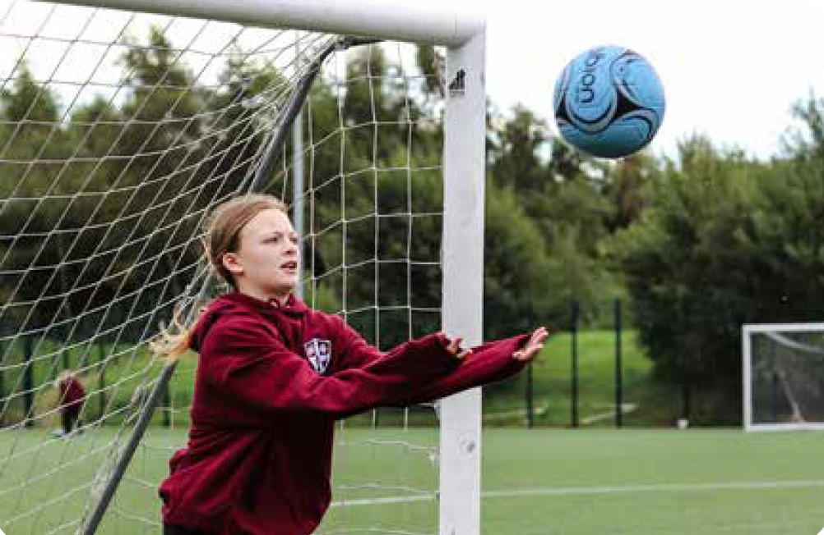
- Establish Academies which are centres of excellence and innovation for leadership, teaching and learning and collaboration
- Support the development of a coherent curriculum which supports strong transition to the next phase of education and prepares all for the next stage of their life
- To encourage the realising of ambition and taking of opportunity
- Be driven by a moral purpose to transform the life chances and opportunities of all children and young people in the Trust
- Work in partnership and in collaboration with schools and colleges in the Trust to support their development as successful centres of excellence aimed at improving achievement for all
- Work in partnership with other schools, academies, and MATs in the Greater Manchester area to share ideas and promote excellence.

- Student centred and inclusive
- A culture of trust and respect
- A collegiate and collaborative approach to quality improvement and innovation
- Unashamedly aspirational for all
- A driver for social mobility
- Supportive yet challenging

The vision of Stamford Park Trust has naturally evolved from the ethos and culture of Ashton Sixth Form College. It demonstrates our commitment to supporting young people in the borough and surrounding area from the age of 4 to 18, helping young people and adults to improve their life chances through improved outcomes. The mission is simple; to work collaboratively to improve the quality of teaching, learning and outcomes for all schools in the Multi-Academy Trust.

Rayner Stephens High School was opened in 2017 when the school was first acadamised. Rayner Stephens High School joined Stamford Park Trust, a Multi-Academy Trust led by Ashton Sixth Form College in January 2021. The school is located in Dukinfield and serves the local community, 8 miles to the east of the city of Manchester and within easy commute from most of the North-West region. The school has been on a journey of improvement both in the quality of provision and in the development of facilities with a £1 million building project due to be completed by the end of 2024.
Rayner Stephens High School is very proud of our students’ achievements and the improvements that have taken place since it was established. We have a strong ethos of ambition and aspiration embodied throughout the school. Rayner Stephens is a highly inclusive school and holds the Inclusion Quality Mark ‘Centre of Excellence’ for the level of provision that we provide. We embrace the fact that we are a small school, currently just over 600 students, and we value opportunities this provides to create a strong community environment allowing us to know all our learners and colleagues as individuals and value their uniqueness.
Our aim is to provide the highest quality teaching and learning for our students so they can reach their full potential. We strive to ensure that all students are supported to achieve their goals and open the doors to future opportunities. We provide a dynamic curriculum which engages, inspires and challenges all our students

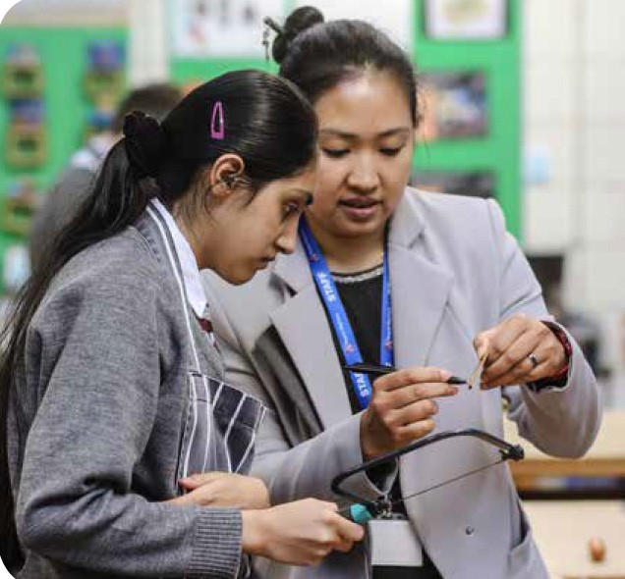
All Students follow a broad and balanced curriculum in Years 7,8 and
9 which not only prepares them for their examination courses, but also develops their skills, talents and interests so that they are prepared for the next stage of their educational journey. Our teaching staff know our students well, and to promote the best learning, staff engage and enthuse students through a wide range of learning activities which promote progress, achievement and enjoyment.
Our aim is to ensure our students become independent, lifelong students equipped with the knowledge and skills they will need to become successful adults, both in the workplace and in their personal lives.

Rayner Stephens is a vibrant, caring and inclusive school. There is a strong ethos of genuine mutual respect, integrity and community spirit where everyone can feel safe, included and well supported in a caring and happy environment.
Our Inclusion Team is the heart of our school. We have our HIVE centre dedicated to supporting the academic and emotional well-being of all our students. Our inclusion team work with individuals, groups and families to remove any barriers to progress.

We have established strong professional values on the importance of good attendance, smart uniform, classwork and homework. We believe that our students learn best when they are happy and motivated and as such we ensure that we celebrate our students’ achievements and reward their hard work and effort.

At Rayner Stephens High School we are unashamedly aspirational for all students. We believe that every child should flourish and enjoy their time with us. There are a variety of student leadership programmes which are provided every year, throughout all curriculum areas. These help students to develop professional working relationships with their peers and act as representatives of the school.
We link with local colleges, universities and leaders in industry to provide a comprehensive range of activities and opportunities to inspire our young people throughout their time at Rayner Stephens. Every student is encouraged to build upon their strengths and develop new talents. We are committed to
developing excellent partnerships and firmly believe that the skills, knowledge and expertise of those around us can be harnessed and developed for the benefit of our students and the wider community. Our aim is to secure strength in our partnerships, which will enable our students to access a wide variety of academic and enrichment opportunities.

Rayner Stephens High School has a state-of-the-art leisure facility for both student and community use 7 days a week. Our goal is to create that ultimate workout experience and use sport and physical activity as a driver for student health and well-being. Our award-winning community provision really shows the impact and importance of the school being a central hub site for sport, physical activity, health and well-being and community engagement. We have over 30 community clubs delivering a wide range of sessions each week for juniors and adults of all ability levels and activity preference.

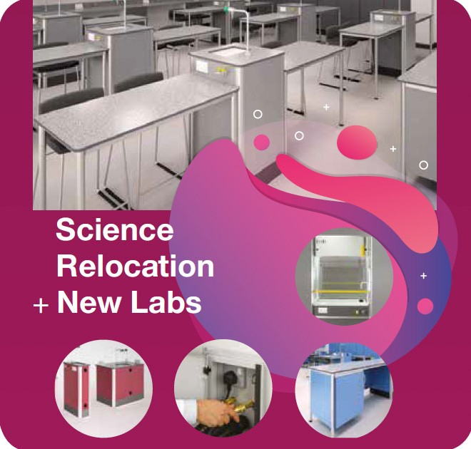
A central aspect of our plan to reinvigorate and improve the student experience at Rayner Stephens High School is the redevelopment of the schools site to ensure that future students have access to the very best facilities for teaching and learning.

Stamford Park Trust, in collaboration with Tameside Council, is investing over £1 million in the next 18 months to turn this dream into a reality. Students will have access to some of the very best accommodation and resources available to support their learning and help them achieve their ambitions.

This is an exciting time to be part of the Rayner Stephens family as part of the wider Stamford Park Trust. We are very excited to have just completed work on creating new Science laboratories in the main body of the building allowing our students to benefit from state-of-the-art facilities. We are also building additional classrooms by adding a Second Floor to a part of the school building. Students will then benefit from additional teaching spaces and a new modernised building providing a clean and modern environment.

The school will also benefit from planned upgrades within the Design Technology Department including replacements to heating systems, windows and lighting along with new resources for classrooms.

How to Apply

We would expect that all prospective candidates spend some time reviewing our website where a vast array of further information about our school exists. However, should you require any additional information about this post or would like an informal discussion or visit, please contact us on telephone number 0161 338 2374 or email Thirza Partovnia on t.partovnia@rshs.spt.ac.uk.

To apply, please email your completed application and recruitment monitoring form to recruitment@spt.ac.uk

All applications that have been submitted electronically will receive an email from the school confirming receipt. A call will be made and an email will be sent to short-listed candidates with details of the interview process.

If you have not heard from us within 2 weeks of the closing date, please assume your application has been unsuccessful.

Rayner Stephens is committed to safeguarding and promoting the welfare of children and young people and expects all staff and volunteers to share this commitment. This position is, therefore, subject to a satisfactory enhanced Disclosure and Barring Service application. We are an Equal Opportunities employer with excellent CPD provision.
Closing Date for Applications
12:00pm – 15th April 2024

Job Description

Teacher of English

On behalf of the Trustees and Local Governing Body Members I would like to thank you for your interest in the post of Teacher of English here at Rayner Stephens High School.

Due to the increase of student numbers and growth of the school, Stamford Park Trust is delighted to be looking to appoint a committed and inspirational teacher with the proven qualities to drive improvement and change the life chances of those students who attend Rayner Stephens High School.

This job description is additional to the basic duties outlined in the latest School Teachers Pay and Conditions document as they relate to Teachers in accordance with the school’s policies and under the direction of the Head of School. A summary of the key accountabilities is outlined below.

General Information:
- This job description is current, but following consultation with you, may be changed by the Executive Principal or Head of School to reflect or anticipate changes in the job which are commensurate with the salary and job title. Whilst every effort has been made to explain the main duties and responsibilities of the post, each individual task undertaken may not be identified.
- The post holder will be expected to participate in the school appraisal programme for teaching staff and to participate in appropriate staff training and development activities.
- Employees will be expected to comply with any reasonable request from the Executive Principal or Head of School to undertake work of a similar level that is not specified in this job description.

Reporting to:
- Head of School, Executive Head and Governing Body

Core Purpose:

• To provide evidence that you are consistently meeting all of the Teacher Standards set out by the Department in Education 2012.
• To plan and prepare high quality teaching and learning courses and lessons and sequences of lessons to meet student’s individual needs, using a range of appropriate strategies for teaching and classroom management, and using information about prior attainment to set well-grounded expectations for students giving clear constructive feedback.
• To give constructive verbal and written feedback in line with the whole school marking and assessment policy.
• Monitor student progress and where necessary implement teacher led intervention to ensure all students make at least expected progress
• To implement and deliver an appropriately broad, balanced, relevant and differentiated curriculum for students and to support a designated curriculum area as appropriate.
• To monitor and support the overall progress and development of students as a teacher/Form Tutor
• To facilitate and encourage a learning experience which provides students with the opportunity to achieve their individual potential.
• To contribute to raising standards of student attainment.
• To share and support the school’s responsibility to provide and monitor opportunities for personal and academic growth.

Key Duties:

Curriculum Provision:

To assist the Head of Department and the link member of the SLT by ensuring that the curriculum area provides a range of teaching that will complement the school’s strategic objectives.
Curriculum Development:

To assist in the process of curriculum development and change so as to ensure the continued relevance to the needs of students, examining and awarding bodies and the school’s SIPs and Strategic Objectives.

Staff Development:

• To take part in the school’s staff development programme by participating in arrangements for further training and professional development.
• To fully participate in the school coaching model.
• Reflect on your teaching practice and use constructive feedback to develop.
• To continue personal development in the relevant areas including subject knowledge and
teaching
methods.
• To engage actively in the Performance Management Review process.
• To ensure the effective/efficient deployment of classroom support
• To work as a member of a designated team and to contribute positively to effective working relations within the school.

Quality Assurance:

• To help to implement school quality procedures and to adhere to those.
• To contribute to the process of monitoring and evaluation of the subject area in line with
agreed school procedures, including evaluation against quality standards and performance criteria. To seek/implement modification and improvement where required.
• To review from time to time methods of teaching and programmes of work and change when appropriate.
• To take part, as may be required, in the review, development and management of activities relating to the curriculum, organisation and pastoral functions of the school.
Management Information:
• To maintain appropriate records and to provide relevant accurate and up-to-date information for Pupil Tracking, registers, etc.
• To complete the relevant documentation to assist in the tracking of students. To ensure that school deadlines are adhered to.
• To track student progress and use information to inform teaching and learning.

Communications:

• To communicate effectively with the parents of students as appropriate.
• Where appropriate, to communicate and co-operate with persons or bodies outside the school.
• To follow agreed policies for communications in the school.
• Attend the appropriate parents evenings/student progress days to help keep parents involved about the progress of their child

Marketing and Liaison:

• To take part in marketing and liaison activities such as Open Evenings Parents Evenings, Review days and liaison events with partner schools.
• To contribute to the development of effective subject links with external agencies.

Management of Resources:

• To contribute to the process of the ordering and allocation of equipment and materials.
• To assist the Head of Department to identify resource needs and to contribute to the efficient/effective use of resources.
• To co-operate with other staff to ensure a sharing and effective usage of resources to the benefit of the school, department and the students.

Student Support System:

• To be a Form Tutor to an assigned group of students including tutor/student interviews if appropriate.
• To liaise with Head of Years or Pastoral Support link to ensure the implementation of the s school’s student support system.
• To register students using SIMS lesson monitor (or a paper register if appropriate) in accordance with school policy at the start of each lesson.
• To evaluate and monitor the progress of students and keep up-to-date student records as may be required.
• Be familiar with the Code of Practice for the identification and assessment of Special Educational Needs and keep appropriate records on Individual Education Plans for students.
• To contribute to the preparation of Departmental Improvement Plans and progress files and other reports.
• To alert the appropriate staff to problems experienced by students and to make recommendations as to how these may be resolved.

• To communicate as appropriate, with the parents of students and with persons or bodies outside the school concerned with the welfare of individual students, after consultation with the appropriate staff
• To contribute to the planning and delivery of PHSE and Citizenship and Enterprise according to school policy

Teaching:

• To provide evidence that you are consistently meeting all of the Teacher Standards set out by the Department in Education 2012.
• To plan and prepare high quality teaching and learning courses and lessons and sequences of lessons to meet student’s individual needs, using a range of appropriate strategies for teaching and classroom management, and using information about prior attainment to set well-grounded expectations for students giving clear constructive feedback.
• To give constructive verbal and written feedback in line with the whole school marking and assessment policy.
• Monitor student progress and where necessary implement teacher led intervention to ensure all students make at least expected progress
• To implement and deliver an appropriately broad, balanced, relevant and differentiated curriculum for students and to support a designated curriculum area as appropriate.
• To teach, students according to their educational needs, including the setting and marking of work in school and elsewhere.
• To assess record and report on the attendance, progress, development and attainment of students and to keep such records as are required.
• To provide, or contribute to, oral and written assessments, reports and references relating to individual students and groups of students.
• To ensure that ICT, Literacy, Numeracy and school subject specialisms are reflected in the teaching/learning experience of students
• To undertake a designated programme of teaching.
• To ensure a high quality learning experience for students which meets internal and external quality standards.
• To prepare and update subject materials. Work should be planned in accordance with schemes of work and National Curriculum programmes of study.
• To use a variety of delivery methods. Plan lessons and sequences of lessons to meet students individual learning needs.
• To maintain discipline in accordance with the school’s procedures, and to encourage good practice with regard to punctuality, behaviour, standards of work and homework.
• To apply the Behaviour Support Plan so that effective learning can take place. Set high expectations for student’s behaviour by establishing a purposeful working atmosphere
• To take appropriate action regarding students involved in misbehaviour in conjunction with Heads of Department, On Call or the Pastoral Support team.
• To undertake assessment of students as requested by external examination bodies, departmental and school procedures.
• Set appropriate and demanding expectations for students’ learning, motivation and presentations of work.
• To mark, grade and give written/verbal and diagnostic feedback with clear targets for future learning as required within a reasonable time span in accordance to the whole school marking and assessment policy.
• Take account of student’s prior levels of attainment and use them to set targets for future improvements.
• Set work for students absent from school for health or disciplinary reasons
• Work in collaboration with classroom support attached to any teaching group.

Professional Standards:

• To support the aims of Rayner Stephens to promote a learning community where children work hard and flourish.
• To be an effective professional, who challenges and supports all students to do their best.
• Treat all members of the community, colleagues and students, with respect and consideration.
• Treat all students fairly, consistently and without prejudice.
• Set a good example to students in terms of appropriate dress, standards of punctuality and attendance.
• Promote the aims of the school by attendance at and participation in events such as open evenings, parents’ evenings and the like.
• Support the ethos of the school by avoiding confrontation, rewarding achievement with positive classroom management

• Take responsibility for your own professional development and participate in staff training when required. Liaise with the CPD coordinator or SLT about training options available.
• Reflect on your own practice as well as the practices of the school with the aim of improving all that we do.
• Read and adhere to the various policies and priorities of the school as expressed in the School Improvement Plan, the staff handbook, subject team/year team documentation etc.
• Participate in the management of the school by attending various team and staff meetings.
• Undertake duties as prescribed within school policies.
• Ensure that all deadlines are met as published in the school calendar.
• Undertake professional duties that may be reasonably assigned to you by the Headteacher e.g. cover etc.
• Be proactive and comply with the school’s Health and safety policy and undertake risk assessments as appropriate

Other Specific Duties:

• To play a full part in the life of the school community, to support its distinctive mission and ethos and to encourage staff and students to follow this example.
• To support the school in meeting its legal requirements for worship.
• To promote actively the school’s corporate policies.
• To undertake any other reasonable duty as specified by the Headteacher not mentioned in the above.

Please Note that whilst every effort has been made to explain the main duties and responsibilities of the post, each individual task undertaken may not be identified.

Employees will be expected to comply with any reasonable request from a manager to undertake work of a similar level that is not specified in this job description.

Employees are expected to be courteous to colleagues and provide a welcoming environment to visitors and telephone callers.

The school will endeavour to make any necessary reasonable adjustments to the job and the working environment to enable access to employment opportunities for disabled job applicants or continued employment for any employee who develops a disabling condition.

Employees are expected to subscribe to the School Improvement Plan.

Person Specification

Teacher of English

No. | Categories | Essential/ Desirable | Application Form | Interview/ Task
Qualifications
1. | Degree | E | •
2. | QTS | E | •
3. | Willingness to complete relevant professional training as defined by the school | D
Experience
6. | Ability to demonstrate excellent classroom skills | E | • | •
7. | Understanding of strategies to raise the quality of teaching | E | • | •
8. | Successful teaching experience at Key Stages 3 and 4 | E | • | •
9. | Demonstrate excellent pedagogical practice | E | • | •
10. | Ability to use data to improve learning | E | • | •
11. | Understanding of current developments in education sector | D | • | •
12. | Developing classroom practice to meet the needs of all learners including those who are most able and those who are SEND | D | • | •
13. | Experience of managing a budget | D | • | •
Abilities, Skills and Knowledge
14. | Experience of using data to identify underachievement and lead successful intervention  strategies | E | • | •

15. | High level interpersonal skills | E | • | •
17. | A clear vision and understanding of ways to remove barriers to learning | E | • | •
18. | Ability to communicate effectively in a variety of situations | E | • | •
19. | The ability to build and sustain effective working relationships | E | • | •
20. | Ability to plan strategically | E | • | •
21. | Knowledge of current thinking in promoting positive attitudes to learning | D | • | •
22. | Knowledge of current thinking in promoting high attendance at school | D | • | •
Professional Development
26. | Commitment to own professional development | E | • | •
28 | Evidence of recent training and development | D | • | •
Personal Qualities
29. | Pleasant and friendly manner | E | • | •
30. | Polite and punctual | E | • | •
31. | Reliable | E | • | •
32. | A commitment to working as part of the whole school team and supporting the vision and aims of the school | E | • | •
33. | Commitment to lifelong learning | E | • | •
34. | Flexibility and adaptability | E | • | •

