Our Ref: STF/JOB/Teacher of Science /Applicant Letter/LAM
January 2021

Dear Applicant,

TEACHER OF ENGLISH

Thank you for your interest in the above role. This post is an exciting opportunity to join a rapidly improving school towards our journey #RoadToGreatTogether .

Farnham Heath End School is an 11-16 Academy serving Farnham and Aldershot areas. We have approximately 950 students on roll and are truly comprehensive in our intake, both in ability profile and social backgrounds.

Farnham Heath End School is part of the Weydon Multi Academy Trust (www.weydonmat.co.uk). Within the Trust we have 4 mainstream secondary schools, FHES, Weydon, Woolmer Hill and most recently Rodborough serving the young people of Farnham and Haslemere and within the special sector we have the Abbey School, The Park School and Ridgway to create a diverse and exciting Trust. Part of this exciting relationship is the ability to join leadership programmes to help you prepare for a pathway of NQT through Chief Executive.

We are fortunate to have a good staff, both teaching and non teaching, although inevitably in the South East teacher recruitment is a challenge. Visitors frequently comment on the warm and welcoming atmosphere in the school.

At Farnham Heath End School we believe in working and playing hard. Our students and staff throw themselves into events like Comic and Sport Relief and Staff Pantomime with tremendous energy and enthusiasm. The success over the past 3 years since I arrived at the school has been built on culture team work and camaraderie. This was report on in the recent successful Ofsted report. There is a real energy and enthusiasm in the staff room and a real sense of #teamFHES.

The Senior Leadership Team comprises: Principal, 2 Vice Principals, 3 Assistant Principals, one being the SENCO, and 1 Associate Assistant Principal. We are very fortunate to have a Governing Body which actively supports the school as our ‘critical friends’. I firmly believe in the concept of distributive leadership because I am convinced that I do not have all the good ideas and that leadership is a team activity.

What I am looking for to complement an already great team is someone who has a zest for their subject, a passion to inspire young people and excitement to move the school forward.

If you are interested in applying for this post please do so by letter of application and application forms (no CVs or additional information). In your letter of application, which should be no more than two sides of A4, please could you address the following points:

- Why you are particularly attracted to this post at this school
- A summary of your experience to date particularly in relation to leadership and management of developments and people
- Your educational philosophy.
- Anything else you may wish to add.

If you decide to apply I look forward to reading your letter which should be returned to school by Friday 29 January 2021, however we interview sooner if we have a strong field. Please ensure that you include contact numbers for both daytime and evening and an email address. I know from my own experience how long it takes to draft letters of application and thank you in advance for your time and effort.

Thank you for your interest in this post and whatever the outcome, may I wish you the best of fortune in your future career.

Yours sincerely,

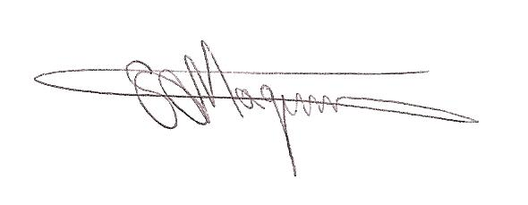

MR STUART MAGINNIS
Principal

