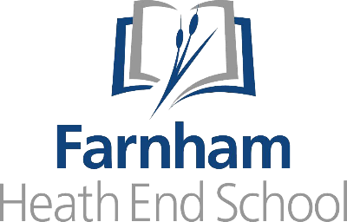

WELCOME TO THE ENGLISH DEPARTMENT

The English department at FHES is a friendly and supportive place to work, including 10 specialist members of staff with a range of experiences and backgrounds. We can guarantee that any future members of the team will receive excellent support and guidance throughout their induction period and indeed for the whole time that they work with us. We work very well as a team and share lots of centrally planned resources; no teacher is expected to plan their day of teaching from scratch, but instead use our department Schemes of Learning, freeing up time for teachers to focus on excellent delivery, great explanations, and responsive teaching. This helps to maintain consistency, but also reduce staff workload. In addition to this, we use the comparative judgement software No More Marking for most of our assessments, and focus on providing high-quality live and whole-class feedback, rather than expecting staff to write extensive comments on the students’ work. Again, this is proven to both reduce workload while also increasing the accuracy of the results.
We have worked hard over the past couple of years to rewrite our curriculum. In doing this we have been aiming to formulate a knowledge rich curriculum offer, that’s based on the principles of high expectations and challenge; we believe that all students have the immense potential to achieve very highly in English and, as a result, all of our lessons are “taught to the top”. To allow for this, all out Schemes of Learning are well-planned and sequenced, many with a booklet of extracts to accompany them. We also have planned in a strong focus on the use of academic language and regularly push students with the vocabulary we expose them to.
At Key Stage Three (Years 7 and 8), we focus on laying strong foundations to set the students up to be successful at Key Stage Four. Examples of Key Stage Three Schemes of Learning are: Greek mythology, Macbeth, and Where The World Ends; every Key Stage Three student also has a weekly library lesson where we aim to create a passion for reading while use the Accelerated Reader programme to track progress. At Key Stage Four (Years 9-11), we follow the AQA specification for both English Literature and English Language. The English Literature texts we study are: Romeo and Juliet, A Christmas Carol, An Inspector Calls, and the Power and Conflict cluster in the AQA anthology.
FHES has a strong commitment to research-informed teaching and learning and the English department is committed to using strategies with a strong research base to ensure we give all our students the very best chance of success. Every classroom has a visualiser for live modelling or feedback, we regularly train students to use etymology to help them remember and use key vocabulary, and all our lessons have knowledge recall built in to enable success.
The English department at FHES is a fantastic place to work and we look forward to welcoming someone who shares our passion for the subject and our drive for student success.

