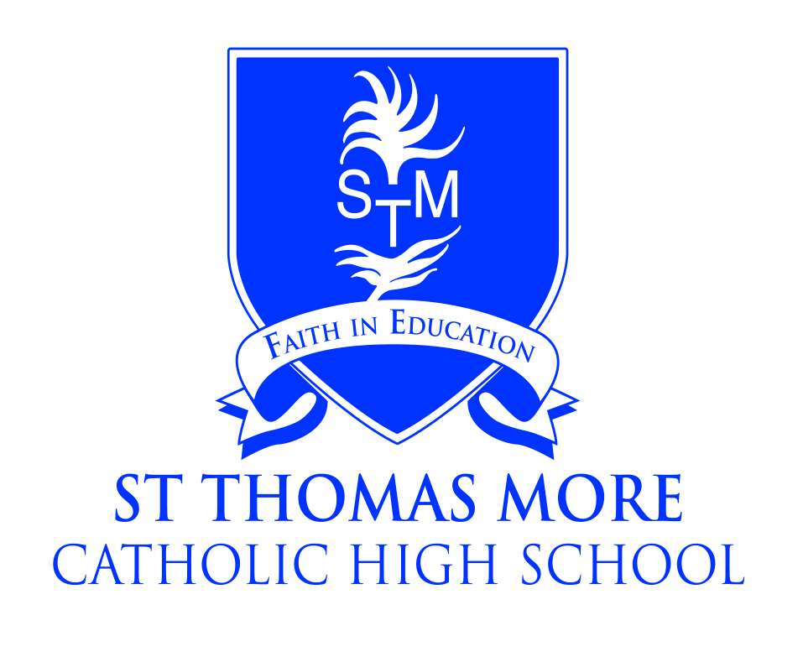
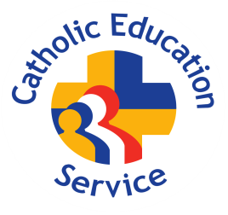
St Thomas More Catholic High School, Crewe
A Catholic Voluntary Academy

Teacher of English

Salary: Teachers Pay Scale
Required: September 2025

The Governors of St Thomas More Catholic High School are seeking to appoint an excellent teacher of English.

A good honours graduate to teach English to all abilities at KS3/4 (including GCSE’s). Knowledge and an ability to teach Functional Skills up to and including Level 2 would be preferable.

The English Department at St Thomas More Catholic High school is an outstanding Department which achieves exceptional results. This is an exciting opportunity for an inspiring teacher to contribute further to an already successful team and build on the high standards and encourage students across the age and ability range.
We are a friendly and caring community placing the academic progress and welfare of our pupils at the heart of everything we do. Teaching as a vocation is key to our ongoing success and so offer a variety of opportunities for professional development and formation.
The post would suit either a newly qualified or experienced teacher.

Further details and a recruitment pack is available from the school website or by e-mailing:
recruitment@st-thomasmore.cheshire.sch.uk

Closing Date: Monday 31st March 2025 at 12pm

Please send completed applications to recruitment@st-thomasmore.chseshire.sch.uk
Please do not apply online or download Cheshire East’s Application Form.

The academy is committed to safeguarding children and successful candidates will be subject to an Enhanced DBS check. Our Commitment to safeguarding is underpinned by robust processes and checks which are in place.

