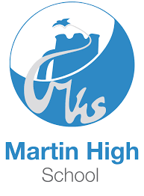
Teacher of English
Based at Martin High School, part of the Lionheart Academies Trust
Main and Upper Pay Range Applications
We are delighted to offer the opportunity for a talented and inspirational Teacher of English to join our outstanding team from August 2021. Martin High School is an Ofsted rated Good secondary school based in Leicestershire delivering KS3 and KS4.

If you would like to come and have a look round, to see us hard at work, don’t hesitate to make contact with our HR Team, to arrange a mutually agreeable time.

This is a great opportunity to join a progressive and supportive employer of choice, with an unwavering commitment to continuous professional development and staff wellbeing.
This post is eligible for a DBS check under the Rehabilitation of Offenders Act 1974 (Exceptions) Order 1975 (i.e. it involves certain activities in relation to children and/or adults) and is defined as regulated activity under Part 1 of the Safeguarding Vulnerable Groups Act 2006.
This post is designated as a regulated activity and requires enhanced criminal records check for a regulated activity (including a barred list check)

If you would like to apply please visit: https://www.martinhigh.org.uk/about-us/vacancies/teaching-vacancies/
Please note CV's WILL NOT be accepted.
For any queries about our vacancies please contact the recruitment team: 0116 2363291 or email izzy.tedder@martinhigh.org.uk
- Closing date: 10th May 2021 at 9am
- Interviews: To be confirmed

