job description
teacher of environmental science
reports to: Head of Science
hours: Full Time
salary: £24,765- £40,418
start date: 24th August 2021
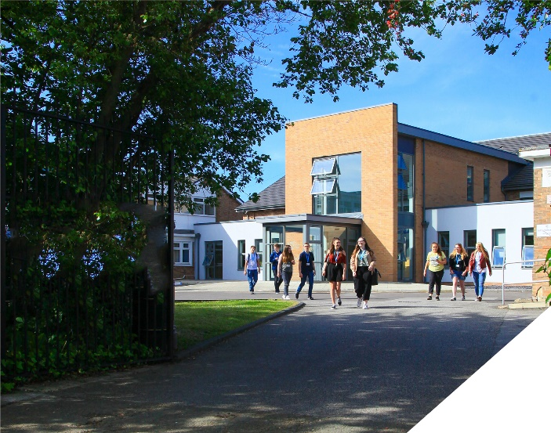
This is an exciting opportunity to develop a brand new course
about the role.
This is a fantastic opportunity to develop and teach a brand new course at the college, A-level Environmental Science (AQA Specification). We seek to appoint a committed and hardworking teacher who is able to teach both A-level Geography alongside Environmental Science.
Experienced teachers and NQTs are encouraged to apply. Whatever your experience you will be supported in a way that best supports your development in a college renowned for its innovation as well as the exceptional progress of its students. A-level Environmental Science is a brand new course for September 2021 and you will be able to play a leading role in it introduction to the curriculum. A-level Geography is a well-established course at the college and due to its growing popularity this position will combine Environmental Science with Geography teaching.
You will be joining the Science department which is a successful part of an ambitious College, with highly dedicated and hardworking teachers. The department offers BTEC courses in Applied Science and A-levels in Biology, Chemistry and Physics, these are delivered by a committed team. Within the department there is a real team ethos with regular opportunities for collaboration and dialogue with colleagues.
The department has 7 fully equipped laboratories and has a team of 5 dedicated technicians to support with practical work and resourcing. The college is currently planning on expanding the number of science labs in response to the growing popularity of science courses and for additional courses at the college.
about the College.
You will be joining a highly successful, innovative and nationally recognised sixth form college. The College was awarded the UK Sixth Form College of the Year by the TES in 2018 and this followed being graded outstanding in all areas by OFSTED in December 2016. All staff play a vital role in the experience that students have with us and ultimately their success.

The College currently has a 16 to 19-year-old student population of 1400 and is oversubscribed. Consequently, the College is embarking on an expansion project for 2020/2021 as student applications continue to increase year on year. Due to this high demand for places, work is being completed on a 1.7m new state of the art teaching facility which will be opened in September 2021.

In response to the pandemic and disruption to the learning of students the college is introducing a new timetable to combat the deficits that students will have. This includes teaching time increasing by 60 minutes and also the number of classes a full time teacher has at 4. This will enable teachers to give their students more attention and tailored support to make up for any loss of learning during the past 12 months.

The College is committed to its core values of Positivity, Ambition, Resilience and Thoughtfulness, and these values shape everything we do. Our ethos is centred on the scientific evidence that tells us that everyone can achieve success through purposeful hard work as opposed to the talent myth, and this enables learners to make rapid progress unshackled by any limits previously placed upon them.

person specification.
Qualifications | essential | desirable
Degree in Environmental Science, Geography or an equivalent qualification | 
Qualified Teacher Status | 
Experience
Experience of teaching Level 3 Science/Geography | 
Experience of teaching Environmental Science |  | 
Experience of working in a demanding environment where high levels of organisation are required | 
Knowledge / Skills / Abilities
Ability to teach Level 3 Science and Geography | 
Up to date knowledge & understanding of educational developments relating to the curriculum area | 
Ability to work flexibly as part of a team | 
Ability to form & maintain appropriate relationships & personal boundaries with young people | 
Ability to respond flexibly & creatively to new challenges & opportunities | 
Ability to prioritise & meet deadlines | 
Ability to use Information Technology effectively | 
Excellent communication, interpersonal & organisational skills | 
To demonstrate a commitment to
The Colleges values of Positivity, Ambition, Resilience & Thoughtfulness | 
Personal development and training | 
Safeguarding & promoting the welfare of students | 
Equality & diversity | 
how to apply.
If you are ambitious and determined to make a meaningful difference in one of the country’s leading sixth form colleges then we would be thrilled to have you join our team.

- Please complete the Teacher Application Form which is available on the College website: www.bsfc.ac.uk
- Last 3 years of examination results (if appropriate – if you are an NQT please skip this part of the application procedure)
- On a separate document, answer the following specific questions (each question should be answered separately with each answer being no more than 150 words):

- Aside from your stated qualifications, please outline what you believe makes you academically suited to the position applied for.
- The College does not currently operate a gifted and talented programme. What is your view on this approach?
- Please identify one or two skills or techniques you have used in the classroom to drive learning.
- Select one of the college values and describe ways you demonstrate this in your day to day work.
- You should have provided an accompanying sheet summarising the results you have achieved over the last three years. Is there any context or background you would like to give to these?

Please email these to: hrdept@bsfc.ac.uk

closing date: Thursday 15th April - 12 Noon

Application Form can be downloaded from the College website: www.bsfc.ac.uk

