Teacher of Food

Ellis Guilford School
Start Date: ASAP


Dear Candidate
Thank you for your interest in the vacancy for a Teacher of Food at Ellis Guilford School.

We are looking for a highly skilled individual, who is either an experienced classroom teacher or an NTQ looking for a challenging and rewarding position. Most importantly, the right candidate will be someone who wants a challenge to make a difference in our school. The successful candidate will be able to demonstrate that they have the knowledge, drive, and passion to be an outstanding Teacher of Food.

I joined Ellis Guilford School as Principal in September 2020, together with a new senior leadership team, determined and committed to improving the life chances of the young people at Ellis Guilford. It is a great honour and privilege to be asked to lead a school of over 1300 pupils. We are undergoing a period of rapid improvement and want to recruit only the very best people to help us on our journey.
“
This is a school where everyone is given the chance to belong and succeed.
.

“
You will be joining a vibrant and dynamic team who only want the very best. If you are an individual who would thrive in this type of environment, we want to hear from you.
Ofsted 2023

Ellis Guilford became part of the Creative Education Trust (CET) in November 2018. CET has a strong record of educational improvement as well as providing a varied diet of curriculum and enrichment opportunities by introducing pupils to professionals who are the best in their specialist field whether it be composers, architects, designers or singers. By seeing the best, pupils are inspired and become ambitious to follow careers they may not have considered before.

Our aim is to prepare our pupils to be good citizens of the future and to have the ambition and courage to exceed. If you share our desire to change the lives of young people, we would very much like to hear from you.
If you would like to discuss this role further, please contact our HR department: 0115 913 1338, hr@ellisguilfordschool.org.uk.

Yours sincerely,

Chris Keen
Executive Principal

ABOUT
CREATIVE
EDUCATION
TRUST

Creative Education Trust inspires and enables young people to build successful lives on foundations of learning, resilience and employability. We believe that a rewarding educational experience and the highest possible qualifications are the best way to ensure social mobility for young people.
Creative Education Trust is a growing multi-academy trust educating over 13,000 children in England. It was established in 2010 to work in England’s post-industrial cities and coastal towns: areas of economic disadvantage and with a history of academic underachievement. We transform these schools by integrating a knowledge-rich curriculum with skills and creativity.
Creative Education Trust defines creativity as the ability to find connections between the things we know and turn these connections into new ideas and action. The academic arts and the sciences, practical subjects and life skills all need this creativity, and creativity is valued highly by employers. Our staff and expert advisers use imaginative methods for linking knowledge across subject boundaries, fostering personal development and resilience and developing practical skills that prepare
students for their transition to adult life and employment.

Knowledge Connected

Curricular innovation through our ‘Knowledge Connected’ programmes promotes creative, integrated and pro-active thinking so that our students are equipped for the challenges of the 21st century

ABOUT
ELLIS GUILFORD
SCHOOL

We are a mixed secondary school, catering for children between the ages of 11 and 16 years, located in Old Basford Nottingham.
Since November 2018 we have been part of the Creative Education Trust. This has enabled the school to rigorously pursue rapid improvement for the children we teach.
The school boasts many facilities and we strive to provide an inclusive and expansive education for all of the children in our care.

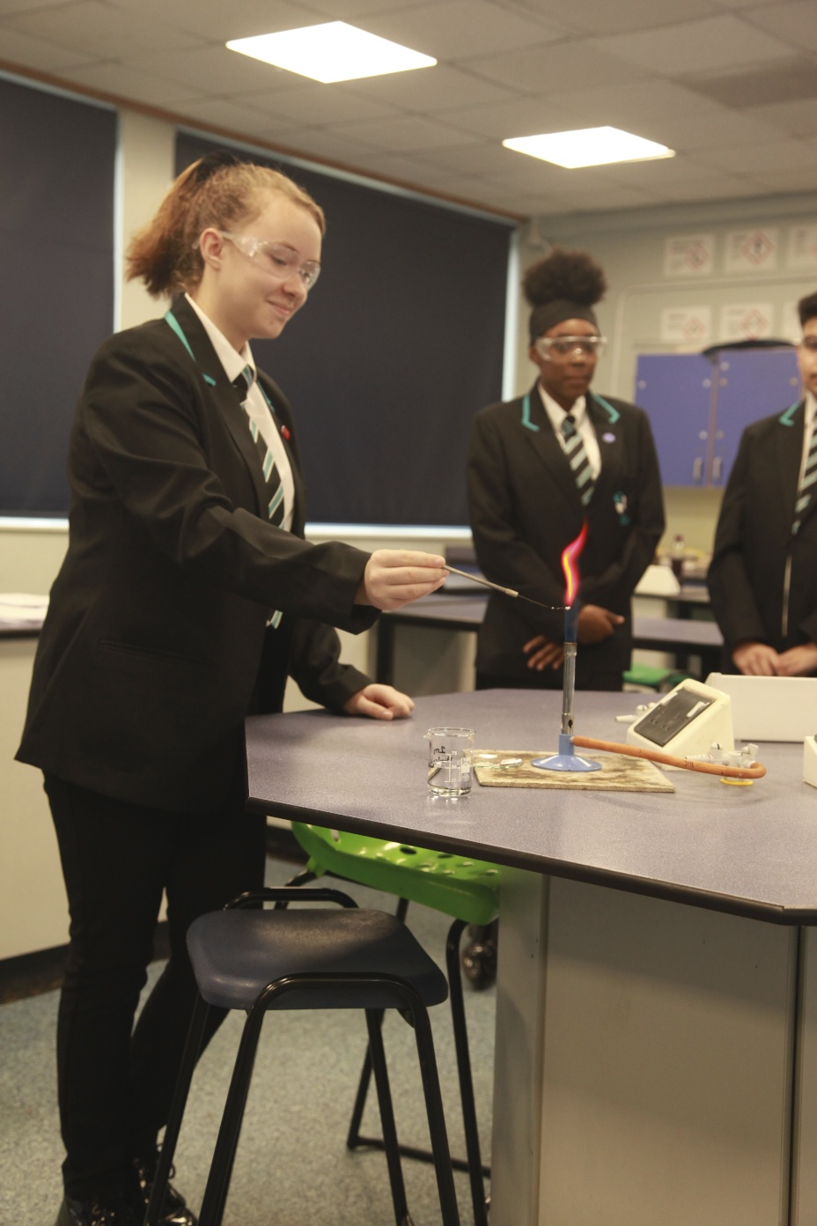
Our on-site facilities include:
Sports fields including 5-a-side football pitches;
Multi-Use Games Area marked up for netball and football;
Astro Turf perfect for football;
Dance studio complete with sound system and mirrored wall;
Hall complete with a stage;
Interactive whiteboards in classrooms;
Modern and open-plan library with wide range of reading materials

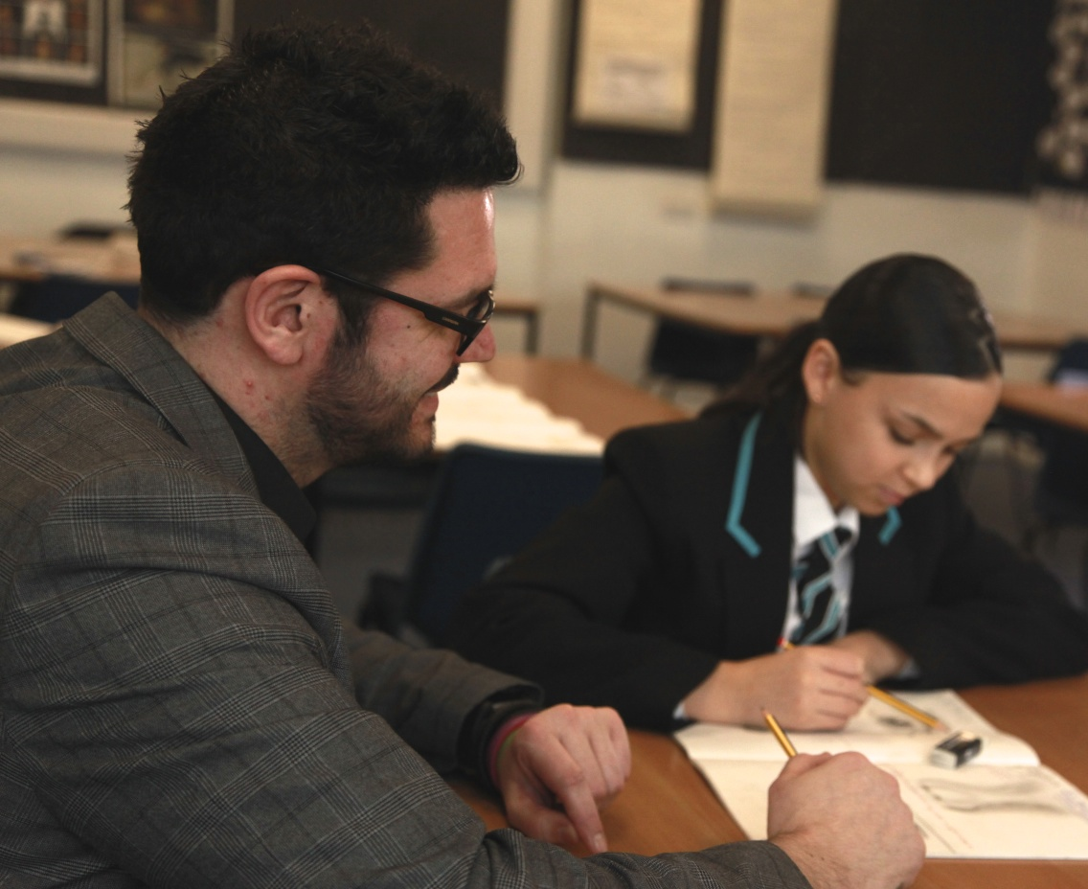

SUPPORT
FOR OUR
STAFF

We are committed to providing our academy leaders with the
highest quality support and challenge to ensure that their schools
excel and give our students the education they deserve.
Our Principals and Headteachers have a good deal of autonomy as
school leaders within a framework developed collaboratively with our
Director of Education and our Director of Standards and Primary Education.
Each of the Creative Education Trust’s schools benefits from a comprehensive programme of support and challenge, including working with former HMIs.
Creative Education Trust places a strong emphasis on CPD for teachers and for senior and middle leaders. We run a regular programme of training events to improve teaching performance and also provide focused management development and one-to-one coaching opportunities. We have an active cross-trust group on the Teaching Leaders programme and use Future Leaders and Teach First extensively.
We believe it is very important that each of our academies plans in such a way that financial and human resources are deployed to support their educational strategies fully. This is supported by our experienced Head Office team, who are available to advise on financial planning, audit, HR, legal and property matters either directly or by referral to our professional advisors.
Each of our Headteacher is a member of the Headteachers’ Forum that meets regularly to help Creative Education Trust develop its ethos and strategy, and to share their professional expertise. As the network of Creative Education Trust schools grows, this forum has increasing value as a means of professional development and problem solving.
There are also a number of cross-group, phase leader and year-specific forums.
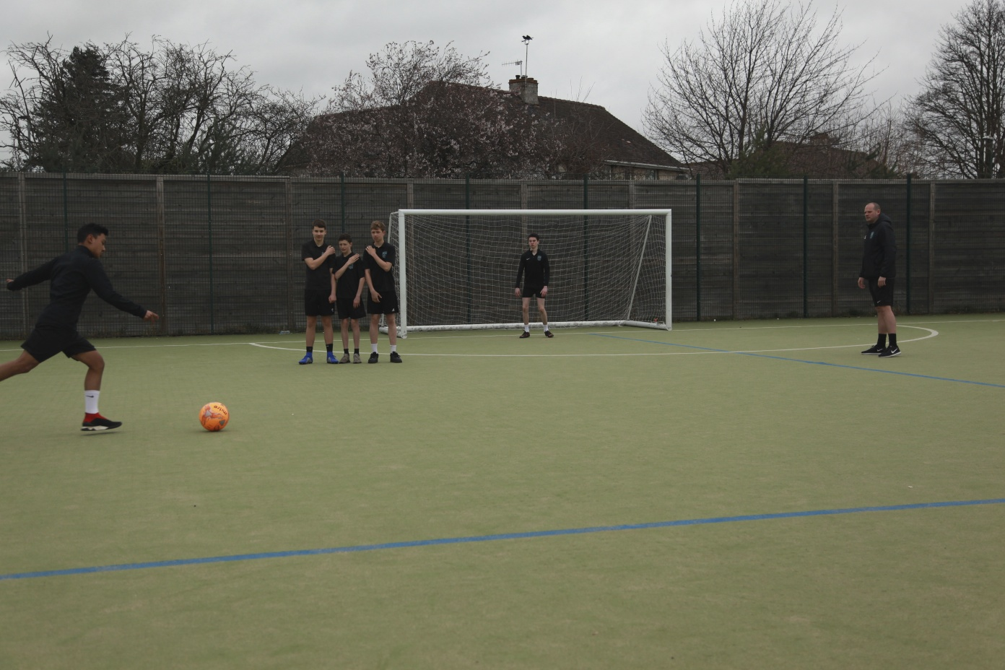
Teacher of Design & Technology
JOB DESCRIPTION

LOCATION
Ellis Guilford School, Nottingham

SALARY
MPS or UPS scale dependent upon experience

PURPOSE AND SCOPE

- To teach exceptional KS4 Design and Technology lessons that engage and challenge all students, whilst creating a supportive and stimulating learning environment in the classroom. To make a significant contribution to the values and the ethos of the school and actively promote and uphold all school policies.

TEACHING AND LEARNING

- With direction from the Director of Faculty and within the context of the school’s curriculum and schemes of work, plan and prepare effective lessons.
- Teach engaging and effective lessons that motivate, inspire, and improve pupil attainment.
- Ensure students acquire and consolidate knowledge, skills and understanding appropriate to the subject taught.
- Ensure that all students achieve the least at chronological age or level or, if well below level, make significant and continuing progress towards achieving at chronological age level.
- Direct and supervise support staff assigned to lessons and when required participate in related recruitment and selection activities.

ASSESSMENT AND REPORTING

- To lead, monitor and evaluate the assessment and feedback to students in line with whole school and department policy.
- To follow department monitoring and tracking systems relating to student’s attainment, progress, and achievement.
- Mark, grade and give written/verbal and diagnostic feedback as required.
- Undertake assessment of students as requested by external examination bodies, curriculum areas and school procedures.
- Assess, record and report on the attendance, progress, development, and attainment of students and to keep such records as are required.

- To follow department policy regarding department tracking of student progress and use information to inform teaching and learning.

SCHOOL CULTURE

- Support the academy’s values and ethos by actively promoting and contributing to the development and implementation of policies, practices, and procedures.
- Help create a strong academy community, characterised by consistent, orderly behaviour and caring, respectful relationships.
- To be active in issues of student welfare and support.
- Support and work in collaboration with colleagues and other professionals in and beyond the school.

COMMUNICATION

- To communicate effectively and constructively with the parents of pupils as appropriate.
- Where appropriate, to communicate and cooperate with persons or bodies outside the school.
- To follow agreed policies for communications in the school.
- To take an active role in activities such as Open Evenings, Parents’ Evenings, Sports days etc

PASTORAL DUTIES

- If required, be a form tutor to an assigned group of students.
- Promote the general progress and well-being of individual students and of the form tutor group as a whole.
- Liaise with the pastoral team to ensure the implementation of the school’s pastoral system.
- Register students, accompany them to assemblies, encourage their full attendance at all lessons and their participation in other aspects of school life.
- Contribute to the preparation of action plans and progress files and other reports.
- Alert appropriate staff to problems experienced by students.

OTHER PROFESSIONAL REQUIREMENTS

- Have a working and up to date knowledge of teachers' professional duties and legal liabilities.
- Operate at all times within the stated policies and practices of the school, including but not limited to, Health and Safety; Child protection; Assessment and marking policies; and Behaviour policies.
- Establish effective working relationships and be an effective role model to pupils through own personal presentation as well as personal and professional conduct.
- Have high expectations for every pupil and endeavour the opportunity to reach their potential and meet high expectations.
- Co-operate with other staff to ensure a sharing and effective usage of resources to the benefit of the school, department, and students.
- Contribute to wider school life through effective participation in meetings and management systems necessary to coordinate the management of the school.
- Work as a team member and identify opportunities for working with colleagues and sharing the development of effective practice with them.
- Undertake other various responsibilities as directed by the Head of Department or Principal.

This job description is not necessarily a comprehensive definition of the post. It will be reviewed at least once a year and it may be subject to modification or amendment at any time after consultation with the holder of the post. The duties may be varied to meet the changing demands of the school at the reasonable discretion of the Headteacher

 | ESSENTIAL | DESIRABLE
QUALIFICATIONS | - Qualified teacher status  - Degree in relevant subject  - Recent and relevant CPD
EXPERIENCE | - Experience of raising attainment in a challenging classroom environment.  - Experience of reflecting on and improving teaching practice to increase student achievement.  - Evidence of continually improving the teaching and learning of their subject through schemes of work and medium- term plans. | - Successful teaching experience in the Secondary phase  - Experience of raising standards through leading staff development  - Design or Industry experience.  - Experience of developing school’s links with other Design and Technology departments and/or design industry organisations to develop curriculum opportunities.  - Leading extracurricular STEM activities.
KNOWLEDGE AND  UNDERSTANDING | - Thorough and up to date knowledge of KS4 Design and Technology or Vocational Design courses, offering a specialist in at least 1 material area.  - Knowledge and flexibility to teach and deliver two KS3 subject areas in Design and Technology, such as Textiles, Resistant Materials, Food or Graphics.  - Good knowledge of KS3 Design and Technology and Food Programmes of Study.  - Understanding of the strategies needed to establish consistently high aspirations to raise attainment.  - Understanding of the strategies required to motivate learners and inspire their curiosity of learning in Design and Technology. | - Knowledge of vocational courses.  - Health and Safety Certification for Machines and Hand Tools.  - Evidence of raising the achievement of groups of students.  - Ability to analyse and interpret data effectively and act upon the information.  - Knowledge of how to implement inclusive education.  - Knowledge of curriculum requirements and developments and educational initiatives, including ICT.  - Recent and relevant in-service training, including assessment for learning, planning for progress, and marking and assessment opportunities.
SKILLS AND  PERSONAL  ATTRIBUTES | - Excellent classroom teacher with the ability to reflect on lessons and continually improve their own practice.  - Effective behaviour management, with clear boundaries, sanctions, praise, and rewards.  - Thinks strategically about classroom tailoring lessons to student’s needs.  - Understand and interprets complex student data to drive lesson planning and student attainment.  - Good communication, planning, and organisational skills.  - Demonstrates resilience, motivation, and commitment to driving up standards of achievement.  - Acts as a role model to staff and students.  - Commitment to regular and on-going professional development and training to establish outstanding classroom practice  - Vision aligned with Creative Education Trust’s high aspirations and high expectations of self and others  - Effective team worker and leader  - High expectations for accountability and consistency  - Genuine passion and a belief in the potential of every student  - Motivation to continually improve standards and achieve excellence  - Effective listening skills that lead to a strong understanding of others.  - Relishes accountability and takes personal responsibility for their own actions  - Excellent critical thinking skills has intellectual curiosity and rigour.  - Proven ability to be able to build trust and mutual respect between pupils, families, and staff  - Strong interpersonal, written, and oral communication skills.  - Ability to demonstrate sound balanced judgement with decisiveness, flexibility, and integrity.  - Commitment to academic and personal excellence.
EQUAL  OPPORTUNITIES | - A demonstrable commitment to supporting and promoting safeguarding, student welfare, equality, and diversity  - Commitment to and belief in equal opportunities and to equally value all students.
SAFEGUARDING | - A thorough understanding of up-to-date safeguarding requirements and best practice.  - Committed to the highest standards for child protection.
OTHER  REQUIREMENTS | - High expectations for every pupil and a proven track record of making a difference to the learning and experiences of pupils inside and outside the classroom.  - Commitment to and vision for developing links with the local community.

