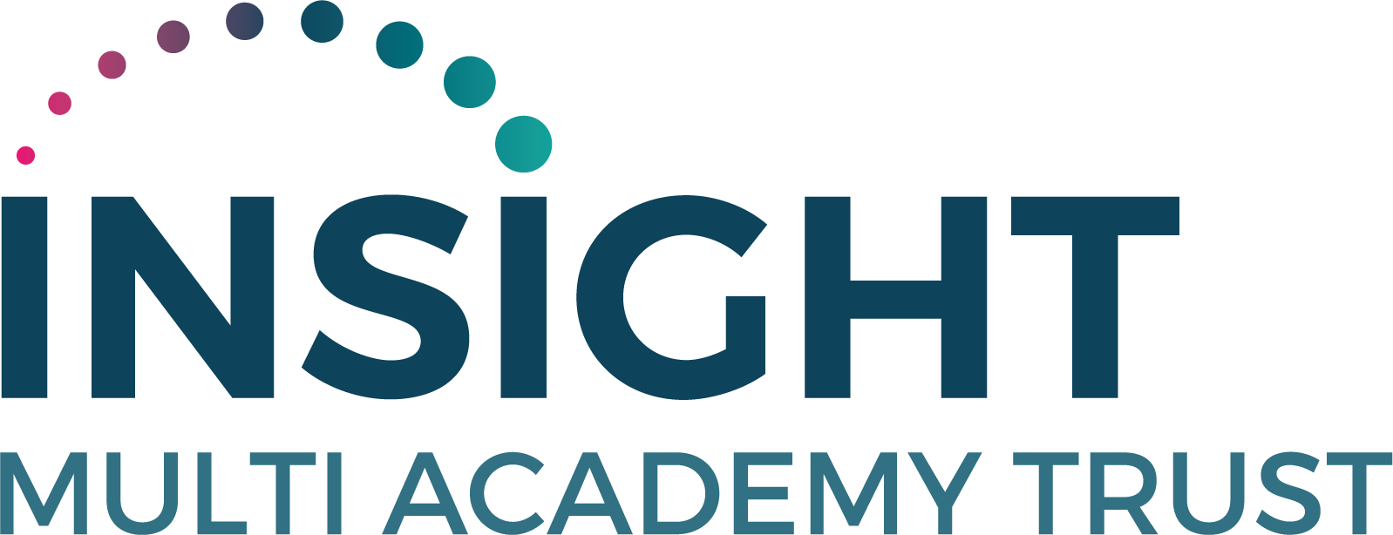

Recruitment Monitoring Form Strictly Confidential

Sir Graham Balfour Multi-Academy Trust is committed to ensuring that job applicants are treated fairly and consistently and that no one is disadvantaged or discriminated against.

Information collected via recruitment monitoring helps the Trust fulfil this commitment and assists greatly in the development and evaluation of employment policy.

Information you provide will be treated in strict confidence and will not be seen by anyone involved in the selection process.

Person/Role Details
Full Name
Job Title
Location/Establishment
Equal Opportunities
As part of our equal opportunities policy, we request that you complete the following information. This information is for monitoring purposes only. All information will be treated as confidential and will not be used when short-listing or deciding on whether an applicant is successful or unsuccessful in obtaining employment. The information you provide will help us to ensure that our recruitment procedures are fair by allowing us to identify and eliminate potential areas of discrimination.
Please indicate your ethnic origin:
Asian or Asian British – Bangladeshi |  |  |  | Asian or Asian British – Chinese
Asian or Asian British – Indian |  |  |  | Asian or Asian British – Other
Asian or Asian British – Pakistani |  |  |  | Black or Black British – African
Black or Black British – Caribbean |  |  |  | Black or Black British – Other
Mixed – Other |  |  |  | Mixed Ethnic Group – White & Asian
Mixed Ethnic – White & Black African |  |  |  | Mixed Ethnic – White & Black Caribbean
Other Ethnic Origin - Arab |  |  |  | Prefer not to say
White – Welsh/English/Scottish/N.Ireland |  |  |  | White – Irish
White – Other |  |  |  | White – Gypsy/Irish Traveller
Other ethnic group: (Please state)
Please indicate your Religion/Belief:
Buddhist |  |  |  |  | Christian
Hindu |  |  |  |  | Jewish
Muslim |  |  |  |  | None
Sikh |  |  |  |  | Prefer not to say
Other religion or belief: (Please state)

Please indicate your relevant Age Range:
16 – 17 |  | 18 – 24
25 – 29 |  | 30 – 39
40 – 49 |  | 50 – 59
60 – 64 |  | 65+
Prefer not to say

Please indicate your Sexual Orientation:
Bisexual |  | Gay
Heterosexual |  | Lesbian
Asexual |  | Prefer not to say

Please indicate your gender:
Female |  | Male
Intersex |  | Non-binary
Prefer not to say
Is the gender you identify with the same as your gender registered at birth?
Yes |  | No
Prefer not to say

Disability

The Disability Discrimination Act (2010) defines a disabled person as someone with a ‘physical or mental impairment which has substantial and long-term adverse effect on his/her ability to carry out normal day to day activities’.

Do you consider yourself to have a disability or health condition?

Yes |  | No
Prefer not to say
What is the effect or impact of your disability or health condition on your work? Please write in here:

The information in this form is for monitoring purposes only. If you believe you need a ‘reasonable adjustment’, then please discuss this with your manager, or the manager running the recruitment process if you are a job applicant.

