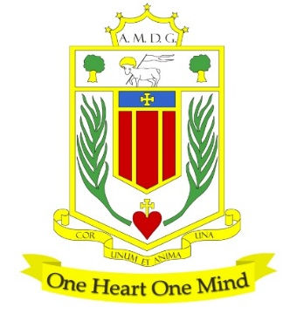
BROUGHTON HALL CATHOLIC HIGH SCHOOL
Yew Tree Lane

Liverpool, L12 9HJ

Telephone 0151 541 9440 / Fax 0151 259 8448
Email: smithg@broughtonhall.com
Head Teacher: Mr G Preston B.A. (Hons), NPQH, PGCE

TEACHER OF FOOD TECHNOLOGY MPS/UPS

START DATE: 1st September 2024
CONTRACT: Permanent
HOURS: Full-time
CLOSING DATE: 1st May 2024

The Governors wish to appoint a first rate, enthusiastic Teacher of Food Technology with the ability to teach across the full age and ability range. If you are hardworking, highly motivated, have a passion for your specialism and have the ability to inspire our pupils and staff then we would love to hear from you.

The Design Technology Department offers qualifications at KS4 and at KS5, including Hospitality & Catering, Food, Photography, Art, and Textiles. Uptake and results are above national. The department is equipped with ten large, well equipped classrooms and is well-resourced. Food is a popular option at KS4.

The successful candidate will be:
- An outstanding classroom practitioner
- Have a proven track record of delivery
- Someone who is passionate about their subject and has the ability to inspire a love of learning
- Committed to the school’s vision and demonstrating compassion through the mission statement
- Dedicated in ensuring students achieve the best outcomes

This post is suitable for ECT/NQT’s.

About Broughton Hall Catholic High School
Broughton Hall is a Catholic High School is an Ofsted rated Good provider (2022). We are proud of our strong Catholic ethos and values. The school has an excellent reputation and promotes an inclusive education which develops creativity, confidence and independence. The school is committed to the continuous professional development of all staff including Aspiring Leaders, NPQML and NPQSL programmes.

The Trustees are the Sisters of Mercy

Application is by way of the school’s Application Form. Please email your application to: smithg@broughtonhall.com

Interviews: To take place as soon as possible after the closing date.

Broughton Hall Catholic High School is committed to safeguarding and promoting the welfare of children and we expect all staff and volunteers to share this commitment to keeping children safe. Any offer of employment will be subject to statutory pre-employment checks including satisfactory references and Enhanced DBS and Barred List checks. This post is exempt from the provisions of the Rehabilitation of Offenders Act 1974 (as amended in 2013 & 2020) and shortlisted candidates will be required to disclose any relevant criminal history prior to interview.
By engaging in this recruitment process, shortlisted candidates consent to an online search in line with the Keeping Children Safe in Education Statutory Guidance.

