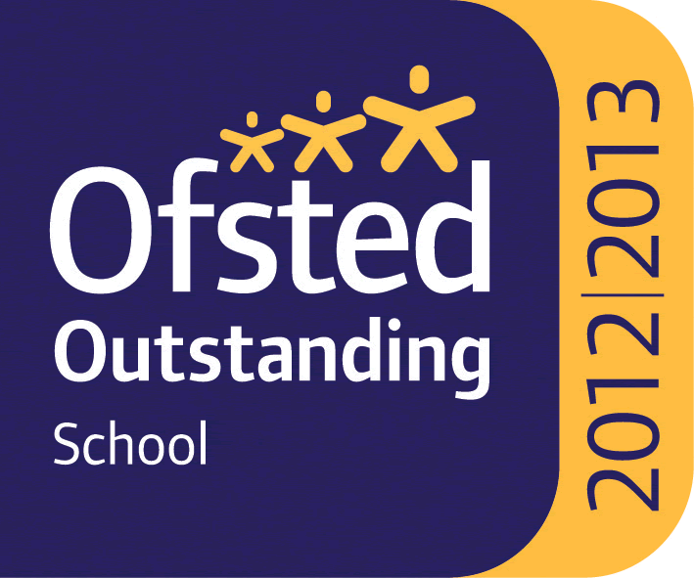

WHITLEY BAY HIGH SCHOOL
13-18 Mixed Comprehensive; NOR 1702 (590 in Sixth Form)

Deneholm, Whitley Bay, Tyne and Wear, NE25 9AS
Headteacher: STEVE WILSON

Outstanding – OFSTED May 2013
National Teaching School

TEACHER OF FOOD TECHNOLOGY/TEXTILES
One Year Fixed Term until 31st August 2022 (in the first instance)

We require for September 2021 a teacher of Food Technology/Textiles to join this very successful and supportive department. Ideally we would initially hope to recruit someone who can confidently teach Food at KS3, KS4 and potentially KS5. The ability to offer Textiles at KS3 and KS4 would be advantageous. However, given the size of the department and range of subjects we teach, including Health and Social Care and Child Development, there may be some degree of flexibility to vary this.

The school is heavily oversubscribed, achieves very high standards and has benefited from substantial investment to improve facilities over recent years.

All staff who join the school benefit from a carefully structured programme of training and support. Any applicant should be committed to making a significant contribution to the wider life of the school.

Please find the job description, application form, application details and school information on the school website ‘Vacancies’ section at: www.whitleybayhighschool.org

Completed applications and a letter (800 words maximum) explaining why your experiences to date have prepared you for this role at Whitley Bay High School, should be sent to jackie.patterson@whitleybayhighschool.org before the closing date below.

Closing date for applications is Friday 21st May 2021 at 10.00am.

We are committed to safeguarding and promoting the welfare of children and expect all staff to respect this commitment. This post is subject to an enhanced DBS check.

