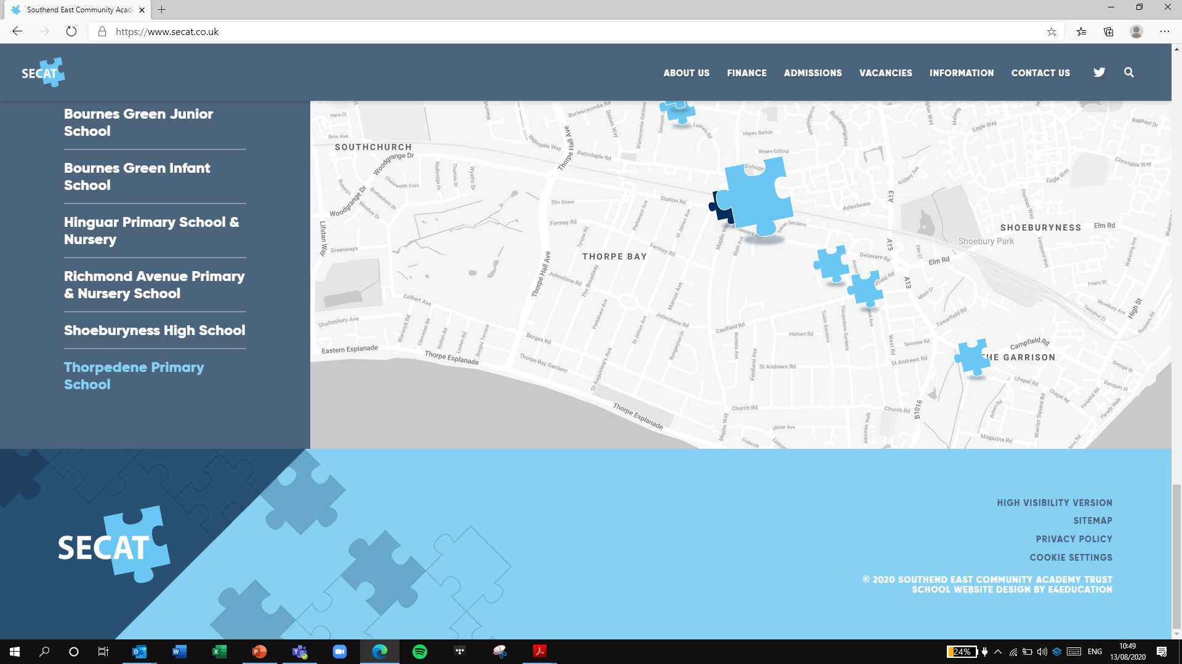

*Building Strong schools*

*Building Strong partnerships*

*Building Strong communities*

**SOUTHEND EAST COMMUNITY ACADEMY TRUST**

# **Recruitment monitoring information**

**Position applying for**:

**Full name (including title):**

We are committed to ensuring that applicants are selected on the basis of their skills/attributes relevant to the role. In accordance with our policy on equal opportunities in employment, we provide equal opportunities to any employee or applicant and will not discriminate either directly or indirectly because of race, sex, sexual orientation, transgender status, religion or belief, martial or civil partnership status, age, disability or pregnancy and maternity. In order to monitor how successful this policy is we monitor all job applications. This information will help us to ensure that our policies and procedures are effective in avoiding discrimination and promoting equal opportunities in recruitment.

All information will be treated in strict confidence and will not be seen by the shortlisting panel. The information provided on this form will be stored separately from your application form and only used to provide statistics for monitoring purposes. If you do not wish to answer any of the questions you can select the “prefer not to say” option.

## Age

0-29  30-50  50+  Prefer not to say

## Gender

Male  Female  Transgender  Prefer not to say

## Marital status

Married (opposite sex)  Married (same sex)  Single  Civil partner

Other Click here to enter text. Prefer not to say

## Sexual orientation

Bisexual  Gay man  Gay woman/lesbian  Heterosexual

Other  Prefer not to say

## Ethnic origin

I would describe myself as (choose ONE section from A to E, and then tick the appropriate box to indicate your cultural background):

1. **White**

British  English  Welsh  Scottish  Irish

Other Click here to enter text.

1. **Mixed**

White and Black Caribbean  White and Black African

White and Asian  Other Click here to enter text.

1. **Asian, Asian British, Asian Black, Asian Scottish or Asian Welsh**

Indian  Pakistani  Bangladeshi  Other Click here to enter text.

1. **Black, Black British, Black English, Black Scottish, or Black Welsh**

Caribbean  African  Other Click here to enter text.

1. **Chinese, Chinese British, Chinese English, Chinese Scottish, Chinese Welsh or other ethnic group**

Chinese  Other Click here to enter text.

**Prefer not to say**

## Disability

Before ticking the appropriate box below please read the definition of disability.

The definition of disability, as outlined in the Equality Act 2010, is a follows: “a physical or mental impairment which has a substantial and long-term adverse effect on a person’s ability to carry out normal day-to-day activities”.

To be protected under the Act:

* An individual must have an impairment which can be physical or mental.
* It has to be substantial, that is something more than minor or trivial.
* It needs to be a long term i.e., the impairment has lasted or is likely to last in total for at least twelve months or more, or is likely to last for the rest of the lift of the person affected (long term included conditions which fluctuate or may recur such as cancer, HIV/AIDS and multiple sclerosis) **and**
* It must affect their day-to-day activities on a regular basis (day-to-day activities includes things such as reading, lifting, and carrying objects, personal care, shopping, meeting, and communicating with people. The effect of your impairment on everyday activities is considered as it would be without medication or aids. The only exception is eyesight which should be judged when an individual is wearing their usual lenses or spectacles).

Yes  No  Prefer not to say

## Data Protection Act

I hereby give consent for the anonymised data provided on this form to be collated and held in a secure file. The anonymised data will be securely destroyed once monitoring has been completed, but within 4 weeks.

The data will only be shared with the relevant school Governors/Trustees for the purposes of fulfilling any statutory duties or as required by law.

Signed: Click here to enter text.

Date: Click here to enter a date.