Teacher of French & Spanish (Maternity Cover - 1 Year)

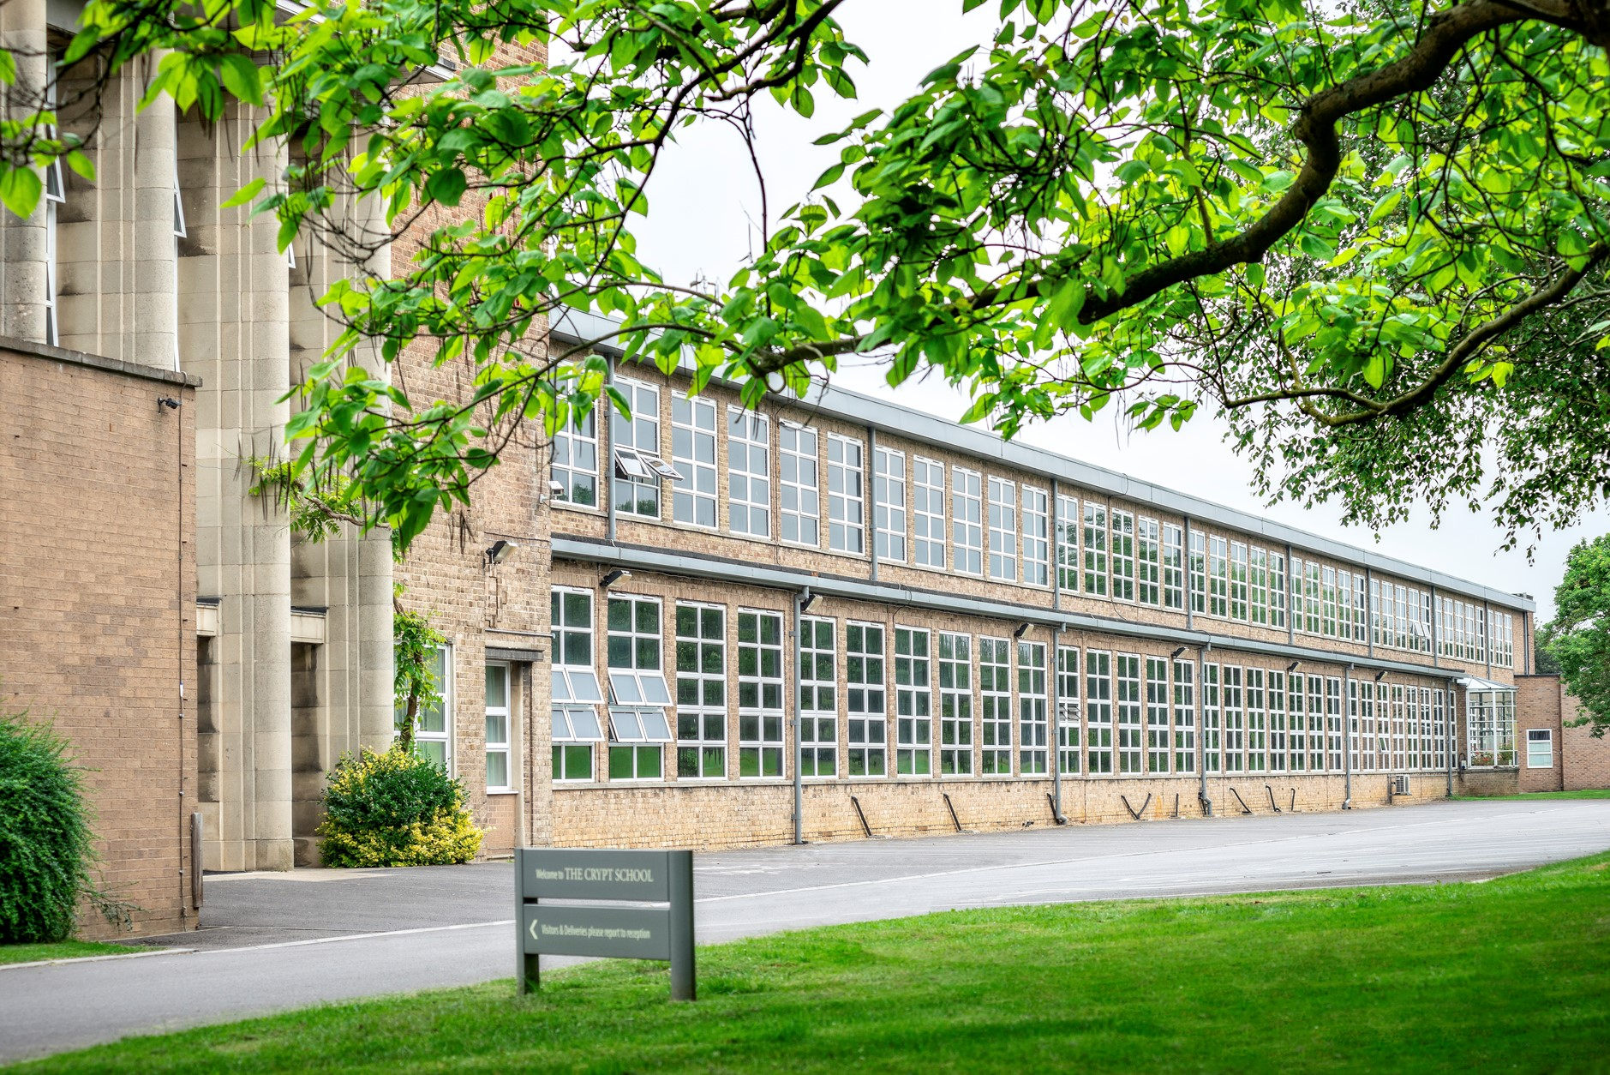

If you would like any further information on the role, please contact Sharon Bailey, HR Administration on sbailey@crypt.gloucs.sch.uk or T: 01452 530291.

The closing date for applications: Noon, Wednesday 24th February 2021

Interview date: Term 4, exact date to be confirmed

Due to the current global situation interviews may take place remotely, if necessary; however, that remote interview will try to replicate as far as possible what would have occurred if candidates had been in school.

If you are invited into school, we have covid-19 procedures in place, temperature checks, hand sanitiser, one way system, social distancing and wearing of a face mask in all communal areas.

The Crypt School is committed to safeguarding and promoting the welfare of children and young people in its recruitment and selection of job applicants and expects all staff to share this commitment.

The successful candidate will be required to undergo an enhanced DBS check.

Message from the Headmaster – Mr. Nicholas Dyer

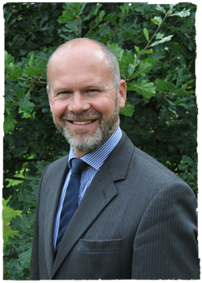
I am delighted that you are considering a role here at The Crypt School. I hope that you find this information helpful and we look forward to receiving your application.

The School is located just outside of the City of Gloucester in the West of England. Gloucester is known for its 11th century Cathedral and close; for Blackfriars, which is a stunning example of a 13th century medieval priory site; the British Waterways Museum, which celebrates the city’s industrial past, and now the vibrant Gloucester Quays, which has a selection of shops and restaurants. Gloucester is a vibrant and growing city, and the School is conveniently located close to the City, and close to good road and rail links to Cheltenham and the surrounding region, including Bristol for example.

Founded in 1539, The Crypt School’s vision is derived from its Latin motto “Floreat Schola Cryptiensis”: floreat means “to flourish” and at The Crypt we wish all our pupils and our young adults in the sixth form, as well as our staff, to flourish in all that they do both in school and in their later adult lives.

We are a vibrant co-educational selective school, a place where learning is valued for its own sake within an environment of strong pastoral care. At the centre of our school life, is a powerful sense of community, where pupils are supported and encouraged to learn and engage with each other. Confident, friendly and respectful, the high quality of our pupils’ personal development is remarkable and is one of the greatest strengths of the School.

We recognise the time and thought that goes into an application and we will certainly give yours our serious consideration.

If you have any further questions or wish to visit the School prior to sending in an application, please contact Sharon Bailey via sbailey@crypt.gloucs.sch.uk who will be able to assist you.

With best wishes
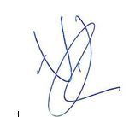
Nicholas Dyer

The Appointment

A well-qualified teacher of MFL, with the ability to teach French to KS5 and Spanish to at least KS4, is required, with the ability and enthusiasm to teach across the age range. This post is a one-year maternity contract, which could potentially have the scope for extension. However, the successful candidate will be fully supported in their role, able to access the School’s CPD programme, and if applicable, the School’s NQT/RQT training programmes. The successful applicant will be expected to be able to teach pupils using our remote learning platform (Google Classroom and Meets) that the School has been successfully using and which ensures the continuity of learning for pupils who are self-isolating at home for example. Training will be given.

In September 2018, the School became fully co-educational in its intake and most of its year groups are now co-educational; however, we must continue to work hard to ensure we meet the academic, pastoral, and wider needs of all the young people within school. The appointee will have the scope to contribute to the wider academic and intellectual development of the School as a whole.

All pupils study German or French in KS3; they then also study Spanish as a second language in Year 9. Schemes of work have been written with the expectation that our pupils will reach grade 4/5 by the end of Year 9. The department has invested heavily in new KS3 teaching materials that reflect the assessment criteria at GCSE. Key to the development of MFL at The Crypt will be the implementation of the “Assessment for Learning” ethos at all levels. Pupils have a choice of languages at KS4 and one of our aims is to encourage as many pupils as possible to study at least one, if not two, full-course languages at GCSE. Currently French, German and Spanish are offered at A Level.

Older pupils also enjoy access to two Foreign Language Assistants and our focus here is on the effective use of these native speakers in helping pupils to gain confidence and enjoyment in language learning.

The department firmly believes in the importance of extra-curricular activities to enrich the provision of MFL at all levels. The department has implemented a range of cultural trips across the key stages and is now looking to initiate exchange programmes. In addition to visits abroad, the department has begun to build up a calendar of cultural events, activities and competitions to motivate and encourage pupils on a day-to-day basis. These take place mainly in lesson time and are further celebrated through cross-curricular citizenship work, displays in the entrance hall and in the school newsletter. All these things will motivate pupils and contribute to the raising of standards through use of the target language and a deeper understanding of the country, its culture and ethos.

The department has also developed an ambitious and varied new programme of study to best prepare students for exam success and the effective use of languages in post-school life. This means that at KS3, the lessons will have already been planned and resourced for you.

The courses followed in different year groups from September are as follows:

Year 7: French – Allez 1 German – Stimmt 1

Year 8: French – Allez 1 & 2 German – Stimmt 2
Year 9: French, German & Spanish – Allez 2 & Stimmt 2
Year 10: French & German – AQA Oxford Kerboodle
Year 11: French & German – AQA Oxford Kerboodle
Year 12: French & German - Hodder A-Level Course
Year 13: German & Spanish - Hodder A-Level Course

The department has three language classrooms situated together; all have interactive whiteboards. All members of staff are given their own laptop and iPad as part of the School’s ICT initiative. Teaching through the medium of ICT is an integral part of the department’s approach to language learning.

Job Description
Teacher of French & Spanish
(Maternity Cover – 1 Year)

Name
Post | Teacher of French & Spanish (Maternity Cover – 1 Year)
Scale | MPS
Relationships | The postholder is responsible to the Head of Department
Purpose | The role of the subject teacher is to provide learning opportunities to which all students can respond with enthusiasm and commitment
Duties and responsibilities | Your duties and responsibilities are contained in the “School Teachers Pay and Conditions Document.

Guidelines for the post of Subject Teacher

- under the guidance of the Head of Department, the subject teacher ensures curriculum coverage, continuity and progression in the subject for all students;
- is responsible for the development of subject specific schemes of work in French and/or Spanish;
- plans lessons with clear objectives for learning outcomes, understands and follows the sequence of teaching and learning in the subject, and effectively communicates such information to students;
- uses appropriate teaching and learning methods to meet the needs of the subject and of different students;
- ensures that there are opportunities for effective development of students’ literacy, numeracy and information communication technology skills through the subject;
- uses the school and departmental policies and practices for assessing, recording and reporting on students’ achievement, and uses this information to recognise achievement and to assist students in setting targets for further development;
- ensures that information about students’ achievement in previous classes and schools is used effectively to secure good progress in the subject;
- sets expectations and establishes clear targets for students’ achievement, and evaluates progress and achievement in the subject by all students;
- ensures that there are opportunities for the effective development of students’ individual and collaborative study skills necessary for them to become increasingly independent in their work and to complete tasks independently when out of school;
- is aware of the subject’s contribution to students’ understanding of the duties, opportunities, responsibilities and rights of citizens;

- establishes a partnership with parents to involve them in their child’s learning of the subject, as well as providing information about curriculum, attainment, progress and targets;
- ensures that there is a safe working and learning environment in which risks are properly assessed.
- responsible for the safeguarding and promoting the welfare of students

As a form tutor the subject teacher:

- plays a key role in supporting, guiding and motivating students;
- monitors academic progress and attendance;
- monitors students’ planners;
- liaises with the Head of Year / Head of Key Stage;
- embodies the vision for the school

We are committed to safeguarding and promoting the welfare of children and young people and expect all staff and volunteers to share this commitment. This post will be subject to an enhanced DBS disclosure. The Crypt School values the diversity of our workforce and welcomes applications from all sectors of the community.

Please read our Safeguarding Policy and Recruitment, Selection and Disclosure Policy and Procedure which can be found on our school website by clicking on the link below.

https://www.cryptschool.org/parents/parents-hub/policies-forms

The Crypt School
January 2021

