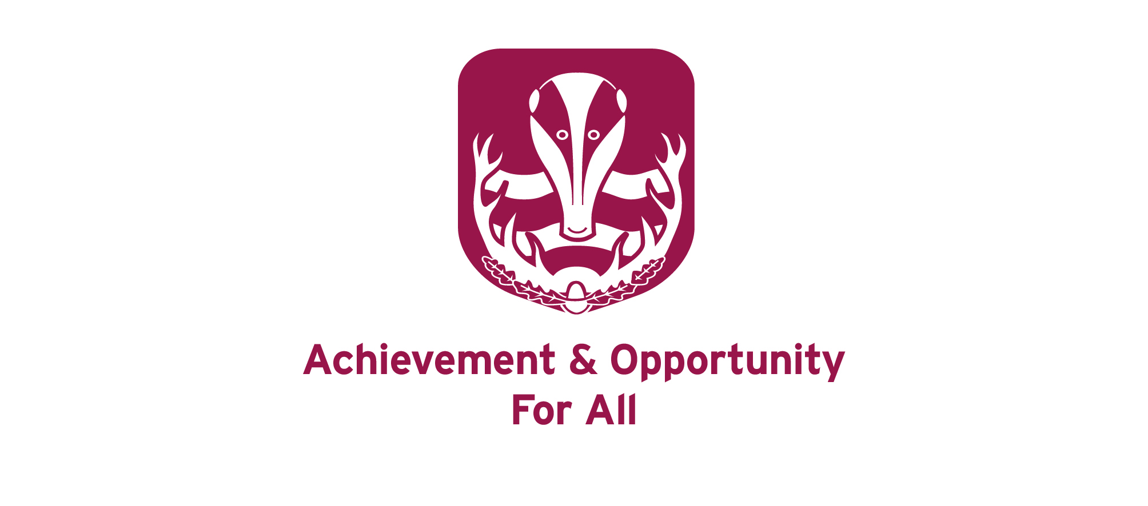

MODERN FOREIGN LANGUAGES DEPARTMENT

The Staff

We are an enthusiastic and forward-looking department in an outstanding and oversubscribed school. There are six full-time and one part-time language teachers teaching French, Italian and German. The Head of Languages works closely with the Head of French and Head of German. An Italian Assistant provides support, working six hours per week.

Accommodation

In spring 2021, we moved into our new school and the department has eight teaching rooms, each equipped with the latest digital screen.

Teaching

All students study French from Year 7 using Schemes of Work which incorporate resources from NCELP and Studio. From Year 8, three of the eight forms start German using the course book ‘Echo Express’ and NCELP resources and three start Italian using the course book ‘Tutti Insieme!’ and our own resources. This continues into Year 9. At present pupils are entered for the AQA GCSE in French, German and Italian and Edexcel at A-level. As part of our work with the National Centre for Excellence in Language Pedagogy we are currently helping to develop and deliver resources and we work closely with four local hub schools in our role as one of the nine Lead Schools in the country.

Results

At present 351 pupils take languages at GCSE and 16 at A-level.

Induction / Support

The school offers a fully supportive induction package to new and experienced teachers. ECTs meet regularly to discuss classes' progress and preparation for examinations and in addition ECTs receive support and guidance from a designated mentor member from the Senior Leadership Team.

The Languages Department offers excellent opportunities for career development. It is very supportive and meets regularly to discuss future plans, to divide responsibilities and share ideas and concerns. We are looking to appoint a teacher who would enjoy working as part of a team and would contribute fully to the department.

Letter of Application

In their letter of application, which should not exceed two sides of A4, candidates should, amongst other points, indicate their thoughts on what constitutes good teaching and learning in MFL.

FRENCH DEPARTMENT

Key Stage 3

All students start French in Year 7 using Schemes of Work which incorporate the full range of resources available to the modern language teacher: textbooks, Linguascope, and a wide range of online resources. All students have access to a digital textbook and online support exercises. There is a wide variety of materials available for use on the interactive whiteboards. There are detailed Schemes of Work for each year group offering advice and support for the teacher. There is also a detailed assessment scheme for each year group. There is a wide variety of French readers, magazines and films available in the school Library for pupils to read in school and at home. Year 9 students use the AQA Expo Foundation text book.

Key Stage 4

Most students continue to study a Modern Foreign Language with the possibility of continuing with two languages if they wish.

For Year 10 and 11 students we have a suite of Studio resources including online homework exercises. We have all the materials that accompany these books plus a wide variety of extra materials which we have developed ourselves. We aim to enter the majority of students for the Higher paper at GCSE. All GCSE students have access to the “This Is Language” website that has a wealth of engaging activities for independent learning.

Sixth Form

We follow Edexcel and students are provided with their own copy of the newly-published recommended textbook. These are supplemented with a wide variety of materials including DVDs and CDs and Grammar software.

Extra-Curricular

We see our programme of visits as an integral part of our work. Year 7 students are offered a residential trip to France and KS5 students have the opportunity of work experience abroad. Year 8 students participate in a one-day interactive French performance experience entitled ‘Les Trois Mousquetaires’

GERMAN DEPARTMENT

Key Stage 3
Two classes of pupils in Year 8 start German as a second language. The course book used is “Echo Express" and all the resources accompanying this course are available including flashcards, photocopiable copymasters and assessment material. There are also DVDs and other materials based on the course. There is a comprehensive scheme of work to help and advise the teacher.

Key Stage 4

In Years 10 and 11 we follow the AQA GCSE course. Pupils use “Echo” as their main text book. All the worksheets, CDs and teachers' books are available. All GCSE students have access to the “This Is Language” website that has a wealth of engaging activities for independent learning.

Sixth Form

We follow the EDEXCEL course at A-Level. Students use ‘Dynamic Learning’. There is also a range of other material available to supplement the text book. The department has topic files for oral topic preparation and staff also work closely with the school reference library.

Extra-Curricular

The German department organises an exchange with a “Gymnasium” in Schopfheim in the Black Forest for students from Years 9 to 13, with Year 12 and 13 students benefiting from work experience as part of their exchange visit.

ITALIAN DEPARTMENT

Key Stage 3

Currently, three classes in Year 8 and four classes in Year 9 are studying Italian as their second language. Pupils follow the Tutti Insieme course book in Year 8 and Amici in Year 9 and the department has all the available resources which accompany these courses: textbooks, teacher’s books, audio material and student workbooks. There is also a detailed assessment scheme for each year group.

Key Stage 4

Students continue to use the Amici course book. Again, the department has all the available resources to build on the work started in year 9: textbooks, teacher’s books, audio material and student workbooks.

In addition, at Key Stages 3, 4 and 5, teachers have created a wide variety of stimulating activities for use on the interactive whiteboard. These are available for all staff on the shared drive.

All classes also benefit from working with an Italian Language Assistant in small groups. This enables them to consolidate learning in class and practise their oral skills.

All GCSE students have access to the “This Is Language” website that has a wealth of engaging activities for independent learning.

Sixth Form

Students use a wide variety of authentic texts and multimedia resources to prepare for the Edexcel A Level exam. The department has a wealth of advanced level resources and detailed schemes of work and assessments. All students have individual or paired lessons with the Italian Language Assistant to develop their oral skills.

Extra-Curricular

The Italian department organises a study visit to Urbania for all students of Italian. The visit includes daily language lessons delivered by Italian teachers, cookery and ceramics sessions and a cultural visit to Perugia. Sixth Form students are also given the opportunity to complete a week’s work experience in Urbania.

