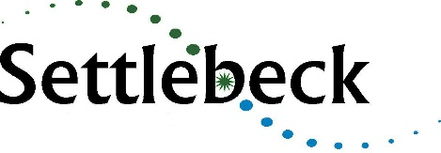

Post: Teacher of Art
Start Date: September 2021
Contract: 0.4 FTE permanent
Salary: MPS/UPS
Closing date: 9.00am, Friday 30th April 2021
NQTs Considered: Yes

Qualified Teacher of Art
Are you passionate about the truly transformative power of arts education?
Do you have excellent subject knowledge and the drive to inspire young people to love art?
If so, becoming a teacher at Settlebeck School is the job for you.
This is a rare and exciting opportunity for an NQT or experienced teacher to join a committed team of staff at our thriving, small and inclusive rural 11-16 academy.
Settlebeck School is situated in the beautiful market town of Sedbergh - which borders the Lake District and Yorkshire Dales National Park - and has been proudly serving its local community for the last 70 years. The school also benefits from wide-ranging links and partnerships within the Cumbrian educational community and particularly the South Lakes Federation, which is a long-established federation of 10 secondary schools, Kendal College and the University of Cumbria.
We have a truly comprehensive intake with 192 students, 11-16, currently on roll. As a strategically resourced provision for young people with autism, the successful candidate must be fully committed to inclusion. Visitors are always impressed by our family atmosphere, the warmth of relationships between staff and students and value for the individual.
Arts subjects are highly valued and have an important place on our curriculum, both at KS3 and KS4. We believe that studying the arts has a positive impact on every aspect of a child’s development. We seek the right candidate to inspire our students to develop their passion for art.
Applications from NQTs and experienced professionals are warmly welcomed. Applications should be emailed to office@settlebeck.org
Should you wish to discuss your application, please contact the Headteacher by email campbells@settlebeck.org
Settlebeck School is committed to safeguarding and promoting the welfare of young people and expects all staff to share this commitment. All applicants must be willing to undergo child protection screening appropriate to the post including an enhanced DBS check.

