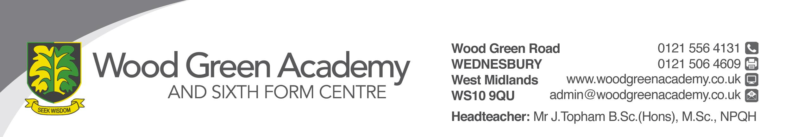
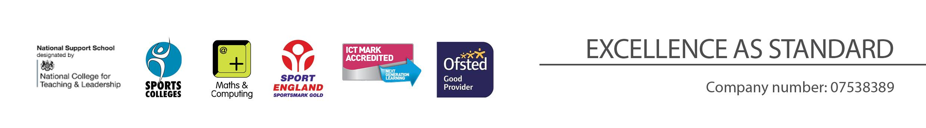

REQUIREMENT | ESSENTIAL | DESIRABLE
LEGAL REQUIREMENTS | Enhanced DBS Clearance
QUALIFICATIONS  Principally assessed through letter and application form | Completed DfE recognised teaching qualification (QTS)
EXPERIENCE and PROFESSIONAL COMPETENCE  Principally assessed through letter, application form | Currently teaching or teaching practice in a secondary school  Experience in the delivery of KS4 GCSE French curriculum  Wide range of learning and teaching skills  Effective lesson planning to meet the needs of all students  Effective classroom management  Ability to engage and motivate all students | Experience in the delivery of A Level French  Experience in the delivery of KS3 German
KNOWLEDGE  Principally assessed through letter and interview process | Up to date subject knowledge  Monitoring, assessment, target setting, recording and reporting of pupil progress | Knowledge of German  Current education initiatives  SEND  HP
COMMUNICATIONS  Principally assessed through letter and interview process | Have excellent written and verbal communication skills
PERSONAL ATTRIBUTES  Principally assessed through references, letter and interview process | To be committed to safeguarding and promoting the welfare of children and young people  Flexibility and willingness to be involved in the school  Committed to teaching and a willingness to continue to learn through professional development  High student expectations  Work effectively as a member of a team  Be an effective role model through presentation and personal conduct  Enthusiasm, energy, vigour, reliability, and integrity
Teacher of Modern Foreign Languages (FRENCH)
Person Specification

