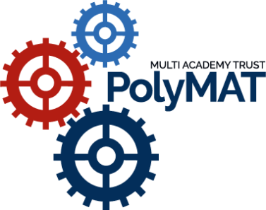

Teacher of French

January 2022 to June 2022

Closing Date: 29 October 2021
Interviews: Week Commencing 8 November 2021
Salary: QTS Pay Scale plus inner London Weighting
Contract: Full-time hours, fixed term contract to cover maternity leave
Start Date: January 2022

We are a small but expanding MAT, our vision is ‘success for everyone’. There are currently two schools in the Trust, Woolwich Polytechnic School for Boys, a highly successful all-inclusive boys’ school with a co-educational offer at Post 16, and the newly built Woolwich Polytechnic School for Girls, that is already making huge strides in the education arena. The schools pride themselves on a culture of high standards from staff and pupils. They are demanding yet rewarding schools where students and staff feel valued and supported.
Woolwich Polytechnic School for Girls are looking to appoint an exceptional teacher of French with a dynamic and inspirational approach to teaching, an individual that will become an integral part of the department, who will support the department in achieving its ambitious targets and goals. We would like a teacher who believes in collaboration both for students and when working with colleagues. The ideal candidate will be expected to contribute to extra-curricular activities within the department as well as the pastoral life of the school.

The ideal candidate is:
- passionate about teaching languages and can inspire students’ language learning
- fluent in French and can teach up to or beyond KS4
- organised, proactive and creative
- uses research informed approaches
- welcomes a culture of feedback and continual professional progression
- collaborative in the planning and delivery of lessons
As a member of staff at Woolwich Polytechnic School for Girls we can offer you:
· Opportunities for career progression
· Excellent professional development
· A contributory pension scheme
· Opportunities to collaborate with outstanding and dynamic teaching professionals
· Access to various discounts for a small monthly fee
· An employee assistance programme
· Season ticket loans
· Finders fees for personal introductions of staff that we employ
· Excellent catering facilities
· Secure on-site parking
PolyMAT is committed to safeguarding and promoting the welfare of children and young people and expects all trustees, staff and volunteers to share this commitment. All successful candidates will be subject to an Enhanced Criminal Record Disclosure from the Disclosure and Barring Service, along with other relevant employment checks, including overseas criminal background checks, where applicable. All new trustees, employees and volunteers will be required to undertake safeguarding training on induction, which will be regularly updated in line with statutory guidance.
The school is also committed to promoting equality, challenging discrimination and developing community cohesion. We welcome applications from all sections of the community.
Suitable candidates will be interviewed promptly upon receipt of application. The closing date will be brought forward in the event that the post is filled.
For further information, a confidential discussion or any other queries please contact Ms Ann Cherry, PolyMAT HR Manager at acherry@polymat.co.uk

