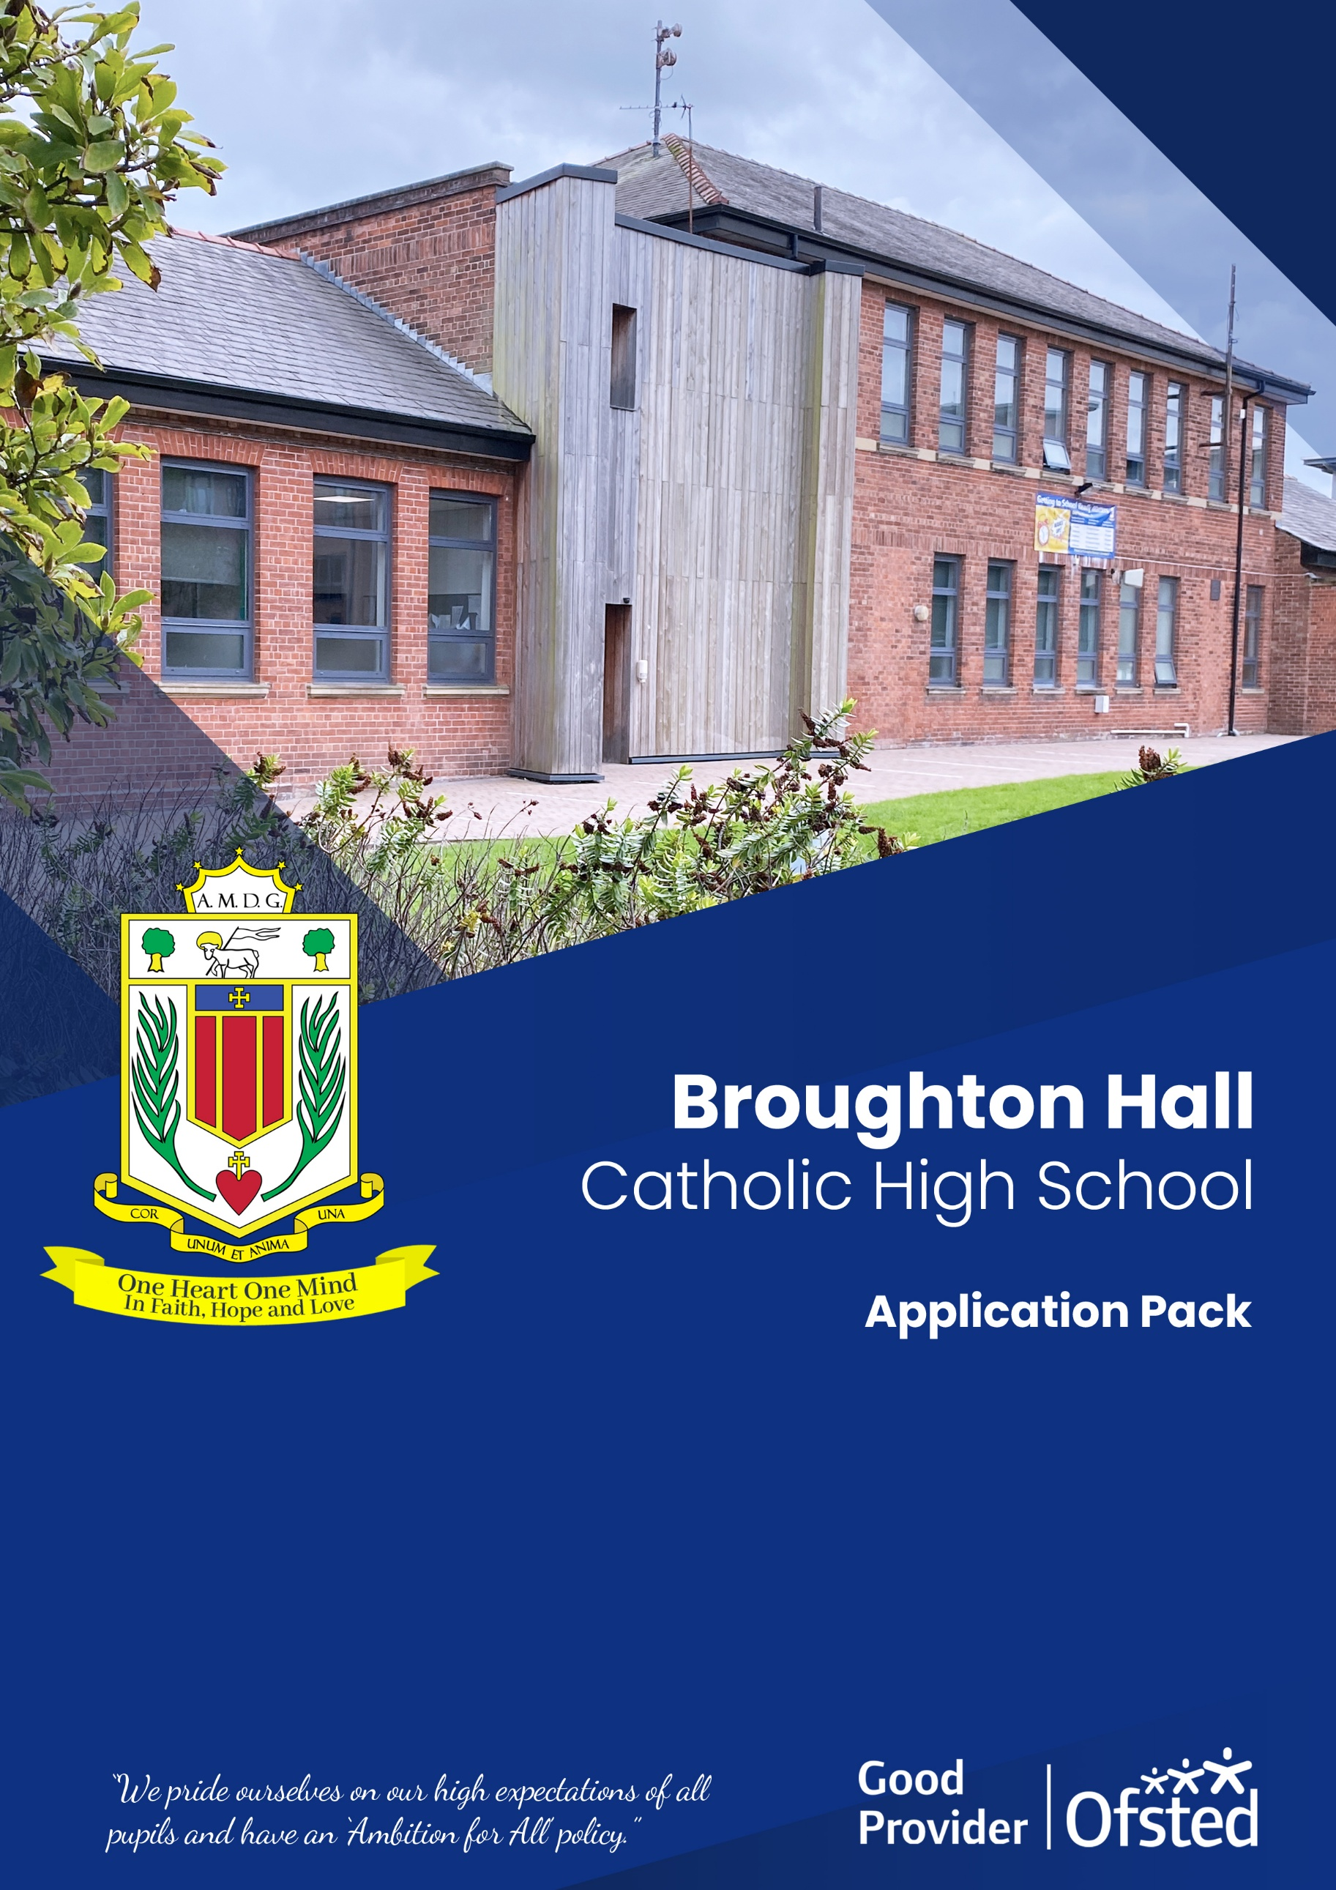

Salary Scale: MPR / UPS as applicable with TLR 2b £5867

Headteacher
Closing Date: 30th April 2026 at 10.00 AM

Headteacher
Shortlisting Date: After the closing date

Headteacher
Interview Date: To be confirmed

Headteacher
Start Date: 1st September 2026
Headteacher111
Contract Term: 1 x Full-Time - Permanent

Headteacher
Role: Teacher of General Science with responsibility for KS3 Science and KS5 Vocational Science

Broughton Hall Catholic High School
Founded in 1928 under the trusteeship of the Sisters of Mercy, Broughton Hall Catholic High School, an all-girls Catholic secondary school in Liverpool, provides the very best in modern education based on the Gospel values of mutual respect and care.
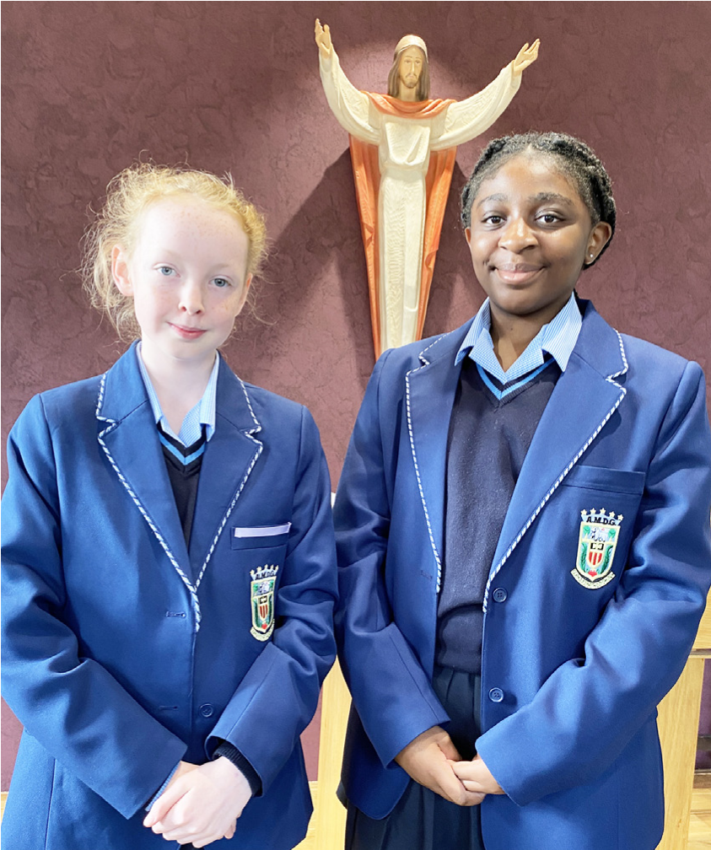
The central aim of our school is to provide excellent educational opportunities enabling each pupil to develop their God given talents, to grow in confidence and self-esteem and to fulfil their potential.

As a Catholic school Broughton Hall centres its mission on the person of Jesus Christ, and promotes the Gospel values throughout the school community and in all aspects of school life: spiritual, academic, pastoral, and personal. By proclaiming and living out the faith of the Catholic Church, we support each other in shared experiences of teaching and learning, prayer, worship and charity. Our mercy values permeate throughout our community.

Broughton Hall is Ofsted rated as a “Good” provider (November 2022).

Our facilities are bright, spacious, high tech and designed to meet the needs of all our pupils. We have a separate 6th Form facility, which is shared with our neighbouring boys school Cardinal Heenan Catholic High School. A full range of extra-curricular activities are provided to further the creative, sporting and academic talents of each pupil and offer Outward Bound and Duke of Edinburgh Award schemes as well as the opportunity to attend educational visits and residential trips.

We pride ourselves on our high expectations of all pupils and have an ‘Ambition for All’ policy. Whatever your role within the school, you will share these values and be able to encourage and motivate pupils with your passion, presence and personality.

Our school motto ‘Cor Unum et Anima Una’ - One Heart and One Mind, reflects the strong sense of community amongst pupils, staff, parents and Governors.

School has a weekly Newsletter – please click here to view our latest edition. https://www.broughtonhall.com/newsletter/

Welcome

Thank you for your interest in the position of Teacher of Science with responsibility for KS3 and KS5 Vocational Science.

The Science Department is a successful, supportive one and offers qualifications at both Key Stages 4 and 5. The Science Department is equipped with 8 new laboratories and is well-resourced.

This pack has been designed to help you should you choose to submit an application form, which we sincerely hope you do. We hope it answers your initial questions, but if not, please do not hesitate to contact us and we will endeavour to help you through your application process.

Broughton Hall Catholic High School is the largest all-girls school in Liverpool and serves many different areas making us a vibrant a diverse school. Our aim is to be a good school in all areas and we are seeking staff to apply to work with to be of that journey. Ofsted rated the school as “Good” in November 2022.

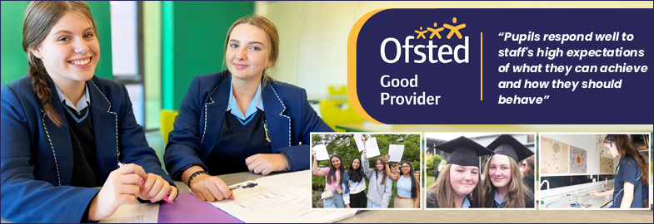

We work hard to ensure Broughton Hall Catholic High School remains a friendly and welcoming environment for all those who work, study or visit here and hope that you are the person we are looking for to bring creativity and innovation to the role.

The school actively supports the training of middle leaders through well-respected Teaching Leaders’ programme. Opportunities for promotion exist for suitable candidates. Our staff are passionate about teaching and are committed to develop exciting and stimulating lessons that not only engage students.


We look forward to hearing from you.

Sarah O’Rourke
Head Teacher

We Offer

- Pensions Scheme – Teacher Pension Scheme for teaching staff or Merseyside Pension Fund for support staff
- Regular training and development programme
- An enhanced Occupational Health & Well-Being App (Smart Clinic) with access to a wide variety of services e.g.
- Virtual GP
- 24 hour employee assistance line
- Physiotherapy
- Mental Health Services
- Self-support and guidance tools
- Cycle2Work Scheme
- Tax Free Childcare Vouchers
- Supportive work environment where all staff are valued
- Continuous professional development for all staff and follow a whole school approach to staff performance and development

And that’s not all, we place the outcomes of the children in our school at the heart of everything we do, so you’ll wake every day in the knowledge that your role will have a significant positive impact on the lives of others.

Equal Opportunities

Broughton Hall Catholic High school is an equal opportunities employer.

We welcome applicants from all backgrounds and value everyone as an individual. We are committed to organisational practices, which promote diversity and inclusion for all employees and volunteers regardless of age, gender reassignment, marriage or civil partnership status, pregnancy and maternity status, disability, race (including colour, nationality, ethnic or national origin), religion or belief, sex, or sexual orientation. Connecting these differences creates a productive environment in which everyone feels valued.

Monitoring information in relation to job applicants will be to assist us in equality monitoring. The recruitment panel will not have access to job applicant’s monitoring information.

To assist us in monitoring the operation of equal opportunities policy, and for no other reason, please ensure you complete and submit the Equal Opportunities Monitoring Form with your application form.

Safeguarding & Enhanced DBS Checks

Broughton Hall Catholic High School is committed to safeguarding and promoting the welfare of young people and expect all pupils, staff, volunteers and visitors to share this commitment

All posts are subject to an enhanced DBS check and full pre-employment checks to comply with the current Keeping Children Safe in Education statutory guidance for schools.

All staff will be expected to follow Broughton Hall Catholic High School’s child protection policies, code of conducts and managing allegations against staff procedures.

All roles in school, including this post, are exempt from the Rehabilitation of Offenders Act (ROA) 1974. The Ministry of Justice’s guidance on Rehabilitation of Offenders Act 1974 and the Exceptions Order 1975 provides information about which convictions must be declared during job applications and can be accessed here.

All applicants must therefore declare all previous convictions and cautions, including those which would normally be considered ‘spent’ except those received for an offence committed in the United Kingdom if it has been filtered in accordance with the DBS filtering rules. Information about filtering offences can be found in the DBC Filtering Guide, which can be accessed here.

By engaging in this recruitment process, shortlisted candidates consent to an online search in line with the Keeping Children Safe in Education Statutory Guidance 2022.

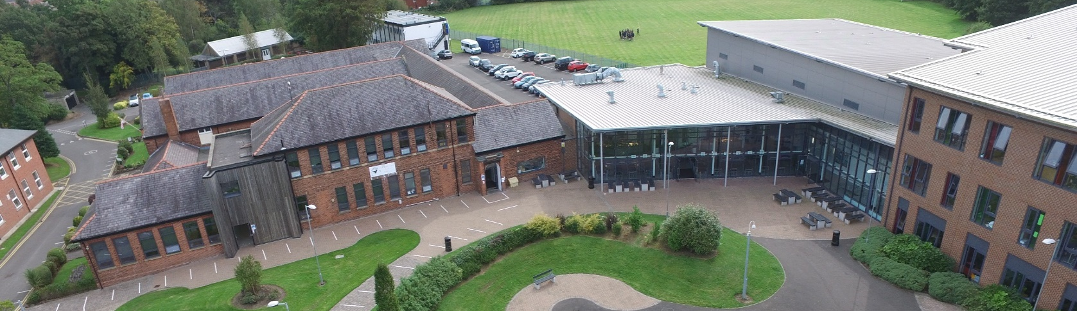

TEACHER OF SCIENCE with responsibility for
Advert
KS3 Science and KS5 Vocational Science

SALARY: MPS/UPS with TLR 2b £5,867
CONTRACT: Permanent
HOURS: 1.00 FTE
CLOSING DATE: Thursday, 30th April at 10.00 am
INTERVIEWS TO BE HELD: As soon as possible after the closing date
START DATE: September 2026

Governors wish to appoint a first rate, enthusiastic Teacher of Science with the ability to teach across the full age and ability range. We are looking for a dynamic candidate who has the leadership capabilities to lead the curriculum at KS3 and KS5 Vocational Science. If you are highly motivated, have a passion for Science and have the ability to inspire our pupils then we would love to hear from you.

The Science Department is a successful, supportive one and offers qualifications at both Key Stages 4 and 5. The Science Department is equipped with 8 new laboratories and is well-resourced.

The successful candidate will be:
- An outstanding classroom practitioner
- Someone who is passionate about Science and has the ability to inspire a love of learning
- Committed to the school’s vision and demonstrating compassion through the mission statement
- Dedicated in ensuring students achieve the best outcomes

About Broughton Hall Catholic High School
Broughton Hall is a Catholic High School is an Ofsted rated Good provider (2022). We are proud of our strong Catholic ethos and values. The school has an excellent reputation and promotes an inclusive education which develops creativity, confidence and independence. The school is committed to the continuous professional development of all staff.

Applications to: recruitment@broughtonhall.com
For further information please visit the school’s website www.broughtonhall.com

Broughton Hall Catholic High School is committed to safeguarding and promoting the welfare of children and we expect all staff and volunteers to share this commitment to keeping children safe. Any offer of employment will be subject to statutory pre-employment checks including satisfactory references, on-line checks and Enhanced DBS and Barred List checks. This post is exempt from the provisions of the Rehabilitation of Offenders Act - accessed here - and shortlisted candidates will be required to disclose any relevant criminal history prior to interview.

Job Description

Teacher of Science with
Responsibility for KS3 Science and KS5 Vocational Science

JOB DESCRIPTION

At the heart of this role is the provision of professional leadership to secure a high-quality Science education for all pupils, ensuring that the curriculum is ambitious, coherently planned, well taught and inclusive.
The post holder will support the Head of Department in leading and developing Science, with particular responsibility for the KS3 curriculum and KS5 vocational pathways, ensuring that pupils develop secure scientific knowledge, understanding and skills over time.
The role requires a strong focus on curriculum intent, implementation and impact, high expectations for pupils and staff, and a relentless commitment to improving outcomes, personal development and well-being for all learners.

JOB PURPOSE
To assist the Head of Department in leading, managing and developing Science across Key Stage 3 and KS5 vocational courses, ensuring:
- A clearly sequenced and ambitious curriculum
- High-quality teaching rooted in strong subject knowledge
- Inclusive practice that meets the needs of all learners
- High standards of achievement, behaviour and engagement
- Positive contributions to pupils’ personal development and well-being

REPORTING
The post holder is accountable to the Head of Department.

AREAS OF RESPONSIBILITY
The post holder will have responsibility for:
- Curriculum development and coordination at KS3 and KS5 vocational Science
- Teaching across KS3, KS4 and KS5 as required
- Supporting departmental staff in curriculum planning, pedagogy and assessment
- Contributing to enrichment and extra-curricular Science provision

WORKING TIME AND CONDITIONS
In accordance with the School Teachers’ Pay and Conditions Document, including participation in:
- Extra-curricular provision
- School events and functions, including Awards Evenings

KEY ACCOUNTABILITIES

1. Strategic Direction and Curriculum Development
- Support the production, implementation and evaluation of an annual Science development plan aligned with the School Improvement Plan
- Lead the development of a coherently sequenced KS3 Science curriculum that builds knowledge and skills over time
- Ensure curriculum plans reflect high ambition for all pupils, including SEND and disadvantaged learners
- Keep up to date with national developments in Science education, qualifications and pedagogy
- Contribute to health and safety compliance, risk assessments and safe practical work
- Represent the department where appropriate within the wider school community and with external partners

2. Teaching, Learning and Assessment
- Model consistently strong classroom practice rooted in secure subject knowledge
- Support colleagues to plan lessons that prioritise learning, understanding and retention
- Promote effective formative assessment that informs teaching and supports pupils to know and remember more
- Contribute to the development and consistent use of departmental schemes of work and assessment approaches
- Ensure homework and independent learning support curriculum intent and learning progression
- Promote enrichment activities that widen pupils’ experiences and engagement with Science

3. Staff Development and Professional Culture
- Support, challenge and develop colleagues to improve teaching quality and curriculum delivery
- Contribute to performance management processes in line with school and national expectations
- Encourage a culture of professional learning, collaboration and reflective practice
- Share effective practice within the department and contribute to whole-school CPD

4. Pupil Progress, Inclusion and Standards
- Maintain high expectations for behaviour, effort, attendance and work completion
- Use assessment information intelligently to identify pupils who need additional support or challenge
- Support intervention strategies that are targeted, timely and curriculum-focused
- Ensure effective communication with parents/carers regarding curriculum and progress
- Contribute to reporting and meetings with parents/carers as required

5. Effective Use of Resources
- Support the efficient deployment of staff, accommodation and resources
- Contribute to the creation of a stimulating learning environment that promotes curiosity and pride in Science
- Support effective team working and positive professional relationships

6. Vocational Science (KS5)
- Coordinate BTEC standards verification and sampling processes
- Attend relevant BTEC training and updates
- Ensure vocational provision meets awarding body and quality assurance requirements

OTHER DUTIES
- Fulfil the Teachers’ Standards at all times
- Uphold safeguarding responsibilities and promote pupil welfare
- Model professionalism, punctuality and the school’s Catholic ethos and Gospel values
- Undertake other reasonable duties appropriate to the role, as directed by the Headteacher

The job description is current at the date shown, but, in consultation with you, may be changed by the Head Teacher to reflect or anticipate changes in the job commensurate with the grade and job title.

Post Teacher of Science with responsibility for KS3 Science KS5 Vocational Science
Person Specification
Pay Spine Main Scale/UPS (as applicable) + TLR
Date April 2026
Responsible to Head of Department

1. QUALIFICATIONS AND TRAINING
- Degree in a relevant Science subject
- Qualified Teacher Status (QTS)
- Evidence of strong subject knowledge appropriate to KS3, KS4 and vocational KS5
- Evidence of ongoing professional development, including engagement with subject pedagogy and curriculum development
- Willingness to engage in further professional learning aligned to whole-school and departmental priorities

2. TEACHING, LEARNING AND CURRICULUM EXPERIENCE
- Successful teaching experience in Science at KS3 and KS4, and preferably KS5 vocational courses
- Evidence of consistently strong teaching that secures positive progress for all groups of pupils
- Secure understanding of how pupils learn science, including common misconceptions and how to address them
- Experience of designing and delivering a coherently sequenced KS3 curriculum that builds knowledge and skills over time
- Strong understanding of curriculum intent, implementation and impact, particularly at KS3
- Ability to plan lessons that focus on learning rather than task completion
- Effective use of assessment to:
  - Check understanding
  - Inform responsive teaching
  - Identify pupils who need additional support or challenge
- Secure understanding of progress without over-reliance on internal data systems
- Experience of adaptive teaching strategies to meet the needs of:
  - SEND pupils
  - Disadvantaged pupils
  - High attainers
- Evidence of maintaining high expectations for behaviour, effort and engagement
- Ability to create a calm, purposeful classroom environment that supports learning
- Evidence of contributing to intervention or support strategies that improve outcomes
- Experience of pastoral responsibility, such as form tutor duties

3. LEADERSHIP AND MANAGEMENT (KS3 CO-ORDINATION / KS5 VOCATIONAL)
- Ability to lead and develop aspects of the KS3 Science curriculum to ensure consistency, ambition and progression
- Ability to support colleagues with curriculum planning, pedagogy and assessment practice
- Confidence in monitoring and evaluating the quality of teaching and learning within your area of responsibility
- Willingness to engage in professional dialogue focused on improving outcomes for pupils
- Commitment to evidence-informed practice and ongoing curriculum refinement
- Ability to contribute positively to departmental self-evaluation and development planning

4. PERSONAL AND PROFESSIONAL QUALITIES
- High expectations of all pupils and a commitment to helping them succeed
- Reflective practitioner with a willingness to adapt and improve practice
- Resilient, organised and able to manage workload effectively
- Positive, professional relationships with pupils, colleagues and parents/carers
- Commitment to the wider life of the school and enrichment opportunities
- A clear moral purpose and desire to make a meaningful difference to young people
- Professional integrity, reliability and good attendance

5. INCLUSION, SAFEGUARDING AND ETHOS
- Strong commitment to inclusive education and equality of opportunity
- Understanding of the role of teachers in supporting pupils’ personal development and wellbeing
- Commitment to safeguarding and promoting the welfare of children, young people and vulnerable adults
- Willingness to uphold and model the school’s values and expectations
- Commitment to ongoing professional development and collaboration

Department Overview
Science Department
Departmental Descriptions
The Science Department is led by Mr Roberts and is presently comprised of 11 full time and 2 part time teachers and 2 technicians. Miss Skiming has responsibility for KS4 and Chemistry, Mrs Williams has responsibility for Biology and KS3 and KS5 Vocational matters are coordinated by Miss Bradley. Broughton Hall Science is an improving and forward thinking department to work in, recently celebrating the best set of Science results in recent years. The department offers help and support to new staff whether they are trainees or experienced teachers.

The Science Department offers courses at KS3 which deliver a national programme of study in preparation for studies at KS4 where both GCSE Separate Sciences and Trilogy combined Science qualifications are studied. At KS5 A-level courses in Biology, Chemistry, Physics and BTEC /AAQ Vocational Qualifications in Applied Science and Applied Human Biology have proved both popular and successful.

Our aims are to:
- Develop and maintain students’ interest in Science and related disciplines.
- Develop in our students a wide and relevant body of scientific knowledge and understanding.
- Help students to develop investigative skills across Biology, Chemistry and Physics.
- Continue to develop both literacy and numeracy within a scientific context.
- Develop transferable skills such as problem solving within our students.

The department has always believed that education is continually evolving and as teachers we need to keep developing our skills and practice. The department works closely with the Local Authority and Diocese networks to ensure that staff receive the most up to date training in new developments and approaches. The department is also benefitting from the Stimulating Physics Partnership with bespoke training being available for staff. As part of the Triple Science Support Programme Broughton Hall Science has access to resources and funding designed to increase uptake of the 3 separate science GCSE’s, a national target.
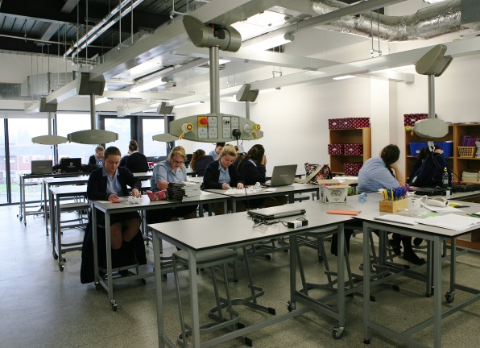
As with all departments science is also looking within itself for developments and improvements by sharing good practice via Triad teaching and learning groups and an openness to share ideas at department meetings which are regular within Broughton Hall.

Accommodation and Resources
The Science department is mainly based in 8 new purpose-built Labs with NAWIS gas and electric facilities. There are 3 science preparation rooms and a shared preparation area for use by teachers and technicians.

All laboratories benefit from Promethean interactive boards. The Science department also has access to 45 laptops for use solely within Science lessons, and two sets of interactive handsets. Practical equipment is well maintained by our experienced technicians and covers most standard practicals and topics. Excellent technical support from our technicians has allowed Broughton Hall to respond quickly to the emphasis on required practicals and a practical endorsement at both KS4 and KS5.

Key Stage 3
Year 7 & 8, follow an in house National Curriculum based scheme focusing on Core Scientific skills, which is fully resourced. Assessment is via tests at the end of each topic and an end of year exam. These assessments and the data they provide are used to give guidance on courses at KS4.

Key Stage 4
Year 10 students all study for a GCSE qualification in AQA Trilogy Combined Science or AQA Separate Sciences, this is offered as an elective over the two years.
The successful completion of these courses leads to students pursuing level 3 courses in Biology, Chemistry, Physics and Applied Science or Applied Human Biology.

Key Stage 5
In years 12 and 13 students enjoy quality teaching and learning towards AQA A-levels in Biology, Chemistry and Physics and BTEC Qualifications in Applied Science and Applied Human Biology. Students studying A levels in Biology, Chemistry and Physics typically have grades 6 or better in GCSE qualifications in Science and Maths. Students with GCSE grade 4 or better qualifications in Science and grade 4 in GCSE Maths will be offered a course leading to a BTEC / AAQ in Science. Students who study A levels in science continue their studies at Further education level with the majority of students going on to science-based degrees in medicine, dentistry, radiography, chemical, civil and mechanical engineering, pharmacy and others at Universities that in 2024 included Oxford, Cambridge, Liverpool, Manchester, and Lancaster.
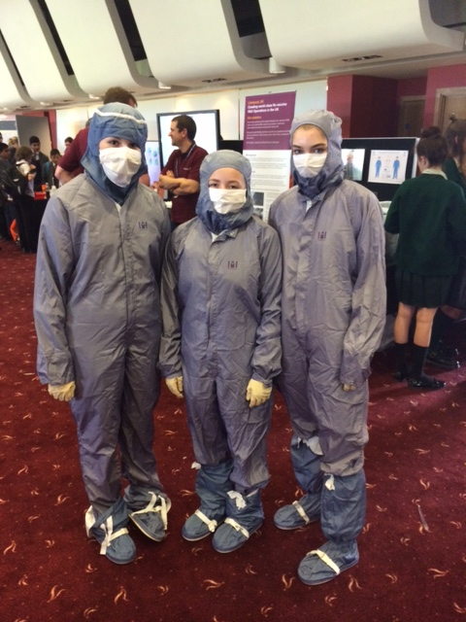

Extra-Curricular Activities
Intervention classes in Science are offered both before and after school to KS3/KS4 and KS5 students. There is also ‘Science Wednesday’s available to all year 10 and year 11 students on Wednesdays 3.05 – 4.05. KS3 students enjoy investigative work done within our STEM Club run after school. There are also intervention and general preparation classes at KS5 in all subjects. Numerous trips out add interest and enthusiasm to the science curriculum at Broughton Hall and recently there have been visits to Daresbury Laboratories for their ‘Chemistry at work day’, The Blood Transfusion Centre at Speke, the Blue Planet Aquarium, the Big Bang Event at Aintree, a Robotics Challenge Days at Liverpool University and Hugh Baird College, and an alien experience visit to Jodrell Bank. The 6th Form trip to Cern, Geneva proved exceedingly popular and proved to be an excellent opportunity to see cutting edge Science research up close.

