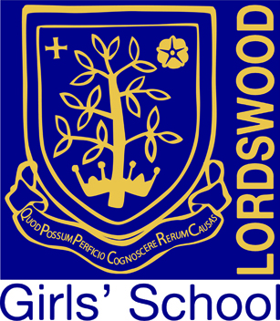

Lordswood Girls’ School & Sixth Form Centre

Knightlow Road, Birmingham B17 8QB

Headteacher: Mrs Jane Götschel

Teacher of Geography
Main Pay Scale
Full Time, Maternity Cover – two terms in the first instance

Closing Date: Apply by 12 noon on Friday 12th March 2021
Start date: September 2021
Location: Lordswood Girls’ School & Sixth Form Centre
Contract Type: Full-time, maternity cover, two terms in the first instance

At Lordswood Girls’ School we are constantly striving to improve on our best and we are very proud of our position as one of the top schools, both in the city and nationally. The school has consistently been ranked within the top 4% of schools nationally based on its Progress 8 score, and enjoys an excellent reputation for its academic, sporting, and artistic achievements.

We are looking to appoint an excellent practitioner who is passionate about their subject. The successful candidate will have the ability to teach geography across Key Stages 3 – 5 and able to inspire all students to reach their full potential.

The post offers excellent working conditions and a comprehensive development programme, in addition to all staff being enrolled as members of the UK Healthcare provision.

Application form and further details are available for download from the Lordswood Girls’ School website at www.lordswoodgirls.co.uk and are also available from Sheila Allport by email at s.allport@lordswoodtrust.co.uk.
Application deadline is 12.00 noon on Friday 12th March 2021.

Lordswood Academies Trust is committed to safeguarding and promoting the welfare of children and young people and expects all staff to share this commitment. An enhanced DBS check is required for the successful applicant.

