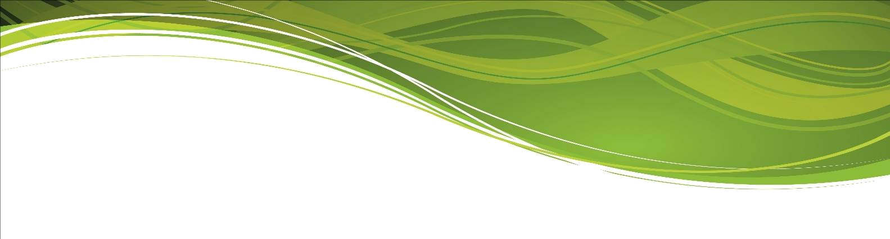

TEACHER OF GEOGRAPHY – Full time or Part time (minimum 0.8fte)

Thank you for your interest in this post. We have included for you details of the post and the department, information about Millom School and the application process. We hope that you find these details useful in supporting your application.

Millom School is committed to safeguarding and promoting the welfare of its students. All applicants are subject to the requirements of Keeping Children Safe in Education guidelines. This will include checks with past employers and the need for the successful applicant to hold or undergo a suitable enhanced DBS disclosure.

The Post
We are looking for an enthusiastic, energetic and committed teacher who will participate fully in the teaching and development of Humanities within the school. You will be innovative and inspiring, and will help teach across the full age and ability range. Geography is taught at both GCSE and A level at Millom School.

We welcome applications from NQTs/ECTs.

We are unable to provide Visa sponsorship for this post.

The deadline for applications is 12 noon, Tuesday 18 March 2025
Interviews will be held during the week commencing Monday 24 March 2025

Please ensure that your application includes both a daytime and an evening telephone number where you can be contacted, and an email address.

If you have particular questions about the post, we will be happy to answer them for you. Please ask for the Headteacher’s PA, Sheila Minter, who will be pleased to help you. The selection process will include a tour of the school and an opportunity to meet with colleagues and students both formally and informally.

The Application Process

Please download and complete the application form from the school website. Your application form should be accompanied by a letter of application.
Letters, which should not be longer than two sides of A4, font Arial size 11, should outline how you would use your teaching skills to introduce and inspire students to engage with Humanities.

Completed applications should be returned via email to hr@millom.cumbria.sch.uk, by the deadline of 12 noon on Tuesday 18 March 2025.

