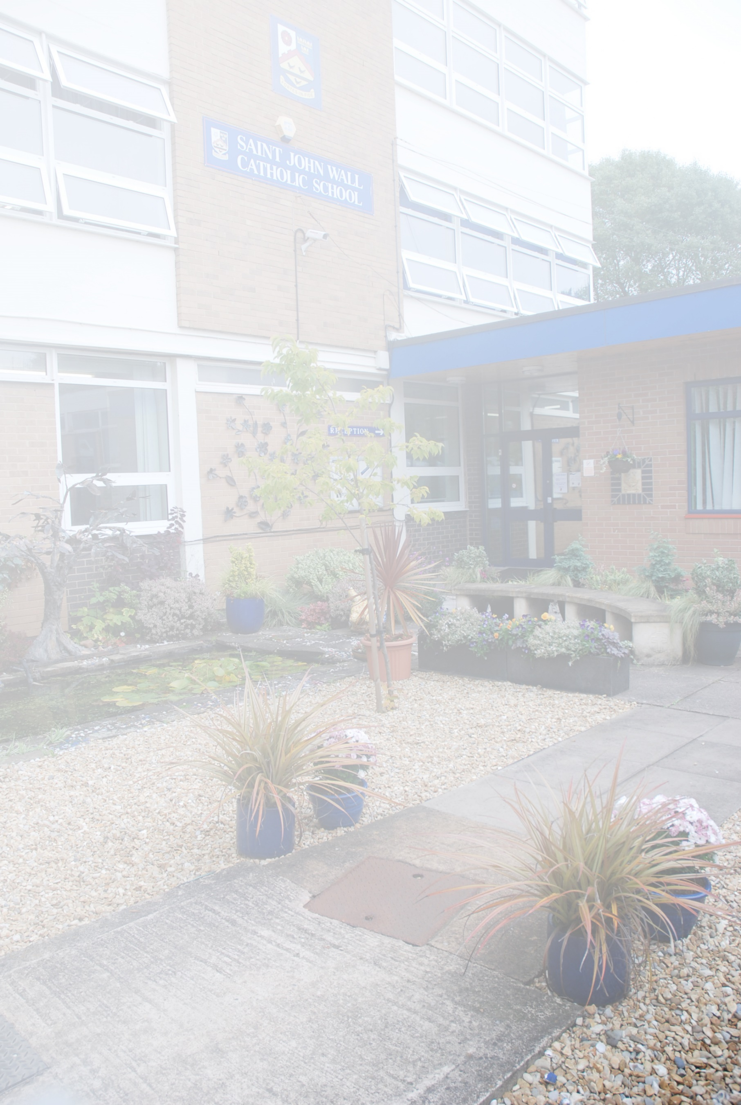

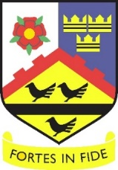

**Saint John Wall Catholic School  
*A Catholic School For All***

**Mission Statement**

**‘To educate each and every unique child in our care to hear and respond to what God calls them to be’**

**Teacher of Geography**

**Salary: MPS/UPS required from 1 September 2022**

Saint John Wall Catholic School is a highly successful oversubscribed 11‐16 school with a mixed and diverse population, serving the community of North West Birmingham. Over 50% of our pupils qualify for additional Pupil Premium funding, and there are over 50 different languages spoken by members of our school community! We are a catholic school for all and endeavour

*‘to educate each and every unique child in our care to hear and respond to what God calls them to be’*

**The Role**

As a teacher of Geography, you will help the Humanities Team to maintain and further develop the effective delivery of an outstanding curriculum, which will enable the highest quality of education, within the Department. You will be a member of a highly professional team, and promote outstanding academic and personal achievement, within a nurturing and rigorous environment.

**Responsibilities**

You will be teaching Geography to KS3 and KS4. You will be part of the successful and well respected Humanities Team, and will collaborate to continually improve the quality of education provided by the Department. You will strive to deliver a highly engaging and challenging curriculum that inspires children and develops their skills and subject knowledge.  This includes hosting extra-curricular enrichment activities.

**The Individual**

You are someone who understands the difference a great education can make to pupils’ lives. You are committed to our mission statement and are a great role model for pupils and colleagues. You must be educated to degree level or above and have experience in delivering a consistently outstanding curriculum to pupils of all ages and abilities. You will need to be a great team player and teacher with a resilient character and strong personal drive.

To find out more about Saint John Wall Catholic School, please visit www.sjw.bham.sch.uk. The application form and job description can be found on the website. If you have any questions, please email enquiry@sjw.bham.sch.uk

Closing date: 9.00am Monday 16 May 2022

*As a Catholic School we will expect that you actively support the Catholic ethos, and help us to follow the highest standards of safeguarding for our pupils. The successful candidate will be subject to enhanced DBS and any other relevant employment checks.*