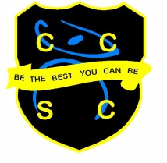
Physical Education Department

The Physical Education department is a flourishing, energetic and happy department that enhances the health and well-being of all pupils at Chesterton Community Sports College. The department is at the heart of the school. Where many schools are making cuts to physical education provision, we are expanding with students completing two timetabled lessons per week through both KS3 and KS4. Option choices are also popular with high numbers choosing to further their talent and understanding of physical education through the GCSE and Cambridge National qualifications. We are looking to employ a dynamic, innovative and committed PE teacher to provide maternity cover for a member of our team. Our department currently consists of four full-time members of staff with a multitude of specialisms as well as the District School Games Organiser.

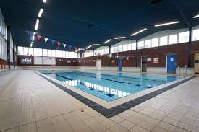
As a department we have a proven track record of delivering high quality lessons that have pace to ensure progression whilst meeting the needs of all pupils’ abilities. At the core of our curriculum is the philosophy that all pupils aspire to ‘Be The Best You Can Be’. We offer a breadth of activities that develop physical, social and cognitive skills through performance, planning and analysis; this works to keep levels of non-participation low.

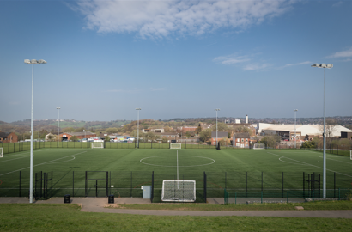
Due to the increased demands of examination subjects at KS4, it is essential that physical education staff illustrate the highest standards of classroom-based practice. As a team we work collaboratively to produce outstanding, differentiated and engaging lessons that enhance the progress and attainment of our GCSE and Sports Science pupils. Classrooms are equipped with ‘Apple TV’ which link to your personal MacBook and iPad to support teaching and learning. All pupils also enjoy the use of their own iPads, which can be incorporated into your lesson planning, whether it be researching a topic area, accessing authentic websites or producing coursework materials. We use Microsoft Teams as our teaching and learning platform.

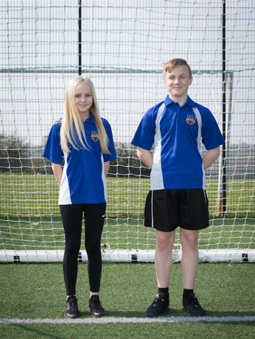
Chesterton Community Sports College provides the ideal working environment for any physical educationalist. Our facilities are some of the best in the County and we consider ourselves fortunate to work in such surroundings. The 3G floodlit AstroTurf provides a perfect surface for activities ranging from football, rugby and hockey through to rounders, softball and athletics. There are also two sports fields that host a range of sports including our illustrious cross-country course and indoors, we have a four-court sports hall that is used for net/wall games, trampolining, gymnastics and racket sports. A mirrored dance studio affords an ideal location for all styles of dance performance whilst the swimming pool allows for the development of technique and speed swimming, aqua aerobics, lifesaving and personal survival.

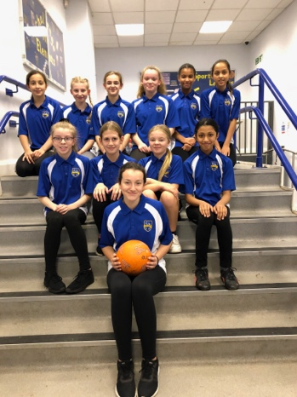
We pride ourselves on the level of extra-curricular provision we offer. In recognition of this we hold the Sainsbury’s school games Gold award in provision of opportunities for pupils to further enhance their talents both in performance and leadership; one of the few schools in the County to hold this level of award. School teams are some of the most successful in the area with many going on to represent the district at county and regional events. We are skilled at running a program that enables sport for all whilst enhancing those most able and talented. The success we achieve as a school is testament to the drive, resilience and commitment of both staff and students alike.

