**FINHAM PARK 2**

**TEACHER OF GIRLS PE**

**Part Time 0.8 – Temporary (Maternity Cover)**

**Starting April 2025**

**Grade TMS / UPS / ECT**

We are delighted to announce that we are seeking to appoint an a highly motivated teacher of Girls PE for Maternity Cover (0.8). They would need to teach a variety of sports and take an active role in our extremely popular extra-curricular programme. The successful applicant will join a strong team where teachers are committed to developing active learning strategies to challenge and inspire all our students. The successful candidate will be required to teach to Key Stage 3 and 4.

Finham Park 2 is an exciting, friendly and supportive 11-19 co-educational comprehensive school based on the West side of Coventry near the border of Solihull and close to Warwick University. We opened in September 2015 with 120 students and have grown year on year, including our 6th form, which opened in 2020.

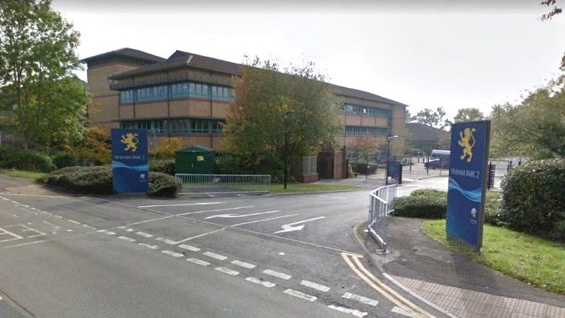In September 2016 we moved to our new building- a light and spacious, high quality refurbishment with superb facilities including a brand-new sports hall. We are fully staffed with a positive, supportive, forward thinking team. We continue to be heavily oversubscribed each year. Our last Ofsted (November 2023) described Finham Park 2 as a good school in all areas with “a purposeful atmosphere around the school”, “a calm and orderly manner” and “a highly ambitious curriculum”, where “leaders carefully consider staff workload which staff are appreciative of.”



Finham Park 2 is a truly comprehensive school with almost 700 students on roll. The vast majority of our students are happy, well-behaved, friendly, inquisitive, polite and wear their uniform with pride. On entry students are broadly in line with national averages with approximately 85+% middle or higher prior attainment.

We offer an exciting curriculum that provides opportunities for **all** **students** to ensure they all achieve and make the best progress they are capable of, no matter what their starting points; a curriculum that nurtures every child’s talents and provides exceptional opportunities for students to have the ‘time of their lives’.

Finham Park 2 is supported by and proud to be part of Finham Park Multi Academy Trust. As part of the Multi Academy Trust, we enjoy working in collaboration with the other MAT schools. This provides fantastic opportunities for both our staff and students.

Successful candidates will join an established and strong team, where our teachers are committed to delivering a high quality, lively and interesting curriculum to challenge and inspire all of our students.

We are looking to appoint a charismatic, dynamic individual who naturally inspires others and is passionate about teaching and its impact on learning. The successful candidate will be driven by a commitment to create the best possible educational opportunities for our pupils, in order to raise aspirations and transform lives.

To apply, please read our pack before providing a full application form along with the equal opportunities form. Please ensure your supporting statement sets out why you feel that you are suitable for this role and includes demonstrable impact of your achievements.

Details of our interview arrangements, will be provided to the shortlisted candidates.

**Closing date: Tuesday 28th January 2025**

**Interview date: TBC**

**How to Apply**

Applications are submitted through our Every Candidate Portal. Click the link below to take you directly to the site.

<https://candidates.every.education/Vacancies/Details?advertKey=da03b1ba-758f-4c52-8117-cb7960458648>

Alternatively, you can click on the ‘application form’ on our careers website which will direct you to the application page.

To request any of the documents in an accessible format, or to request an application form via email please contact apply@finhampark.co.uk or call 02477 180000 and select option 2 for HR.

If you are a new user to our portal, you can click on ‘Register’ to complete your candidate profile. If you want to apply directly for this role and not save your data for any future vacancies, you can click on the ‘Apply Now’ button at the bottom of the Every page.

For further information on this role and other opportunities within the MAT, please visit https://careers.fpmat.co.uk

***Finham Park Multi Academy Trust requires all applicants to be eligible to work in the UK with no restrictions as we are unable to offer sponsorship/work visas. You will be required to provide proof of Right to Work at interview stage and if you are offered a job position with us.***

***Online Checks***

***In line with KCSIE (Keeping children Safe in Education) 2024 we will complete online searches as part of our due diligence on all shortlisted candidates. If anything is identified as part of these checks they will be discussed with you at interview. If any safeguarding concerns are identified we reserve the right to withdraw your application.***

***Finham Park Multi Academy Trust is committed to safeguarding and promoting the welfare of children and young people and expects all staff and volunteers to share this commitment.***