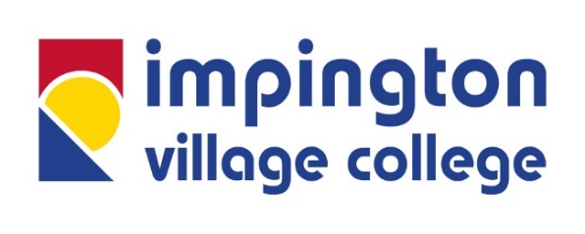

Impington Village College
Teacher of Girls’ PE with Netball Specialism
Required September 2021
Salary: Main Scale / UPS

Join East Anglia’s “State Secondary School of the Year”
This is a fantastic opportunity to join one of the UK’s leading comprehensive schools, recently ranked third nationally in the Sunday Times’ ParentPower publication for the second year running. Due to the continued expansion of the College, including our outstanding sixth form, we are looking to recruit a passionate and exceptional Teacher of Girls’ PE, preferably with a netball specialism to support our thriving netball scholarship programme. NQTs are welcome, and will be nurtured and developed with an exemplary support package.

Impington Village College has achieved consistently excellent outcomes for the last five years. With a truly comprehensive intake, student progress is regularly in the top 5% of all non-selective schools in the country. Student attainment is exceptionally high, with 15% of all grades at Grade 9, 43% at 7-9 (or equivalent) and 85% of grades at 4-9. You will also be joining the College as it embeds a transformed curriculum, innovative and unique in the state sector, and built around our status as an IB World School. The College has also received a number of other national accolades, including the Gold Carnegie Medal for its work in supporting mental health and wellbeing, and SSAT Awards for progress, attainment and curriculum design.

The Sport faculty at IVC is a central part of the College and uptake at both KS4 and KS5 is very high, with very strong outcomes. The successful candidate, depending on their interest or specialism, will have the opportunity to teach across three different courses at KS4, including GCSE PE, BTEC Sport and OCR Sport Science, and BTEC Sport and IB Sport Science at KS5 in addition to our exciting core PE curriculum. We also have a thriving scholarship programme in our sixth form for Football (in partnership with Norwich FC), Rugby (in partnership with Cambridge RUFC), Netball (in partnership with Serena Guthrie and Legacy Netball), Handball (in partnership with Cambridge Handball Club) and Rowing (in partnership with Rob Roy Rowing Club). As part of our sports scholarships, students benefit from expert coaching and bespoke training sessions, as well as the chance to compete at an elite level.

We are very lucky to have an on-site Sports Centre with excellent facilities, including a full-size indoor swimming pool, and a large expanse of outdoor sports pitches and green spaces.

You will be joining an innovative, collaborative and dynamic faculty where staff are highly committed to professional development and sporting excellence, engaging with the latest pedagogical research and to developing students' passions for sport and physical wellbeing. There will be numerous opportunities to continue developing your teaching practice, through connections a range of in-house and external CPD programmes. You will be well supported in the faculty by a number of highly experienced colleagues, and have the chance to lead extra-curricular activities based on your own sporting interests.

With your knowledge and passion for PE, you will have the opportunity to build upon the successful curriculum embedded at IVC and deliver a high quality learning experience to our inspirational students.

In return IVC and the Eastern Learning Alliance (ELA) can offer you:

• reduced contact time for all teachers to facilitate professional learning/reduce workload, with a further reduction for new staff as part of our induction programme and an extensive support package for NQTs
• the opportunity to teach all key stages including the International Baccalaureate in our Sixth Form
• the opportunity to work for a faculty where collaboration is a high priority and the programme of professional learning is outstanding
• excellent career pathway opportunities with a culture of looking to promote from within, including positions across our growing Trust, the Eastern Learning Alliance
• access to the opportunities created through the Morris Teaching School Alliance, where IVC is the Lead School
• support to undertake a Masters in Education through our links with Cambridge University, the “SUPER Programme” and other L5 accredited providers
• support in an organisation where wellbeing is at the heart of everything we do and which has led to the introduction of a successful wellbeing directory to improve wellbeing and work-life balance
• subsidised access to IVC’s sports centre leisure facilities available for use before, during and after the school day

The ELA is committed to Equal Opportunities and to safeguarding and promoting the welfare of children and young people and expects all staff to share this commitment. All post holders are subject to employment checks and a satisfactory enhanced Disclosure and Barring Service check.

Closing Date: 9am on Wednesday 5 May 2021

An application pack is available from our website www.impington.cambs.sch.uk. Applicants must complete a College application form - we cannot accept CVs. Potential applicants are strongly encouraged to visit the College and please contact HR Enquiries hrenquiries@ivc.tmet.org.uk to arrange a visit.

