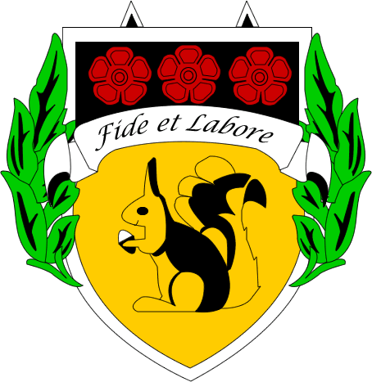

BACUP AND RAWTENSTALL GRAMMAR SCHOOL

Further information about Physical Education at BRGS

The Physical Education Department is staffed by a strong team of specialists and results in external examinations are consistently very good. The Physical Education department is led by Brendan Baird and the second in department is Karin Kolbuck with responsibility for girls PE.

Key Stage 3

Pupils are encouraged to develop their
- Motor skills and mental and physical activity
- Thinking skills in terms of decision making, analysing and evaluating performance
- Participation in a healthy active lifestyle.

These are taught through the following activities: basketball, table tennis, trampolining, football, badminton, dance, netball, cricket, health related fitness, athletics and striking and fielding activities.

Key Stage 4

Core Physical Education

All pupils in Year 10 and Year 11 have one period of core PE each week. Activities include football, basketball, health related exercise, netball, trampolining, badminton, dance, rounders, volleyball, athletics, softball and cricket. Pupils will continue with the processes they have developed in years 7-9.

GCSE Physical Education

There is a strong uptake of PE as an exam subject with usually one third of the year group choosing PE as an option. AQA exam board is followed with a split of 60% theory and 40% practical marks.

Students receive four extra periods of PE a fortnight alongside one core PE lesson.

The course consists of both practical and theory elements. Students will gain marks for performances in three activities including one individual, one team plus one other. The practical work is continuously assessed.

In school, football, table tennis, netball, badminton, basketball, trampolining and athletics take place.

Pupils can also be assessed in activities taken outside of school. For example, skiing, gymnastics, golf and horse riding.

Theory lessons cover wide ranging topics such as physiology, media and sponsorship, drugs in sport and healthy active lifestyles.

Key Stage 5

A Level Physical Education

A level Physical Education is studied through AQA specification and is a wide ranging and challenging course that promotes learning in both the scientific and social aspects surrounding physical activity and sport. With 30% of the course based on one practical activity, pupils are encouraged to relate theory to practical. The physiology of the body is linked into sporting performance, as is how the mind picks up and learns skills. Students are encouraged to analyse and evaluate theories and be able to plan advanced training and fitness programmes. From elite sport to health issues, A-level PE is an interesting, challenging and enjoyable course which prepares students for both further studies and an active lifestyle.

Students receive nine lessons a fortnight.

Results are always good at A-level. We have had 100% pass rate for the past six years and 43% grade A or above in 2019.

Facilities

The department has a sports hall (four badminton court size), a fitness room, dance studio, a MUGA and two astro-turfs as its main facilities.

Extra-curricular Sport

We offer a varied extra-curricular programme which aims to provide opportunities to all levels of pupils. BRGS has success in a number of sports from regional to national level.

Activities that are offered as extra-curricular activities include football, netball, cricket, rounders, basketball, table-tennis, badminton, trampolining and athletics.

