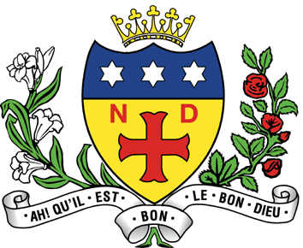

NOTRE DAME HIGH SCHOOL
11-18 Mixed Catholic Comprehensive School
FULWOOD ROAD, SHEFFIELD, S10 3BT

Tel: 0114 2302536

We are looking to appoint to the following post from September 2022:

Teacher of Health and Social Care
Full Time/Permanent
(£25,714 - £41,604 p.a. pro-rota)

We are looking to appoint an enthusiastic and expert Health and Social Care Teacher. You will be an excellent classroom practitioner with a genuine passion for Health and Social Care, able to lead by example and inspire our pupils to understand the importance of applying the values of care in daily life. The need to promote Health and Social Care, particularly careers within these sectors has never been greater and your role in fostering student engagement and motivation in this subject should be a core part of your pedagogy. This is an exciting opportunity for a dedicated teacher to develop their career within a school that prides itself with investing in teacher CPD.

For further details and an application pack please visit our website: www.notredame-high.co.uk or telephone the school.

Closing date for receipt of completed applications: 9am on Monday 17th January 2022

Notre Dame High School is committed to safeguarding and promoting the welfare of children & young people and expects all staff to share this commitment. The successful applicant will be required to complete an Enhanced DBS Disclosure. In addition, this post is exempt from the Rehabilitation of Offenders Act and a self-disclosure is required for applicants shortlisted for interview.

