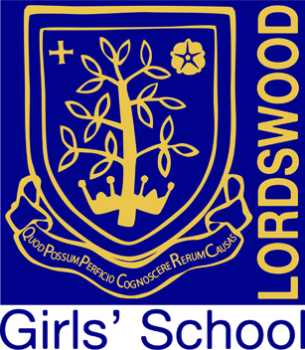

Lordswood Girls’ School & Sixth Form Centre

Knightlow Road, Birmingham B17 8QB

Headteacher: Mrs Jane Götschel

Teacher of Health & Social Care
Permanent, Part-Time 0.6
Main Pay Scale

Closing Date: 12 noon on Friday 18^{h} June 2021
Start date: September 2021
Location: Lordswood Girls’ School & Sixth Form Centre
Contract Type: Permanent, Part-time 0.6

At Lordswood Girls’ School we are constantly striving to improve on our best and we are very proud of our position as one of the top schools, both in the city and nationally. The school has consistently been ranked within the top 4% of schools nationally based on its Progress 8 score, and enjoys an excellent reputation for its academic, sporting, and artistic achievements.

We are looking to appoint an excellent practitioner with the ability to teach health and social care at Key stages 4 and 5 and to contribute to the delivery of the new T Level in Education. The successful candidate will be passionate about their subject area and capable of inspiring all students to reach their full potential in this very popular curriculum area.

The post offers excellent working conditions and a comprehensive development programme, in addition to all staff being enrolled as members of the UK Healthcare provision.

Application form and further details are available for download from the Lordswood Girls’ School website at www.lordswoodgirls.co.uk and are also available from Sheila Allport by email at s.allport@lordswoodtrust.co.uk.
Application deadline is 12.00 noon on Friday 18th June 2021.

Lordswood Academies Trust is committed to safeguarding and promoting the welfare of children and young people and expects all staff to share this commitment. An enhanced DBS check is required for the successful applicant.

