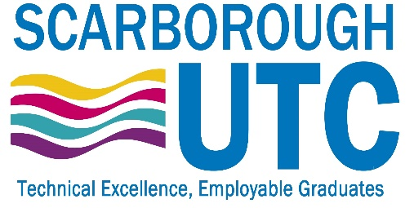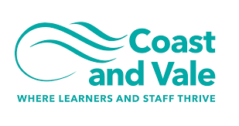

It’s ‘school’, but not as you know it…

Teacher of Health & Social Care
Closing Date: Friday 20th May 2022, 12 Noon
Recruitment Information Pack
1 Ashburn Road
Scarborough, North Yorkshire
YO11 2JW

Contents

Coast and Vale Statement 3
Welcome from the Principal 4
Our Visions and Values 5-6
Our schools 7-9
Application process and how to apply 10
Job Description/Person Specification 11-17
Safeguarding/Equal Opportunities 16-17

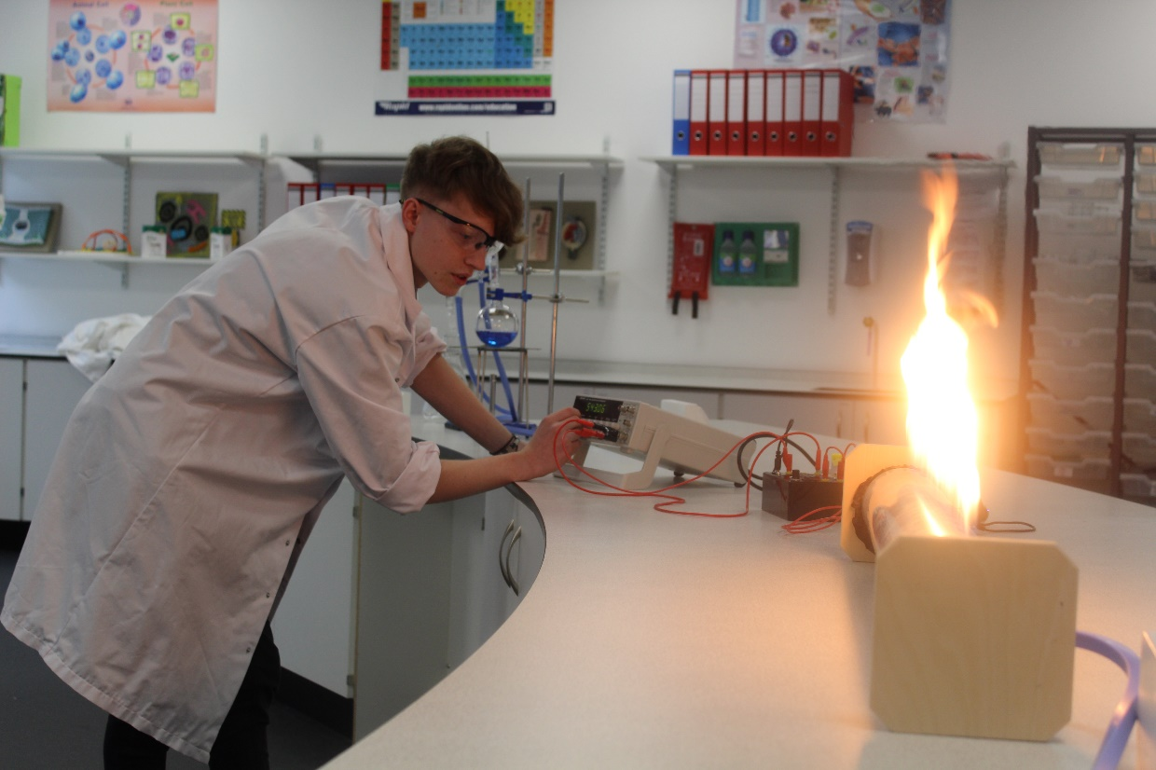

Coast and Vale Learning Trust

Coast and Vale Learning Trust is a growing family of schools located on the beautiful Yorkshire Coast. The Trust was founded by Scalby Secondary School but has grown over the last few years to include Newby and Scalby Primary School, Friarage Primary School and the Scarborough University Technical College (SUTC) in Scarborough and Lady Lumley’s Secondary School in Pickering. Our ambition is to continue to welcome new schools into our Trust where we can add capacity, resources, improvement and make sure all our young people have access to the very best education.

The aim of the trust is to serve all the education community along the North Yorkshire Coast and down the Vale of Pickering. We are committed to supporting all schools in becoming great schools, whether they are part of Coast and Vale Learning Trust or not. The learners of our community deserve the best education regardless of their background or location.

Choosing where to work and who to work for is one of the vitally important decisions in life. In choosing to work for Coast and Vale Learning Trust you would be joining a team of colleagues dedicated to transforming the lives of 3000 children and young people.

We have a simple vision in wanting our schools to be places ‘where children and staff thrive’. Coast and Vale Learning Trust will work tirelessly to make this a reality.

Working For Us

As well as being committed to your ongoing development and training we also offer a range of employee benefits including a competitive salary, access to a government pension scheme, an employee assistance programme as well as a variety of retail discounts.

Dear Applicant

Thank you for your interest in teaching at Scarborough University Technical College. This is an exciting opportunity to work in a new, state-of-the-art building which is part of a prestigious £47million development in the heart of the charming coastal town of Scarborough which boasts the UTC, a new university campus and sports village. Scarborough is currently undergoing an exciting development phase with key players in the engineering and computer science industries establishing themselves in the region thus offering excellent progression routes for aspiring students.

We are a unique institution serving Scarborough, the District of Ryedale, the northerly edge of the East Riding of Yorkshire, Whitby, Filey, Malton, Bridlington and Driffield. Working in partnership with employers allows us to deliver an exciting curriculum with students benefitting from a wealth of commercial knowledge and the chance to experience work and everyday life within a business context. For our students, studying at Scarborough UTC opens up a world of exciting careers in areas such as cyber technology, robotics, engineering and health. Our students will become the new generation of engineers, scientists, designers, technicians and health care workers, contributing towards Scarborough’s continuing transformation into a centre of excellence for innovation.

The strength of Scarborough UTC is its close working relationship with our employers that is forged through the workplace and higher education. By exposing our brightest and most determined young people to the full scale of engineering, design, computer science and health care disciplines and opportunities, we are able to provide a unique learning experience which strongly reflects the commitment of our employers, such as Unison Ltd, GCHQ, McCain, Anglo American and the Universities of Hull and CU Scarborough. Scarborough UTC opened in September 2016 and each year admits students into year 9, 10 and 12 from across the region.

We are delivering outstanding educational opportunities for our young people that will inspire them to have successful careers in engineering, computer science and health. We are therefore looking for outstanding professionals who have an energy and enthusiasm for teaching and learning, who are passionate about their subject and who are driven to make a real difference to the life chances of our young people. If you wish to be involved in the challenge and be part of an outstanding learning community then we look forward to hearing from you.

Thank you

Lee Kilgour

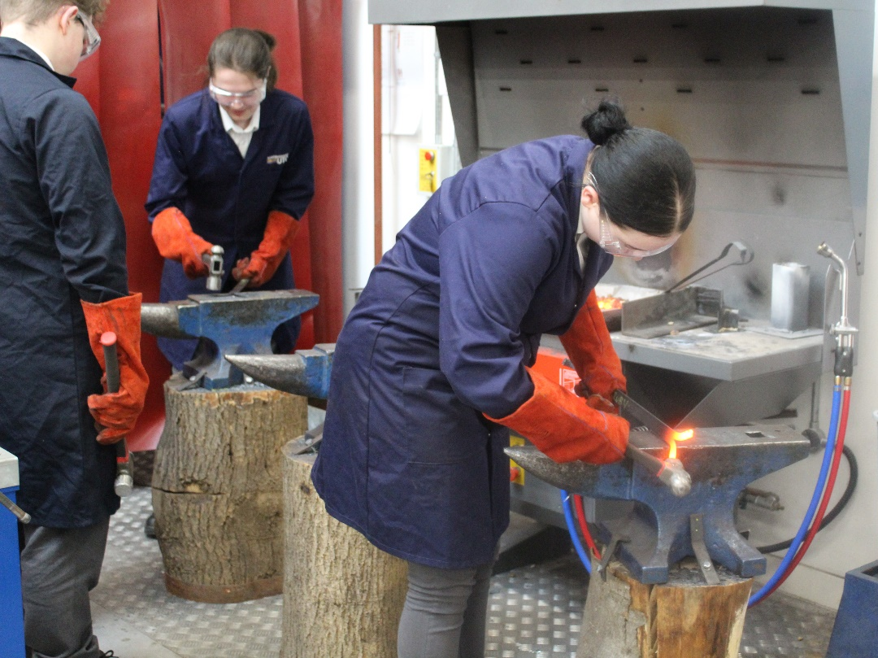

Visions and Values

Technical Excellence, Employable Graduates

The strength of Scarborough UTC is its close working relationship with our employers that is forged through the workplace and higher education. By exposing our brightest and most determined young people to the full scale of engineering and design, cyber and health disciplines and opportunities, we will provide a unique learning experience and strongly reflect the commitment of our employers and the University of Hull. We aim for Scarborough UTC to become a centre of excellence for 13-19 technical education in the region which sits at the heart of its community, alongside other schools and colleges.

Our mission is to provide:

Technical progression routes in to careers in the engineering, computer science industries and health.

Technical excellence and frequent real employer experiences.

The highest standards of teaching and learning every day.

High quality student outcomes at age 16 and age 18.

Our Professional Values are:

Here at Scarborough UTC what defines us is our core Professional Values & Employability Skills that we use to underpin every aspect of UTC life for the students, they are:

S

Self-management including organisational skills and hard work, good manners, Using initiative and being self-motivated, Working under pressure and to deadlines, Ability to learn and adapt, respect and be honest

U

Understanding including problem-solving, enquiry and analysis, Numeracy and IT skills

T

Teamwork, Valuing diversity and difference, Communication, literacy and interpersonal skills, Negotiation skills including collaboration, kindness and resilience

C

Creativity including curiosity, imagination and ingenuity

Our schools

Friarage Primary School
Here at Friarage Community Primary School we provide a nurturing and inspirational education setting which serves our diverse school community. Our catchment area covers right across Scarborough town and beyond.

Our values and ethos of ‘together we can’ is firmly embedded and we are constantly told by visitors that our school has a positive energy about it. To be a colleague at Friarage you have to be nurturing, have the highest expectations for our wonderful children and be committed to providing a curriculum that not only enables success but also makes life long memories.

As an academy within the Coast and Vale Learning Trust we are working closely with our sister school Newby & Scalby Primary as we share learning and build a primary hub that our coastal area can be proud of. With access to the Teaching Alliance, based at Scalby School, we continue to rightly place staff development, training and resources at the heart of our journey.

To learn more about us please visit us at: Friarage Community Primary School - Home (coastandvale.academy)

Lady Lumley’s School
Lady Lumley’s is an 11-18, mixed comprehensive, community school serving the town of Pickering, surrounding villages and warmly welcomes students from Scarborough to Rosedale. We strive to ‘Be our best’, working to improve the experience for all students, staff, and the community. Our broad and balanced curriculum is ambitious for all, and we place great value in academic qualifications alongside the arts and practical subjects. Set in an idyllic location, we make the most of fantastic sporting facilities and run an immensely popular Duke of Edinburgh experience alongside over 30 Enrichment clubs. Our students and staff are loyal to Lady Lumley’s and strive to improve our learning journey, whilst celebrating success.

Lady Lumley’s benefits from the knowledge and experience of Coast and Vale Trust as we are unique school with shared vision. Through leadership development, collaboration and investment Lady Lumley’s is enabled to maintain its identity whilst belonging to a larger family of schools.

To learn more about us please visit us at Lady Lumley's School - Home (coastandvale.academy)

Useful Links

Lady Lumley's School - Home (coastandvale.academy)
Welcome to Pickering. Gateway to the North York Moors, Yorkshire

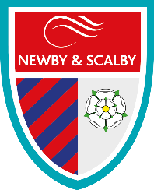
Newby and Scalby Primary School

We are one of the schools of choice in our community and we are within commutable distance of Whitby, Teesside, York and surrounding areas. In 2018 Ofsted judged us to be ‘good’ in all areas and as a school were are very much outward facing both in terms of teaching and learning and in constantly thinking about how we can improve.
Since our ‘good’ Ofsted, we continue to build on our successes and we are a family and a team, where everyone is given the challenge and support to be the best they can possibly be in a safe, welcoming and positive environment. Children and staff will work and play together developing skills so that we all become ambitious and reflective lifelong learners as well as being respectful and respected members of the community.
To learn more about us please visit us at:
Newby and Scalby Primary School - Home (coastandvale.academy)

Scalby School
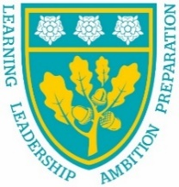
Scalby School is a successful and popular 11-16 community school based in picturesque seaside town of Scarborough on the North Yorkshire Coast. We currently have approximately 1000 students on roll. In recent years we have become the school of choice in our local community. Our P8 score in 2019 placed us in the top 20% of schools nationally again.

Our students are diverse, exciting and talented – and the same is true of our staff. We put huge emphasis on professional development, most of it in-house, and are proud of the highly effective teaching, which characterises our school. We are also noted for our ‘can do’ attitude. We are keen, always, to encourage new and/or young staff to make their mark as soon as they are ready.

A ‘Good’ school in every area as judged by Ofsted in 2012 and in 2019. We are constantly looking at ways to improve our learning offer, and are very ambitious improving the school further. Our aim is to provide a ‘Great’ education for the young people of our beautiful coastal community.
To learn more about us please visit us at: Scalby School - Home (coastandvale.academy)

Scarborough University Technical College

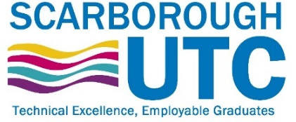
Scarborough UTC is a growing University Technical College (year 9 to year 13) based in a new building, with fantastic technical facilities in the centre of Scarborough. As a University Technical College, we offer a high quality academic and technical education for our students through the specialisms of engineering, health and cyber security. Our unique approach provides students with an excellent range of opportunities including Combined Cadet Force (CCF Navy), strong links to our industrial partners, project-based learning and our flagship Career Development Programme for our Sixth Form students.

Our work with employers and universities ensure we are able to deliver an innovative blend of technical, practical and academic learning which ensures our students make good progress and go on to outstanding destinations.

Our staff are our greatest resource and we have invested in both our teaching and support staff teams which has ensured that educational standards have improved significantly. We have built a staff team of key support and teaching practitioners who are proud to work at our University Technical College.

To learn more about us please visit us at: https://www.scarboroughutc.co.uk

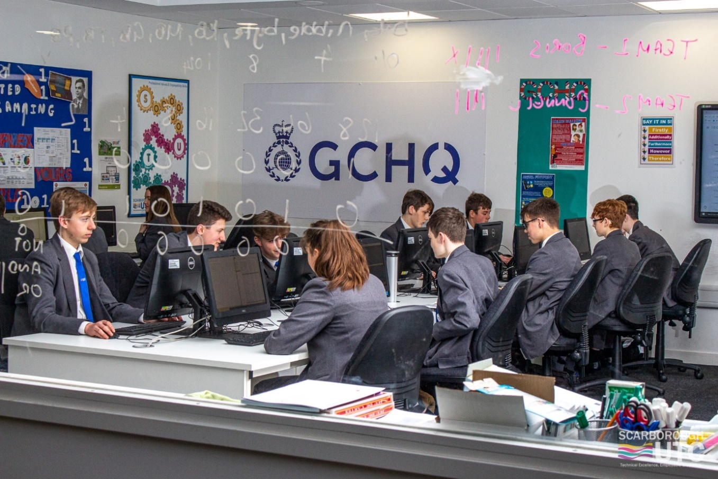

Application Process

The closing date for all applications is Friday 20th May 2022, 12 Noon.

Interviews will be held week commencing 23rd May 2022

Please complete the Trust’s application form which can be downloaded from Coast and Vale Learning Trust - Vacancies Across Our Trust and email your completed form to Garry Morrison the Trust’s Recruitment Partner at garry.morrison@northyorks.gov.uk

Please contact Garry Morrison if you need an application form in a different format. We do not accept CVs.

If you think you’re the person for the job, please complete the enclosed application form and send to the email address above by the closing date.

An email will be sent to shortlisted candidates with details of the interview process. If you have not heard from us within a week of the closing date please assume your application has been unsuccessful.

Queries
Please contact Garry Morrison at garry.morrison@northyorks.gov.uk or on 07814935700

Job Description
Location: Scarborough UTC
Post title: Teacher of Health & Social Care
Salary: Competitive
Hours: 37.5 per week
Contract type: Full-time permanent
Responsible to: Vice-Principal
Introduction
Teachers are crucial to the success of Scarborough UTC. Working as a key part of a dedicated team of professionals, teaching staff will be responsible for promoting a culture of achievement and excellence both within their subject and throughout the UTC. Teachers are responsible for all aspects of teaching, learning, assessment and progress. The Teacher for Health and Social Care is an important role and will contribute to the development of this subject.
We are looking to appoint an innovative, dynamic Teacher of Health and Social Care to join us and become a part of our dedicated and passionate team of staff. You will be responsible for the delivery of outstanding and engaging lessons across all year groups and will be able to effectively assess students against learning outcomes to ensure effective progress is made. You will have high expectations of pupil behaviour and establish a consistent level of discipline, maintaining productive and respectful relationships with students. This is an excellent opportunity to establish Health and Social Care as a subject of excellence in this new UTC. This is a genuine chance to deliver innovative and inspiring teaching through an exciting curriculum focused on ensuring the best learning outcomes for students.
An important part of the UTC ethos is working with external employers and external partners to create the future workforce, therefore the role may involve liaison with stakeholders and leading on specific projects.
Qualifications
- Degree (essential)
- Qualified Teacher Status (QTS) or Certificate in Education/PGCE/DTLLS (desirable)
- Relevant professional qualifications
Main purpose
  - To plan, organise and deliver an appropriate learning programme which exploits the integrated curriculum inherent to the UTC educational vision and which guides and encourages students to develop and fulfil their potential at Key Stage 4 and Post 16.
Principal responsibilities
2.1 Demonstrate outstanding teaching across the full ability range at both KS3, KS4 and Post 16.
2.2 Establish a purposeful and safe learning environment, which complies with current legal requirements, national policies and guidance on the safeguarding and well-being of students and young people, so that students feel secure and sufficiently confident to make an active contribution to learning and the UTC.
2.3 Provide outstanding learning experiences for young people that engages and excites.
2.4 Plan, prepare and deliver challenging, engaging, well-organised lessons and sequences of lessons that facilitate active experiences for young people across the age and ability range.
2.5 Use an appropriate range of teaching strategies and resources which meet the needs of students, take practical account of diversity and promote equality and inclusion.
2.6 Build on the prior knowledge and attainment of students in order that students make sustained and rapid progress.
2.7 Develop concepts and processes which enable students to apply new knowledge, understanding and skills.
2.8 Establish and communicate clear objectives for all learning activities.
2.9 Adapt your language to suit the students you teach, introducing new ideas and concepts clearly, using explanations, questioning, discussions and plenaries effectively.
2.10 Keep up to date with developments in subject area, teaching resources and methods and make relevant changes to schemes of work and lesson plans as appropriate.
2.11 Make effective use of an appropriate range of observation, assessment, monitoring and recording strategies as a basis for setting challenging learning objectives and monitoring students’ progress and levels of attainment.
2.12 Support and guide students, colleagues, parents and carers with timely, accurate and constructive feedback on students’ attainment, progress and areas for development.
2.13 Review the effectiveness of your teaching and its impact on students’ progress, attainment and well-being, refining your approaches where necessary.
2.14 Use reports and other sources of external information related to assessment in order to provide students with accurate and constructive feedback on their strengths.
2.15 Support and guide students to become successful independent learners.
2.16 Develop personal ICT skills and use relevant technology to support the learning process, in line with the ICT Vision.
2.17 Actively find, adapt, create and share ICT based resources and to deploy these for learners’ benefit.
2.18 Maintain accurate and complete electronic records of students' progress and development and update all necessary records accurately and completely as required.
2.19 Manage student behaviour in the learning environment by establishing and enforcing rules and procedures in accordance with the rules and behaviour management systems of Scarborough UTC.
2.20 Participate in extra-curricular activities such as social activities, sporting activities, clubs, student organisations and residential and to run one extra-curricular activity each week.
2.21 Participate in subject and college meetings, parent meetings and to communicate necessary information regularly to students, colleagues and parents regarding student progress and student needs.
2.22 Set appropriate work for classes when absent.
2.23 Engage with partner employers and universities in the development and delivery of curriculum projects
General responsibilities
3.1 Model the highest professional standards to students in all aspects of the role, maintaining a visible presence around Scarborough UTC and leading by example.
3.2 Be committed to continuous improvement in teaching practice, and to continued professional development to support such practice.
3.3 Be committed to working in a cohesive, supportive and forward-thinking team of colleagues which shares an ambitious vision to secure outstanding outcomes for Scarborough UTC.
3.4 Be committed to the UTC’s ICT Vision, under which the use of ICT will be at the heart of teaching, learning and assessment.
3.5 Contribute to the formulation and implementation of The Scarborough UTC Development Plan.
3.6 Be prepared to work collaboratively being flexible and interested in other areas of Scarborough UTC.
3.7 Contribute to the marketing and student recruitment events of the UTC.
3.8 Be fully aware of, understand and act upon the duties and responsibilities arising from legislation and guidance in relation to child protection and safeguarding.
3.9 Undertake other such duties as are commensurate with the post and which may reasonably be required by the Principal or your Line Manager.
Terms and Conditions
Safeguarding
- Know about relevant Government and local guidance, policies and procedures, and how they work in the wider workforce
- Adhere to data protection legislation
- Be responsible for promoting and safeguarding the welfare of children and young people.
Systems and Information
- Be aware that different types of information exist (for example, confidential information, personal data and sensitive personal data), and appreciate the implications of those differences.
- Share information appropriately – in writing, by telephone, electronically and in person.
- Have an awareness and basic knowledge of the most recent legislation and the common law duty of confidentiality.
Ensure that information systems are in place to ensure that accurate electronic and manual records are maintained and updated as required.
Data Protection
- To comply with the Trust’s policies and supporting documentation in relation to Information Governance this includes Data Protection, Information Security and Confidentiality.
Health and Safety
- Be aware of and implement your health & safety responsibilities as an employee and where appropriate any additional specialist or managerial health & safety responsibilities as defined in the Health & Safety policy and procedure.
Equalities
- We aim to make sure that services are provided fairly to all sections of our community, and that all our existing and future employees have equal opportunities.
- Ensure services are delivered in accordance with the aims of the equality Policy Statement.
- Develop own and team members understanding of equality issues.
Flexibility
- The Trust provides front line services, which recognises the need to respond flexibly to changing demands and circumstances. Whilst this job outline provides a summary of the post, this may need to be adapted or adjusted to meet changing circumstances. Such changes would be commensurate with the grading of the post and would be subject to consultation. All staff are required to comply with Trust Policies and Procedures.
Customer Service
- The Trust requires a commitment to equity of access and outcomes, this will include due regard to equality, diversity, dignity, respect and human rights and working with others to keep vulnerable people safe from abuse and mistreatment.
- The Trust requires that staff offer the best level of service to their customers and behave in a way that gives them confidence. Customers will be treated as individuals, with respect for their diversity, culture and values.
- Understand your own role and its limits, and the importance of providing care or support.

Person Specification

Requirements | Essential | Desirable
A good/outstanding teacher who is qualified to professional/ degree level
Teaching qualification or equivalent
Inclusive promoting a positive climate for learning by using clear boundaries, sanctions, praise and rewards
Flexible working practices demonstrating resilience, motivation and commitment to drive up standards of achievement
Experience of teaching GCSE or L2 vocational classes to a high standard
Experience of teaching post-16 to a high standard
Acts as a role model to students
Commitment to regular and on-going professional development and training to establish outstanding classroom practice
Highly creative with a passion for your subject and how it translates to the Scarborough UTC vision
Effective team worker with a commitment to the UTC holistic delivery
Commitment to the safeguarding and welfare of all pupils
Resilience and the ability to manage in high-pressured environments
High levels of emotional intelligence
Experience of successfully working with a range of partners, both within and outside the world of education
Experience of involving employers in curriculum design and delivery
Relevant work based professional experience
The ability and confidence to promote the UTC to young people, parents and other stakeholders
Sound knowledge and understanding of qualifications and curriculum frameworks and progression routes in your subject, both academic and vocational in order to maximise successful outcomes for learners
Ability to utilise new technologies to enhance teaching and learning outcomes
Ability to interpret performance data to set targets and raise standards
Ability to implement effectively a range of student centered assessment for learning strategies
Able to demonstrate high aspirations and expectations for all young people
Excellent communication and interpersonal skills- the ability and presence to make points clearly, to listen and respond in a variety of situations
Understand how to modify teaching and learning to meet the needs of gifted and talented students and those with special educational needs

Safeguarding and Equal Opportunities
We are committed to safeguarding and protecting the children and young people we work with and expect all our staff and volunteers to share this commitment. As such, all posts are subject to safer recruitment process, including an enhanced DBS check. We have a range of policies in place which promote safeguarding and safer working practice across our Schools.
We are an equal opportunities employer and welcome applications from all sections of the community regardless of age, gender, race, ethnicity, disability, sexual orientation, social background, religion or belief. We want to recruit the right people for the Trust, from the widest possible backgrounds, to make the most of each individual’s different knowledge and experience.
Your privacy is important to us. By submitting your personal data or information to us, you agree this will be handled in accordance with the Trust’s “Privacy Notice Recruitment” which can be found on our website.

